Charles F. Gosnell - 1909-1993

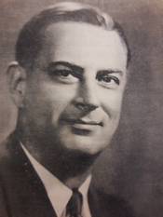

Charles Francis Gosnell (1909–1993) was an academic librarian and educator who held positions in New York state and university library administration and played an active role in national and international library development. Dr. Gosnell was elected president of the Library Administration Division (LAD) of the American Library Association in 1966.

He was born in Rochester, New York. He earned a bachelor’s degree from the University of Rochester, a master of arts from Columbia University in 1932, and a Ph.D. from New York University in 1943.
He began his professional career in 1937 as assistant librarian at Queens College (later part of the City University of New York), advancing to head librarian by 1945.

From 1945 to 1962, Dr. Gosnell served as New York State Librarian and Assistant Commissioner for Libraries in Albany. In this capacity, he pioneered the formation of regional and rural library systems based on local initiatives, rehabilitated several library facilities, and conducted influential studies in the early 1950s that drew national attention to the neglected state of public libraries and many college and university libraries across the United States.

In 1962 Gosnell left state service to become Director of Libraries at New York University (overseeing the development of the Elmer Holmes Bobst Library) and Professor of Library Administration. He also taught library administration and law (including civil liberties and constitutional law) at NYU’s School of Law until his retirement in 1974.
Internationally, he consulted for the University of Brasília, the Inter-American Development Bank, and directed a UNESCO survey of public library services in Colombia. After retiring from NYU, he served as an adviser to the U.S. General Services Administration on archives and records centers.

Professional Activities

Dr.
Gosnell served on the American Library Association member executive board 1953-1957. He was elected president of the Library Administration Division (LAD) of the American Library Association in 1966 (LAD later became the Library Administration and Management Association, or LAMA). He chaired ALA’s Committee on Library Cooperation with Latin America.
He was president of the National Association of State Libraries (1956-1957) and the New York Library Association in 1969.
He was chairman of the Board of Trustees of Public Affairs Information Service (PAIS).
He was a member of the Board of Trustees of Skidmore College from 1945 to 1969.

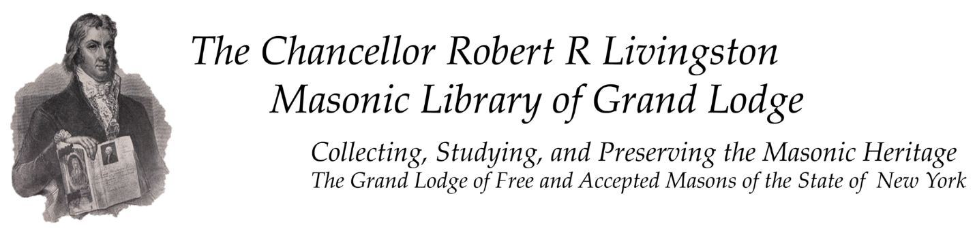
In his later years he was first president of the Chancellor Robert R. Livingston Masonic Library in Manhattan. Gosnell played a central role in its creation and establishment as one of the world’s largest collections of books, artifacts, memorabilia, and archival materials on Freemasonry (with a special focus on New York State Masonic history). The library is located within the Masonic Hall in Manhattan and continues to serve as a major research and preservation center for Masonic heritage.

Gosnell died on July 1, 1993, at St. Luke’s Hospital in Utica, New York.

Selected Publications

Gosnell, Charles F. Spanish Personal Names: Principles Governing Their Formation and Use Which May Be Presented as a Help for Catalogers and Bibliographers. New York: H. W. Wilson Company, 1938.
Gosnell, Charles F. “Values and Dangers of Standard Book and Periodical Lists for College Libraries.” College & Research Libraries 2, no. 3 (1941): 216–221.
Gosnell, Charles Francis. “The Rate of Obsolescence in College Library Book Collections as Determined by an Analysis of the Three Select Lists of Books for College Libraries. PhD diss., New York University, 1943.
Gosnell, Charles F. “Obsolescence of Books in College Libraries.” College & Research Libraries 5, no. 2 (1944): 115–125.
Gosnell, Charles F. “A Voice for National Interests.” College & Research Libraries 6, no. 2 (1945): 99.
Gosnell, Charles F. “Obsolete Library Books.” The Scientific Monthly 64, no. 5 (May 1947): 421–427.
Gosnell, Charles F. “Books of Exceptional Age.” College & Research Libraries 9, no. 1 (January 1948): 33–40.
Gosnell, Charles Francis. “Systematic Weeding.” In “Optimum Size of Libraries: A Symposium.” College & Research Libraries 11, no. 2 (April 1950): 137–138.
Gosnell, Charles Francis. “Libraries: Recent Additions to the New York State Library in the Field of New York State History.” New York History 37, no. 2 (April 1956): 197–201.
Gosnell, Charles F. Survey of Public Library Services in Colombia (UNESCO consultancy report, n.d. [likely 1970s]). [Unpublished or internally distributed; no public citation located.]
Gosnell also produced numerous official reports, book reviews, and state library news summaries during his tenure as New York State Librarian (1945–1962), as well as panel contributions and consulting reports. Many of his later outputs were institutional reports or collaborative ALA/UNESCO documents rather than standalone monographs.

Sources
“Chancellor Robert R. Livingston Masonic Library.” Atlas Obscura. July 26, 2012.
“Charles Gosnell, State Librarian and Mason, 83,” New York Times, July 3, 1993.
Charles F. Gosnell Trustee Papers,” Skidmore College Archives, (accessed May 29, 2026).
“Charles F. Gosnell Papers,” NYU Special Collections Finding Aids, New York University, (accessed May 29, 2026).
Daugherty, Robert, and Robert F. Moran Jr. “Fiftieth Anniversary Special: A Brief History and Timeline of the Library Administration and Management Association, 1957–2007.” Library Administration & Management 21, no. 3 (2007): 109–123.
“List and Biographies of New York State Librarians,” New York State Library.
Nix, Larry. “Charles Francis Gosnell, New York Librarian.” Library History Buff (blog), July 7, 2009.
Prom, Christopher J. “Gosnell, Charles F.” In Dictionary of American Library Biography, Second Supplement, edited by Donald G. Davis Jr., 110–114. Westport, CT: Libraries Unlimited, 2003.

