Anne C. Edmonds – 1924-2018

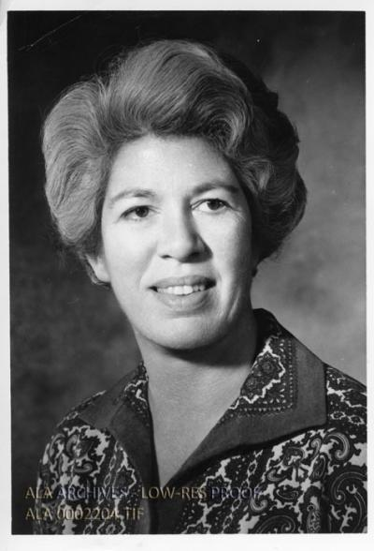

Anne C. Edmonds (1924–2018) was an academic librarian, college library director, and president of the Association of College & Research Libraries (ACRL) from 1970 to 1971.
She dedicated her career to advancing library services in higher education, with a particular focus on liberal arts colleges, while also contributing to international library exchange and community cultural life in her later years.

Anne C. Edmonds was born December 19, 1924, in Penang, Malaysia. Her parents met and married in Penang. In the 1930s the family, including Anne and her two sisters, relocated to Eastbourne, England, where her father ran a pharmacy.
World War II shaped her early adulthood: the coastal town endured heavy bombings and invasion threats. Anne and her sisters were evacuated as part of a government scheme sending schoolchildren to safer rural areas north of London for two years. In 1943 her father was killed in an air raid; the following year Anne herself was injured when a V1 flying bomb struck the town. After two years at the University of Reading, she worked from 1944 to 1946 in the office of the British government’s War Damage Commission in London.

In 1946, following the death of her father, Anne’s widowed mother—retaining her American citizenship—moved the family to the United States. Anne enrolled at Barnard College and went on to earn a master’s degree in library services from Columbia University.
Her library career began as a children’s assistant at the Enoch Pratt Free Library in Baltimore. She transitioned to academic librarianship, serving as a reference librarian at City College of New York and then at Goucher College in Towson, Maryland.
She was library director at Douglass College in New Brunswick, New Jersey, before joining Mount Holyoke College in South Hadley, Massachusetts, where she served as college librarian for thirty years until her retirement in 1994.
Mount Holyoke awarded her an honorary doctorate in recognition of her service.

During her tenure at Mount Holyoke, Edmonds played a prominent national role in the profession. She was elected president of ACRL (a division of the American Library Association) for the 1970–1971 term. She contributed columns and statements in College & Research Libraries News addressing issues such as professional development, library reorganization, and the role of librarians in academic communities.
She spent a year as an exchange librarian at the European Services Library of the BBC in London and served for six months as a consultant at the University of the North (an ethnic-based institution in Turfloop, in South Africa’s northern Transvaal).
She also taught library science courses during summer sessions at Rutgers and Syracuse universities.

Edmonds was a committed historian of her institution as well. She authored A Memory Book: Mount Holyoke College 1837–1987 and wrote articles on the college’s principals and presidents, drawing on her knowledge of its library and archival collections.
Her personal papers, held at Mount Holyoke, document her wartime experiences in England, travels in South Africa, and work on the history of the college and its library.

After retiring in 1994, Edmonds moved permanently to Camden, Maine. She was active in civic and cultural affairs, supporting the Camden Public Library’s renovation projects, serving ten years on the board of the Center for Maine Contemporary Art, participating in the American Association of University Women and its scholarship program for local high-school students, and serving on the vestry and committees of St. Thomas Episcopal Church.
A bench she sponsored at the Camden Public Library bears the inscription from Francis Bacon, “Reading maketh a full man,” reflecting her lifelong commitment to books and learning.
She died on October 30, 2018. Memorial contributions were directed to the Camden Public Library, St. Thomas Episcopal Church, and United Mid-Coast Charities—organizations close to her heart.

Selected Publications

Edmonds, Anne C. “Committee on Non-Western Resources.” College & Research Libraries News 29, no. 3 (1968): 71–73.

Edmonds, Anne C. “Railroad Tracks and Alphabet Soup.” College & Research Libraries 32, no. 4 (July 1971): 269–270.

Edmonds, Anne C. “From the ACRL President.” College & Research Libraries News 32, no. 6 (1971): 160–161.

Edmonds, Anne C. “Mount Holyoke Principals and Presidents.” Mount Holyoke Alumnae Quarterly 71, no. 2 (1987).

Edmonds, Anne Carey. A Memory Book: Mount Holyoke College 1837–1987. South Hadley, MA: Mount Holyoke College, 1988.

Sources
“Anne C. Edmonds.” Pen Bay Pilot, November 21, 2018.
Anne Carey Edmonds Papers.” Archives and Special Collections, Mount Holyoke College, South Hadley, MA.
Edwards, Anne C. “From the ACRL President.” College & Research Libraries News 32, no. 6 (1971).

Edmonds, Anne Carey. A Memory Book: Mount Holyoke College 1837–1987. South Hadley, MA: Mount Holyoke College, 1988.

Submitted by ALA Member

