Cora Paul Bomar (1913– 2008)

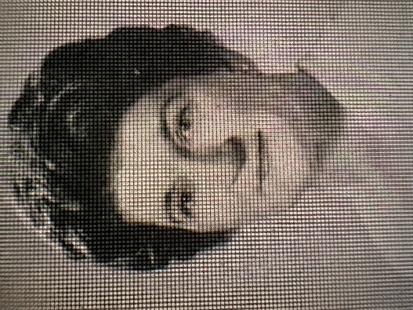

Cora Paul Bomar (1913–2008) was a librarian, educator, and national advocate for school libraries and educational media. She was President of the American Association of School Librarians (AASL from 1962 to 1963.

She began her career in 1932 as a teacher-librarian in a rural one-room school in West Tennessee (teaching grades 1–8). She pursued higher education while working—earning a B.S. in Education from the University of Tennessee, an M.L.S. from George Peabody College, and an M.A. in Elementary Education from the University of North Carolina at Chapel Hill.
In North Carolina, where she spent much of her professional life, Bomar worked for over 18 years in the Department of Public Instruction as Supervisor of School Library Services. In 1966 she became the first director of the new Division of Educational Media. Under her leadership, school library/media programs expanded and by 1969, nearly every public school in the state had a central library.

Cora Paul Bomar joined the faculty of the Library and Information Studies (LIS) program at the University of North Carolina at Greensboro (UNCG) in 1969 and retired in 1979.
Bomar testified before U.S. House and Senate committees on library issues six times and was invited by President Lyndon B. Johnson to the 1964 White House signing of key pro-library legislation. She authored professional guides, including School Library Service in North Carolina (1953) and Guide to the Development of Educational Media Selection Centers (1973, with co-authors).
She is best known for her leadership in the American Association of School Librarians (AASL), a division of the American Library Association (ALA). She also held presidencies in other ALA units, including the Association of State School Library Supervisors and the Library Education Division.

Honors
Mary Peacock Douglas Award for outstanding contributions to North Carolina school libraries, presented by the North Carolina Association of School Librarians (1970)
Honorary life membership, North Carolina Library Association
Honorary Life membership, Southeastern Library Association (SELA) (noted 1988)
American Library Association Distinguished Contribution to Library Education for North Carolina (1987)
Founders Award, North Carolina Delta Kappa Gamma Society (1989; bestowed biennially for contributions to education, publication, and service).

Cora Paul Bomar died on March 18, 2008, at Friends Home West at age 94.

Her legacy continues through the Cora Paul Bomar Summit (formerly the Cora Paul Bomar Lecture), an annual event at UNCG’s School of Education focused on library and information studies topics. She endowed the supporting lecture fund upon her retirement.

Publications

Bomar, Cora Paul. North Carolina School Library Handbook. Raleigh: North Carolina Department of Public Instruction, 1953.
Bomar, C. P. (1955). School libraries in North Carolina. Library Journal 80, 2897–2900.

Bomar, Cora Paul, comp. School Library Service in North Carolina: An Overview. Raleigh, NC: State Department of Public Instruction, Library and Instructional Materials Services, 1964.

Bomar, Cora Paul, and Frances Kennon Johnson. “Planning School Library Quarters.” School Libraries 13, no. 2 (February 1964): 103.

Bomar, Cora Paul. “Legislation and the School Library.” NASSP Bulletin 50, no. 306 (January 1966): 89–95.

Bomar, Cora Paul. “Federal Legislation and Interlibrary Cooperation.” Texas Library Journal 43 (Spring 1967): 23–26.

Bomar, Cora Paul, Program director. Guide to the Development of Educational Media Selection Centers. Program coordinators M. Ann Heidbreder and Carol A. Nemeyer. Chicago: American Library Association, 1973. (ALA Studies in Librarianship, no. 4.)

Bomar, Cora Paul. “North Carolina School Libraries: A Look at the Past, Present and Future.” North Carolina Libraries 50, no. 1 (1992): 14–17.

Sources

Cora Paul Bomar. (2008). American Libraries, 39(5), 67.
Cora Paul Bomar Summit | School of Education
Cora Bomar Obituary (2008) - Legacy Remembers
University of North Carolina at Greensboro -- Faculty. Archives Space. University of North Carolina at Greensboro. https://uncg.as.atlas-sys.com/subjects/790. These include a photo of Bomar with President Lyndon B. Johnson, and a pen presented to Bomar by the president at a 1964 bill signing ceremony .

Submitted by ALA Member

