Joseph A. Boissé - 1937–2015

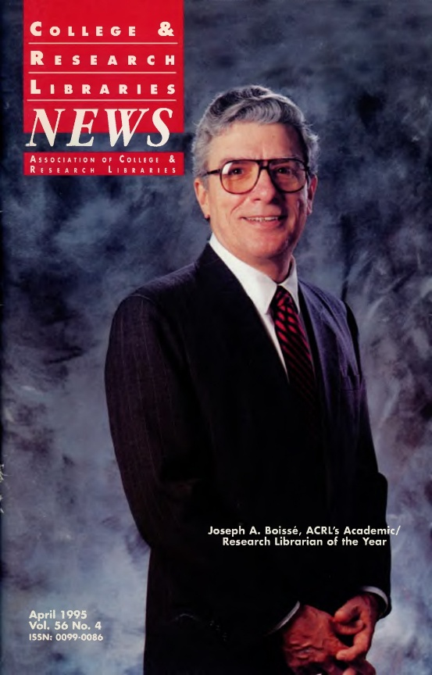

Joseph A. Boissé (1937–2015) was an academic librarian and library administrator known for his leadership in research libraries and his advocacy for diversity and multicultural collections.
He earned an A.B. from Stonehill College, and an M.A. in French literature from Brown University (1965)—his master’s thesis was “La solitude humaine dans les romans de Julien Green (“Human Solitude in the Novels of Julien Green”).
He earned an M.S. in Library Science from Simmons College (1967), and an Ed.D. from Temple University,
Dr. Boissé was assistant director of libraries at Lawrence University (1968–1971) and assistant state librarian for the Vermont Department of Libraries (1971–1973).
He was director of libraries at the University of Wisconsin–Parkside (1973–1979) where he was responsible for the creation of a competency-based library user education program which served as a model for the profession for over a decade.
He was director of libraries at Temple University (1979–1983). In 1983 he was appointed university librarian at the University of California, Santa Barbara (UCSB). Dr. Boissé initiated a Diversity Residency Program which stimulated the University of California System to initiate a similar system-wide program. He retired in 1998.
Associations

Dr. Boissé was elected president of the Association of College and Research Libraries (ACRL) for 1988–1989 and received the ACRL Academic/Research Librarian of the Year Award in 1995. In nominating Boissé, his colleagues noted:
“His pioneering of bibliographic instruction as an integral part of the mission of an academic library, the leadership role he has played in mentoring minorities in the field of academic librarianship, and his extensive contributions to professional organizations . . . place him among the outstanding leaders in our profession.”
Boissé served as ACRL president (1988–89), vice-president (1987–88), Salt Lake City National Conference Executive Committee chair (1990–92 the Colleagues Committee (1993–95), Appointments and Nominations (1983–84), and the Continuing Education Committee (1979–80).
He served on the ALA Council (1991–1995), as chair of the Committee on Instruction in Library Use (1979–83), and was active in the Library Administration and Management Association.
He was an active member of the Association of Research Libraries (ARL):
- Academic Library Program Advisory Committee (1982–1986);
- ARL Microform Project Cataloguing Program Advisory Committee (1981–1986);
- Collection Development Committee (1984–1986);
- Chair of the Task Force on Minority Recruitment (1990–1992);
- Information Policies Committee (1990–1992, 1997–1998);
- Scholarly Communication Committee (1994–1996);
- Scientific and Technical Information Working Group (1993–1996).

He served on the Board of Directors of the Research Libraries Group, a major North American consortium of research libraries focused on collaborative collection development, preservation, resource sharing, and shared cataloging through its RLIN (Research Libraries Information Network) system.
He participated in the International Federation of Library Associations and Institutions (IFLA). He attended IFLA conferences in Paris, Barcelona, and Istanbul. In 1995 he published the article “Library Cooperation: A Remedy but Not a Panacea” in the IFLA Journal, which reflected his long-standing interest in resource sharing and international library collaboration.
Boissé also supported the development of significant research collections in ethnic and multicultural studies, the performing arts, and American religions.

After retiring from UCSB, Boissé and his spouse, David L. Williams, moved to Monkton, Vermont, where he served as Town Lister for approximately fifteen years.
He was an avid reader with a keen interest in Quebecois literature.

Selected Publications

Boissé, Joseph A. “Serving Multicultural and Multilingual Populations in the Libraries of the University of California.” Resource Sharing & Information Networks 11, no. 1–2 (1996): 71–79.

Boissé, Joseph A. “Adjusting the Horizontal Hold: Flattening the Organization.” Library Administration & Management 10, no. 2 (1996): 77–81.
Boissé, Joseph A., and Mary Larsgaard. “GIS in Academic Libraries: A Managerial Perspective.” The Journal of Academic Librarianship 21, no. 4 (July 1995): 288–291.

Boissé, Joseph A. “Library Cooperation: A Remedy but Not a Panacea.” IFLA Journal 21, no. 2 (1995): 89–93.

LaGuardia, Cheryl, and Joseph Boissé. “User Needs, Library Mandates, and Information Magic.” Online 18, no. 3 (May 1994): 9–12.

Stoffle, Carla J., and Joseph A. Boissé. “Your Right to Know: The Profession’s Response.” In Your Right to Know: The Call to Action, ed. by Patricia Glass Schuman. Chicago: American Library Association, 1993.

Boissé, Joseph A., and Connie V. Dowell. “Increasing Minority Librarians in Academic Research Libraries.” Library Journal 112, no. 7 (April 15, 1987): 52–54.

Stoffle, Carla J., Alan E. Guskin, and Joseph A. Boissé. “Teaching, Research, and Service: The Academic Library’s Role.” New Directions for Teaching and Learning, no. 18 (Summer 1984): 3–14.

Guskin, Alan E., Carla J. Stoffle, and Joseph A. Boissé. “The Academic Library as a Teaching Library: A Role for the 1980s.” Library Trends 28, no. 2 (Fall 1979): 281–296.

Boissé, Joseph A. “Library Instruction and the Administration.” In Putting Library Instruction in Its Place: Papers Presented at the Seventh Annual Conference on Library Orientation for Academic Libraries, May 12–13, 1977, edited by Carolyn A. Kirkendall, 3–11. Ann Arbor, MI: Pierian Press, 1978.

Sources
Association of Research Libraries. “Memorial: Joseph Adonias Boisse, 1937–2015.” February 25, 2015.
“Boissé Receives ACRL’s Highest Honor.” College & Research Libraries News 56, no. 4 (April 1995): 259.
“Joseph Adonias Boisse.” Burlington Free Press, February 2015.
“Joseph A. Boisse.” Photograph, ca. 1980. College and Research Libraries News Photograph File, ca. 1960–2003. Record Series 22/3/6, Box 1, Folder: Bi-Bu, ca. 1981–ca. 2000. American Library Association Archives, University of Illinois at Urbana-Champaign.

Submitted by Kathleen de la Peña McCook

