Pura Belpré, 1899-1982
Librarian, children’s books author, puppeteer, storyteller

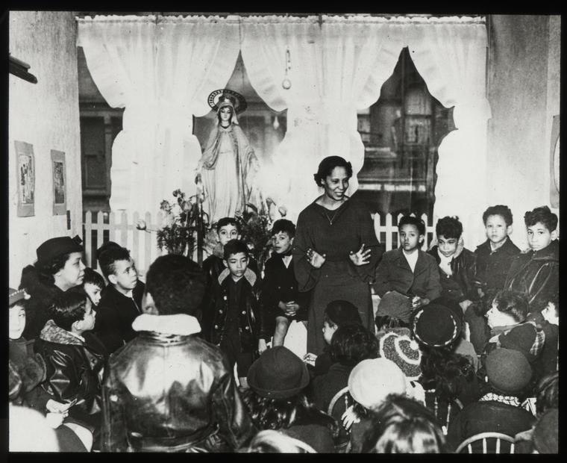
New York Public Library Archives, The New York Public Library. (1875 - 1925). 115th Street, story-telling group, African American children with Miss Pura Belpré. https://digitalcollections.nypl.org/items/cfd48580-c5b4-012f-4868-58d385a7bc34

Pura Belpré Nogueras was born on February 2nd, 1899* in Cidra, Puerto Rico, and died on July 1st, 1982, in New York City. Belpré’s enduring legacy left a mark as a pioneer of bilingual literacy and library programs for children, and for her work creating, preserving, and promoting cultural representation of Puerto Rican folklore and culture in children’s literature.
As soon as arriving to New York City in 1921, Belpré was recruited to work as a bilingual library assistant in the 135th Street Branch of the New York Public Library (NYPL). She worked at NYPL for six decades, with a break between 1944 and 1961.
Instantly connecting with the Spanish-speaking children and families of the Barrio, Belpré soon discovered the inexistence of materials and resources that reflected the community’s culture, and she made it her career’s goal to solve that problem. Her bilingual programs were groundbreaking, and to solve the absence of culturally authentic materials, she brought alive the stories and folktales from her native island. She also became a puppeteer and a talented bilingual storyteller.
She wrote the stories, told the stories, created the puppets, and even designed a mobile puppet theater that was transported to all the NYPL branches.
Pura Belpré married composer and director Clarence Cameron White in December 1943, and she took a leave of her job to accompany her husband in his performances’ tours. During this break from library work, however, she continued writing and publishing books for children. Her books of folktales and stories were a crucial addition to Spanish-language literature for youth in the United States. After White died in 1960, Belpré returned to work at the NYPL where she stayed until her death in 1982.
In 1996, the National Association for library Services to Latinos and the Spanish-speaking
(REFORMA), along with the Association for Library Services to Children (ALSC) of the American Library Association (ALA) named the “Pura Belpré Award” for excellence in books for children written/illustrated by Latino creators and portraying the Latino experience, in recognition of her legacy. Other tributes include having received the New York Mayor's Award for Arts and Culture, the naming of a street in the Bronx as Pura Belpré Way, the publication of picture books and other books for children telling her story, and the creation of a special collection with her papers in the Center for Puerto Rican Studies, Hunter College of the City University of New York.
From the first day Pura Belpré opened the library doors to Boricua children and families, and throughout her whole life, she opened for them the worlds of literacy, wonder, and stories, and through her work she ensured authentic representation of their cultures in stories for children.

*Her date of birth has been reported with variations between 1899, 1901, and 1903.

Selected Publications for Children by Pura Belpré:

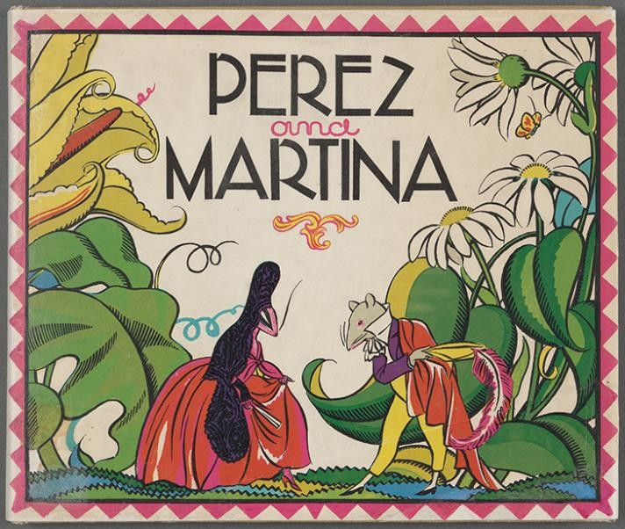
Pura Belpré (1899–1982), author Carlos Sanchez M., illustrator
Perez and Martina, a Portorican Folk Tale. NYPL General Research Division.
https://www.nypl.org/events/exhibitions/galleries/childhood/item/14835

- Perez and Martina: A Portorican Folktale (illustrated by Carlos Sanchez), Warne, 1932; Spanish publication 1961; Viking, 1991.
- The Three Magi, in "The Animals' Christmas" by Anne Thaxter Eaton, 1944.
- The Tiger and the Rabbit, and Other Tales (illustrated by Kay Peterson Parker), Houghton, 1946, new edition (illustrated by Tomie de Paola), Lippincott, 1965.
- Juan Bobo and the Queen's Necklace: A Puerto Rican Folk Tale (illustrated by Christine Price), Warne, 1962.
- Ote: A Puerto Rican Folk Tale (illustrated by Paul Galdone), Pantheon, 1969.
- Santiago (illustrated by Symeon Shimin), Warne, 1969.
- (With Mary K. Conwell) Libros en Español: An Annotated List of Children's Books in Spanish, New York Public Library, 1971.
- Dance of the Animals: A Puerto Rican Folk Tale (illustrated by P. Galdone), Warne, 1972.
- Once in Puerto Rico (illustrated by C. Price), Warne, 1973. Includes many stories.
- A Rainbow-Colored Horse (illustrated by Antonio Martorell), Warne, 1978.

Selected Books for Children about Pura Belpré:
- The Storyteller’s Candle / La Velita de los Cuentos by Lucia M. Gonzalez, illustrated by Lulu Delacre. Lee & Low, 2008.
- Planting Stories: The Life of Librarian and Storyteller Pura Belpré by Anika Aldamuy Denise, illustrated by Paola Escobar. Harper Collins, 2019. [Also in Spanish]
- Pura's Cuentos: How Pura Belpré Reshaped Libraries with Her Stories by Annette Bay Pimentel, illustrated by Magaly Morales. Abrams, 2021. [Also in Spanish]
- The Life of / La vida de Pura (a bilingual English/Spanish book) by Patty Rodriguez and Ariana Stein, illustrated by Citlali Reyes. Lil’ Libros, 2022.
- She Persisted: Pura Belpré by Meg Medina and Marilisa Jiménez García. Philomel, 2023. [Also in Spanish]

Sources:
Association for Library Services to Children [ALSC]. American Library Association. “Pura Belpré Award”. https://www.ala.org/alsc/awardsgrants/bookmedia/belpre
Denise, A. A. (2021). Titi Pura: A conversation with Pura Belpré’s great-nieces Cristina Maduro and Lisa Fentstermacher. The Horn Book Magazine, 17(3): 20-23.
Gonzalez, L. S. (2013). The stories I read to the children: The life and writing of Pura Belpré, the legendary storyteller, children’s author, and New York Public librarian. Center for Puerto Rican Studies.
Hernández-Delgado, J. L. (1992). Pura Teresa Belpré, storyteller and pioneer Puerto Rican librarian. Library Quarterly 62, 425–440. https://doi.org/10.1086/602497
Jiménez-García, M. (2014). Pura Belpré lights the storyteller's candle: Reframing the legacy of a legend and what it means for the fields of Latino/a studies and children's literature. Centro Journal, 26(1), 110-147.
REFORMA. (n.d.). Pura Belpré biographical notes. https://www.reforma.org/content.asp?contentid=510
REFORMA. (2022). Pura Belpré Way street co-naming. https://www.reforma.org/blog_home.asp?Display=174

==
Submitted by a REFORMA member.

