Benjamin E. Powell – 1905-1981
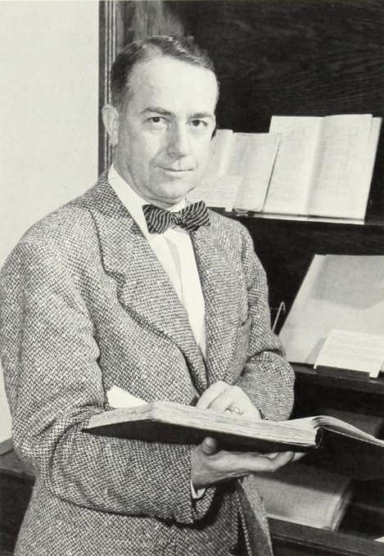

Dr. Benjamin Edward Powell (August 28, 1905–March 11, 1981) was an academic librarian who was President of the American Library Association 1959 -1960 and President of the Association of College and Research Libraries (ACRL) from 1948 - 1949.
Powell was born
in Sunbury, Gates County, North Carolina. He entered Trinity College (which became Duke University in 1924) in 1922 and graduated in 1926 with a major in history.
After brief work in the Duke University library and a year (1926–27) teaching and coaching athletics at Bethel High School in Pitt County, Powell returned to the Duke library staff and advanced to head of the circulation department. In that role he planned, organized, and supervised the move of the library collection from the old Trinity College library to the new General Library on the West Campus.
On leave from Duke in 1929–30, he earned a B.S. in library science from Columbia University School of Library Service. He attended the University of Chicago Graduate Library School in 1934–35 and received a Ph.D. in library science from Chicago in 1946. His dissertation examined the development of libraries in eight Southern state universities up to 1920.

In 1937 Powell left Duke to become head librarian at the University of Missouri, where he remained until 1946; during that period he served as president of the Missouri Library Association (1938–39) and secretary of ACRL (1940–44).
Dr. Powell returned to Duke in 1946 as university librarian, succeeding Joseph Penn Breedlove, and held the post for nearly three decades. Under his administration the Duke library system underwent substantial growth: holdings increased from approximately 875,000 volumes and 975,000 manuscripts in 1946 to nearly 3 million volumes and more than 4.5 million manuscripts by 1975.
The main library was enlarged twice, the Duke University Archives were integrated into the system in 1972, and automated procedures were introduced for serials control, purchasing, accounting, online ordering, and microfiche production of serial records.
Dr. Powell also taught courses in library administration theory at the University of North Carolina School of Library Science, served as a consultant to other libraries and to the U.S. government, and made professional trips to Germany and England.

Professional Association Activity

Powell held numerous leadership positions in library organizations. He was elected president of the American Library Association for 1959–60 and served on the ALA Executive Board from 1956-1961.
In addition to the ACRL presidency (1948–49), he chaired the ALA Cooperative Committee on Library Building Plans (1947–48).
Dr. Powell served on the executive board of the Southeastern Library Association (1950–54) and as acting chair 1951–52). In 1976, SELA awarded him honorary membership in recognition of his long service to the profession and the region.
He served as Chairman of the Federal Relations Committee of the North Carolina Library Association (NCLA) and on the Executive Board (1952–54). The NCLA awarded him Life Membership in 1977 in recognition of his decades of service to North Carolina libraries and the profession.
The Duke University Libraries later established the Benjamin E. Powell Library Endowment Fund to support rare-book acquisitions in his honor.
He died on March 11, 1981.

Selected Publications

Powell, Benjamin E. “Collection Development in Southeastern Libraries since 1948.” Southeastern Librarian 24 (Winter 1975): 59–67.
Powell, Benjamin E. “Redoubled Gothic for Duke.” Library Journal 94 (December 1, 1969): 4397–98.
Powell, Benjamin E. “Growth of an Academic Library.” North Carolina Libraries 25, no. 4 (Fall 1967): 102–106.
Orne, Jerrold, and B. E. Powell. “The Libraries of the University of North Carolina and of Duke University.” Library Trends 15 (October 1966): 222–247.
Powell, Benjamin E. “New Depository Library Legislation.” ALA Bulletin 57 (January 1963): 36–39.
Powell, Benjamin E. The University Libraries, Duke University. Durham, NC: Duke University Library, 1959.
Powell, Benjamin E. “Southern University Libraries during the Civil War.” Wilson Library Bulletin 31 (November 1956): 250–54, 259.
Powell, Benjamin E. “The Second Decade.” College & Research Libraries 9, no. 4 (1948): 295.
Powell, Benjamin Edward. “The Development of Libraries in Southern State Universities to 1920.” PhD diss., University of Chicago, 1946.

Sources
American Library Association Archives. “Powell, Benjamin E. (1905-1981).”
American Library Association Archives. “Finding Aid for Benjamin E. Powell Papers, 1957-1961.”
Duke University Libraries. “Duke University Libraries Timeline.” Accessed May 16, 2026.
North Carolina Library Association. “Past Awards Winners.” Accessed May 16, 2026.

Powell, William S. “Powell, Benjamin Edward.” NCpedia. 1994.

Russell, Mattie U. “Powell, Benjamin Edward (1905-1981).” In Supplement to the Dictionary of American Library Biography, edited by Wayne A. Wiegand, 95–98. Englewood, CO: Libraries Unlimited, 1990.
Southeastern Library Association. “SELA Honorary Membership.” Accessed May 16, 2026.
Whittington, Erma P. “Benjamin Edward Powell.” College & Research Libraries News 42 (1981): 187.

Submitted by Kathleen de la Peña McCook

