Frances Lydia Yocom (1899 - 1994)

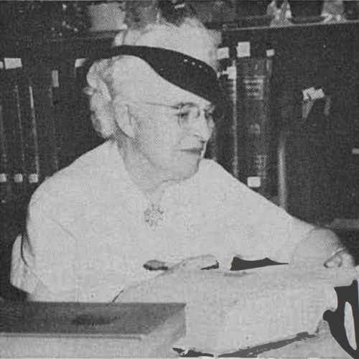

Essay by Dr. Lorna Peterson

Born in Pennsville, Morgan County, Ohio, on May 13, 1899, librarian Frances Lydia Yocom's contributions to librarianship are many, but most notably are marked by her thoughtful, groundbreaking works on subject retrieval of research about and by African Americans, her book reviews of works concerning African Americans, and her bibliographies, which preserve for us titles that without her documentation would likely remain lost to future readers.

Her published works provide a bibliographic foundation for understanding the complexity of subject information retrieval, controlled vocabulary, and implicit bias. Notably, her Berkeley MA thesis published as A list of subject headings for books by and about the Negro, by the H.W. Wilson Publishing Company in 1940 and cited in Arna Bontemps 1944 Library Quarterly article "Special Collections of Negroana is one such seminal work.
Her 1942 review of The Negro Federal Government Worker by Lawrence J. W. Hayes in the Southern Economic Journal minces no words on discrimination and shortcomings of the Civil Service merit system as researched and described by the author Lawrence Hayes. In the same issue of the Southern Economic Journal Ms. Yocom reviews with great care and praise, Eliza Gleason's The Southern Negro and the Public Library[1] which in turn has been cited by library historian Cheryl Knott.[2] These titles are just a few of the works published by a scholar who is in need of remembering and deserving of a deep, and rich, biography.

Who was this white woman who worked at historically black colleges and universities as well as predominately white institutions, and was a librarian who used her bibliographic skills in the crusade for racial justice? Who and what shaped her mission to live in a world of racial equality?

The Yocom family moved to Oberlin in 1907, where the father, Eli King Yocom owned a dry goods store with his brother Joseph. Frances attended Oberlin public schools; she graduated from Oberlin High School in 1917, and graduated from Oberlin College in 1921 with a major in English.
Her obituary lists her having earned the Master of Arts degree from Columbia University Teachers College in 1925. Oberlin alumni magazines from 1927 and 1929 report on Ms. Yocom working at Straight College (a predecessor of Dillard University) as a librarian and also as an English teacher.
Frances Yocom's interest in librarianship was greater than in teaching, as evidenced by her move back to Ohio to work in a library. She is listed in the 1930 Census as living with her mother and working as a librarian at Oberlin College.[3] She also lived in Cleveland where she earned the B.S. in library science from Western Reserve University (now Case Western Reserve University) in 1931.

From Fisk University, Nashville Tennessee records, she is additionally listed in the teacher records/teacher reports for 1931-32, 1935-37. It is here that her friendship developed with Fisk University history professor Theodore S. Currier, who was such an important part of the enriched undergraduate education experienced by future librarian Aurelia Whittington, and her future historian husband John Hope Franklin, that Frances Yocom was mentor to Aurelia Whittington.[4] (Note: Lorna Peterson wrote about Aurelia Whittington Franklin for Women of Library History in 2017. --Ed.)

In 1939, Yocom earned the M.S. in librarianship from the University of California, Berkeley. Her MA thesis was "List of Subject Headings for Books by and about the Negro," 1939, M.A. (California) as cited in "Graduate Theses Accepted by Library Schools in the United States from July, 1938, to June, 1945" by Dorothy Ethlyn Cole, Library Quarterly, Vol. 17, No. 1 (Jan., 1947), page 56.

The January 1946 issue of CRL News, lists Ms. Yocom as a Fisk University associate librarian and cataloger "for a number of years" who has taken a position at Humboldt State College, Arcata CA.[5] From Humboldt State College which is now Humboldt State University, Frances Yocom took a cataloging position at the University of North Carolina, Chapel Hill where she retired from in 1964.
Her career at Chapel Hill was memorialized by Betty Bolton "Small in Stature, great in spirit: A Tribute to Frances Yocom " North Carolina Libraries, Volumes 22, no.3, Spring 1964, pages 87-89.

After retirement, Frances Yocom returned to Oberlin, Ohio and later, moved into Copeland Oaks Retirement Community, Sebring, Ohio. From her obituary, it is stated she kept up an active correspondence with friends and former colleagues. One can only hope that the letters, diaries, and photos of this remarkable librarian have been preserved. This was a life rich in work, education, travel, living in various sections of the United States, and quiet social activism. She was involved in the American Library Association and attended its meetings. She presented at the Southeastern Library Association once it integrated. She is acknowledged in the works of some the nations foremost civil rights activists and historians-for example, Harry Emerson Fosdick[6] and John Hope Franklin. She was a librarian dedicated to civil rights and social justice, using the expertise of librarianship to make positive social change. Her story needs to be told.

Notes
[1] Yocom, Frances L. (1942) Review of The Southern Negro and the Public Library. Southern Economic Journal, 8 (April): 521–2.
[2] Knott, Cheryl The Publication and Reception of The Southern Negro and the Public Library, Race, Ethnicity and Publishing in America pp 51-76, Springer 2014.
[3] 1930 United States Federal Census [database on-line]. Provo, UT, USA: Ancestry.com Operations Inc, 2002; Original data: United States of America, Bureau of the Census. Fifteenth Census of the United States, 1930. Washington, D.C.: National Archives and Records Administration, 1930. T626, 2,667 rolls.
[4] Franklin, John Hope, Mirror to America, 2005, page 47.
[5] "New from the Field" College and Research Libraries, January 1946, vol 7, no 1, page 83.
[6] Miller, Robert Moats, Harry Emerson Fosdick: Preacher, Pastor, Prophet. Oxford University Press, 1985, page 572.

Sources

Essay by Dr. Lorna Peterson and reposted at : Frances Lydia Yocom - Women of Library History.

