Allegra Westbrooks – 1921 -2017

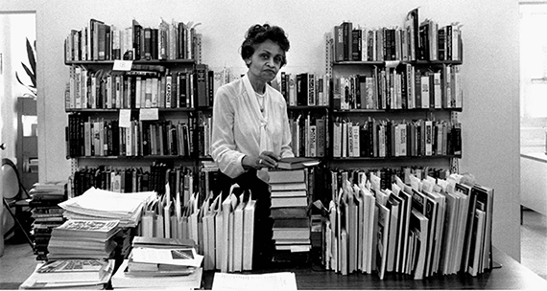

Allegra Westbrooks (Mar 16, 1921 – Apr 26, 2017) was a librarian in Charlotte Mecklenburg Library and the namesake for the Allegra Westbrooks Regional Library branch. She first worked in Charlotte Mecklenburg Library's segregated library branch, the Brevard Street Library for Negroes.
When the system desegregated in 1956, Westbrooks ran the acquisitions at the main branch before being promoted to Supervisor of Branches in 1957. She was the first African American to work in the library system and the first to hold a supervisory position in a library in North Carolina. Westbrooks established a book mobile program to encourage reading and access to reading materials particularly for African American populations. This was particularly crucial before the library system integrated.
. 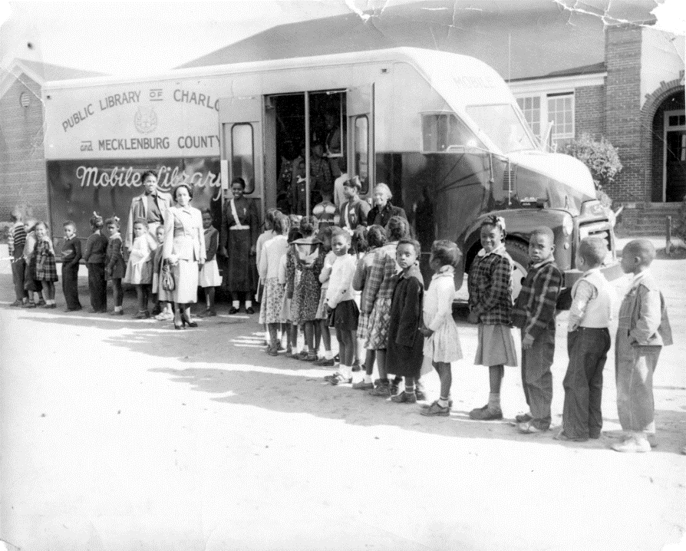

Allegra Westbrooks stood outside black schools because at the time, the book mobile program was not allowed to sit at local public branches of libraries in other parts of the county because they had not been integrated yet, so a black book mobile could not sit on its property.
In April 2020 the Beatties Ford Regional Library branch was renamed the Allegra Westbrooks Regional Library, the first time a branch has been named for an individual.

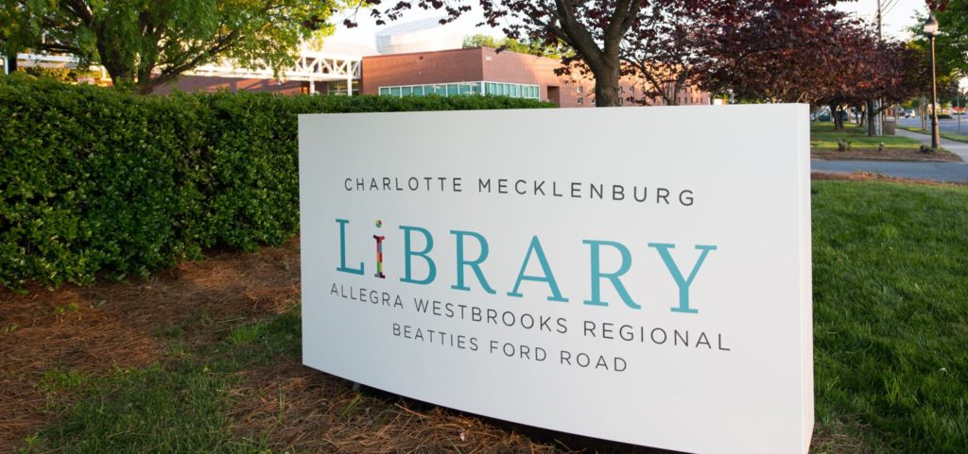

She worked in the system for 36 years retiring in 1984. Kelly Alexander, president of the local NAACP chapter, called her "one of the most important figures in the local civil rights movement."

Sources
Allegra Westbrooks- Women of Library History.
Allegra Westbrooks oral history interview, 2007 March 12. J. Murrey Atkins Library Special Collections and University Archives, University of North Carolina at Charlotte.
(Re)-Named in Honor. Charlotte Mecklenburg Library Foundation.
Allegra Westbrooks was the first African American librarian at Charlotte Mecklenburg Library (then called the Public Library of Charlotte and & Mecklenburg County). She was also the first African American public library supervisor in North Carolina. Now, she’s the first individual for whom one of our Library branches is renamed.Charlotte Mecklenburg Library has renamed Beatties Ford Regional Library as Allegra Westbrooks Regional Library – Beatties Ford Road.. On April 15, 2020, a new sign was erected outside the branch located at 2412 Beatties Ford Road, Charlotte, 28216, the Library location Ms. Westbrooks called home.

Skip Auld (Anne Arundel County Public Library) alerted us to a StoryCorps interview between Miss Westbrooks and her niece, Shara Traynham. Note: an audio excerpt available via WFAE. A transcript of the complete interview is also online.
Jennifer Roberts. Honoring the legacy of library pioneer Allegra Westbrooks. SPECTRUM 1. Feb. 07, 2024.
Mark West. Allegra Westbrooks, Charlotte’s Pioneering African American Librarian. Storied Charlotte. September 07, 2020.
Allegra Westbrooks - Obituary
Allegra Westbrooks -Wikipedia

Submitted by ALA SRRT- Feminist Task Force, Diedre Conkling

