April 6, 2015
Memorial for Helen Wang
Gleeson Gleanings: News & Updates from Gleeson Library
https://usfblogs.usfca.edu/gleeson-gleanings/2015/04/06/memorial-for-helen-wang/

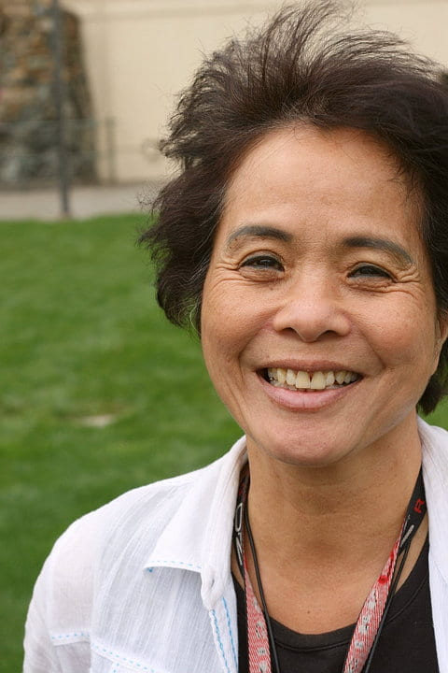
Helen Wang, October 7, 1943 – March 29, 2015
Here at Gleeson we got some very sad news last week. Our longtime colleague Helen Wang passed away on March 29, 2015 after a brief illness.
Helen began her work at Gleeson on January 29, 1979 and received a service award for 35 years at the University’s annual awards ceremony in 2014. Helen was an Acquisitions Specialist in the Acquisitions Department, a “whiz at book ordering and invoice processing” by account of her former long-time supervisor. Library staff often remember her sunbathing during her lunch break out front, her home cooked lunches, her humble but threatening bocce ball skills, her artistic creativity, and her love for dance. You could find Helen dancing the Lindy Hop in Golden Gate Park on Sundays, or with the CCSF dance group at Union Square.
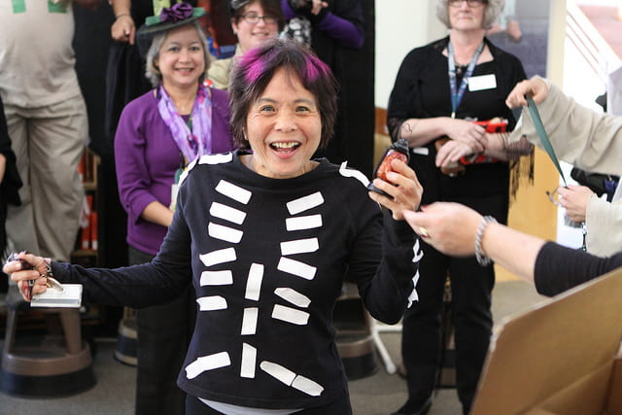Evidence of Helen’s creativity: she made this costume out of processing labels.
Helen’s Memorial Service will be held on Saturday, April 11, 2015 at 11 am at the Valente Marini Perata Funeral Home, 4840 Mission Street, San Francisco, CA.
Here is a video of Helen dancing, the way we would like to remember her forever.
[youtube https://www.youtube.com/watch?v=Y7iq1YAgVKg&w=560&h=315]
Helen is part of the couple in the back right.
If you wish to make a charitable donation in her honor, you may do so to CCSF Dance. Write Helen’s name in the memo line and send your check to:
David Blood
CCSF Wellness Center
50 Phelan Ave.
SF, CA 94112
Helen’s family at Gleeson Library extends its heartfelt condolences to Helen’s friends and family outside the library. She was a wonderful woman with a sweet soul, and we will sorely miss her.
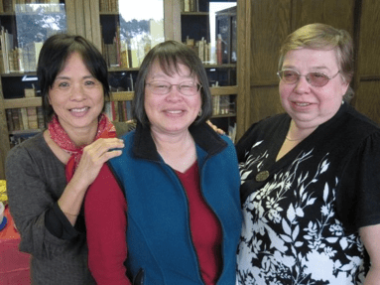Helen (left) with her friends and colleagues Marion (center) and Irina (right).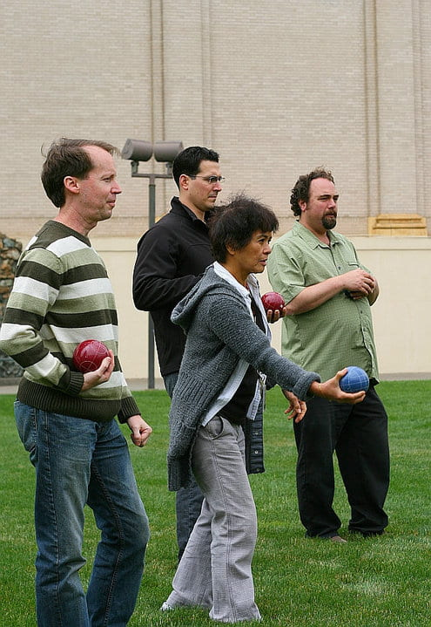Helen poised to make a killer bocce move (center).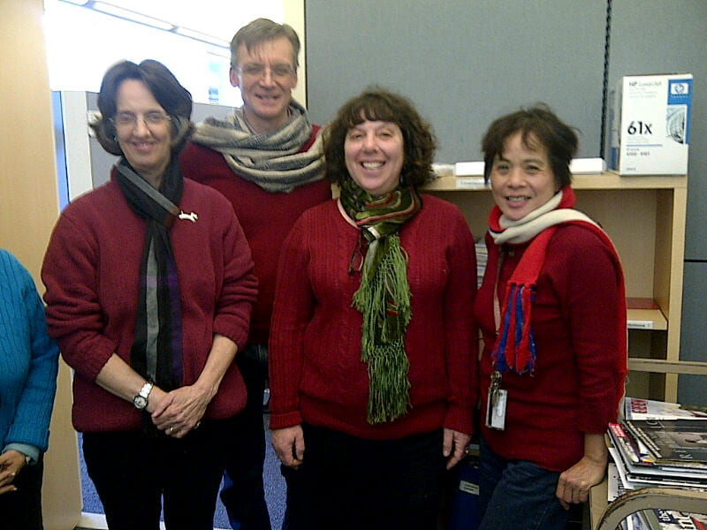A serendipitous day of red sweaters: Helen (right) with her friends and colleagues Kathy (left), David (center left), and Debbie (center right).
If you have memories of Helen you would like to share, we invite you to leave a comment below, and to also share your memories with her family at this Life Tributes webpage.
Share this:
- Facebook
- X


Published by
bibliobebe
View all posts by bibliobebe
CategoriesAnnouncements, USF HistoryTagsGleeson Staff, Gleeson Staff News, librarians, library staff4 Comments
4 thoughts on “Memorial for Helen Wang”
- Penny Scottsays:
April 6, 2015 at 10:24 pm
Miss you, my friend. Gleeson is not the same without you. Kelci, thank you for a lovely tribute.
- Jim Shooksays:
April 7, 2015 at 9:40 am
Thank you so much for creating this blog. It does capture my dear Helen. She truly loved her job at Gleeson. She would come home and tell me about the interesting books she handled at work that day. She cared so much about doing perfect work without mistakes. Many wondered why she did not retire. The reason is that she loved going to work. She loved the books, she loved her friends at work, and yes, she loved basking in the sun on the lawn during lunch………. and her bocce ball trophy is proudly displayed on the mantel at home……
Jim…her partner.
  - Debbie Benrubisays:
April 7, 2015 at 9:49 am
Jim, I am so very sorry for your loss of your dear Helen. Thank you for telling us about her love of the job. It’s hard to believe she won’t be back at work any day now, in a cubicle next to mine. I especially miss her infectious laugh.
- Jim Shooksays:
April 7, 2015 at 9:54 am
Thank you for that Debbie,
She spoke so fondly of her co-workers at Gleeson. I would love to hear any memories or stories of your time together. If you want to share more privately, my email is jimshook@aol.com .
YES……..that infections laugh! I miss it so much.
Here is a video we made for her. https://vimeo.com/124008951
Jim

