Robert G. Vosper (1913–1994)

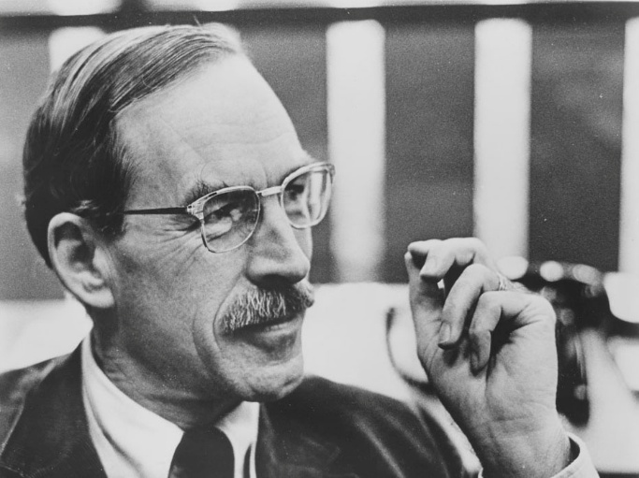

Robert Gordon Vosper (1913–1994) was a leading American librarian, educator, and advocate for intellectual freedom whose career shaped major research library collections and professional standards in the mid-twentieth century. He was included among the one hundred most important people in twentieth-century librarianship by American Libraries magazine. He was President of the Association of College and Research Libraries (1955–1956) and President of the American Library Association (1965–1966). In 1993 he was awarded Honorary Membership by the American Library Association.

Born on June 21, 1913, in Portland, Oregon, Vosper pursued classical studies before entering the library profession. He earned a B.A. in classics from the University of Oregon in 1937 and an M.A. in classics from the same institution in 1939. In 1940 he received a certificate in librarianship from the University of California, Berkeley.

Vosper’s professional career began immediately after library school. He served as a junior librarian at the University of California, Berkeley (1940–1942), then as assistant reference librarian at Stanford University (1942–1944).
In 1944 he joined the University of California, Los Angeles (UCLA), where he rapidly advanced: head of the acquisitions department (1944–1948), assistant librarian (1948–1949), and associate librarian (1949–1952).
In 1952 he was appointed director of libraries at the University of Kansas, a position he held until Under his leadership, the KU Libraries experienced dramatic growth; the collections expanded by nearly as many volumes as had been accumulated in the preceding eighty-five years. He established the Department of Special Collections in 1953 and secured two landmark acquisitions—the O’Hegarty Collection of Irish literature and the Ellis Collection of zoological illustrations and publications.
Vosper championed intellectual freedom during the McCarthy era by mounting an exhibition on banned books and publicly describing the library as an “open sanctuary” devoted to individual intellectual inquiry.

In 1961 Vosper returned to UCLA as university librarian, succeeding Lawrence Clark Powell. Vosper guided the UCLA library system through a period of great expansion. The collections grew into one of the top five university research libraries in North America, surpassing six million volumes by the time of his retirement. He oversaw the dedication of the University Research Library in 1966 and the addition of a second wing in 1971. For these achievements and others, he was named UCLA Man of the Year in 1968.

Beyond campus administration, Vosper played influential roles in national and international library organizations. He directed the Association of Research Libraries’ Farmington Plan Survey (1957–1958), served on the Council on Library Resources, and held leadership positions in the American Library Association (ALA) and the International Federation of Library Associations and Institutions (IFLA).
He was a vocal proponent of multilingual collecting, national and international library planning, and the rights of librarians as full partners in scholarly enterprise. In 1970, during campus anti-war protests, he refused to close the UCLA library, reaffirming its status as a sanctuary for free access to information.
After retiring from the directorship in 1973, Vosper continued to teach at UCLA’s School of Library Service (now the Graduate School of Education and Information Studies) and served as director of the William Andrews Clark Memorial Library at UCLA from 1966 to 1981.

Honors and Awards

- 1959–1960: Guggenheim Fellowship (for international library study in Great Britain and Italy).

- 1967: Honorary LL.D., Hofstra University (awarded during the dedication of its library).

- 1968: UCLA Man of the Year.

- 1974: Honorary Vice President, Library Association of Great Britain.

- Honorary Fellow, International Federation of Library Associations and Institutions (IFLA).

- 1977: Officer, Order of the Crown of Belgium (medal awarded by the Belgian government).

- Joseph W. Lippincott Award, American Library Association (for distinguished service to the profession of librarianship).

- 1988: UCLA Medal (UCLA’s highest honor, presented at commencement).

- 1993: Honorary Member, American Library Association.

Selected Publications
Vosper, Robert. International Library Horizons: Some Personal Observations. The Center for the Book. Viewpoint Series No. 24. Washington, DC: Library of Congress, 1989.

Vosper, Robert G. “Libraries and the Inquiring Mind.” ALA Bulletin 59, no. 8 (September 1965): 709–17.

Vosper, Robert. “European University Libraries: Current Status and Developments.” Library Trends 12, no. 4 (Spring 1964): 417–34. (Also guest editor of the issue.)

Vosper, Robert. A Word to the Wise and the Friendly: Remarks by Robert Vosper, Newly Appointed University Librarian of UCLA. Los Angeles: University of California Library, 1962. (UCLA Library Keepsake, printed by Grant Dahlstrom.)

Vosper, Robert. “There Is No End.” College & Research Libraries 20, no. 5 (September 1959): 369–72.

Vosper, Robert. “Foundation Support of College Libraries.” College & Research Libraries 17, no. 2 (March 1956): 141–42.
Vosper, Robert. “Current Acquisitions Trends in American Libraries.” Library Trends 3, no. 4 (Spring 1955): 369–81. (Also guest editor of the issue.)
Vosper founded and edited the first nine volumes (1952–ca. 1961) of Books and Libraries at the University of Kansas, to which he contributed regularly, including the lead article “A Special Word of Greeting to the Faculty” in the inaugural issue (December 1952).
He also wrote numerous reports, speeches, book reviews, and contributions to library newsletters during his tenure at the University of Kansas and UCLA. A complete bibliography of his writings appears in the Robert Vosper Papers (1938–1997) at UCLA.

Sources

“Robert Vosper papers, 1938–1997,” Online Archive of California, https://oac.cdlib.org/findaid/ark:/13030/kt7p3014fp/.
“Robert Vosper; Led Growth of UCLA Library,” Los Angeles Times, May 23, 1994, https://www.latimes.com/archives/la-xpm-1994-05-23-mn-61084-story.html.
“Robert Gordon Vosper: A Force for Libraries,” KU Libraries Exhibits, University of Kansas, https://exhibits.lib.ku.edu/exhibits/show/vosper.
Vosper, Robert G. Libraries and the Inquiring Mind: Oral History Transcript, 1990–1991. Interviewed by Dale E. Treleven. Los Angeles: Oral History Program, University of California, Los Angeles, ca. 1994. https://oralhistory.library.ucla.edu/catalog/21198-zz0008znv9.
Robert G. Vosper – Wikipedia

Submitted by Kathleen de la Peña McCook

