Jerome A. Van Lom (1949-2005)

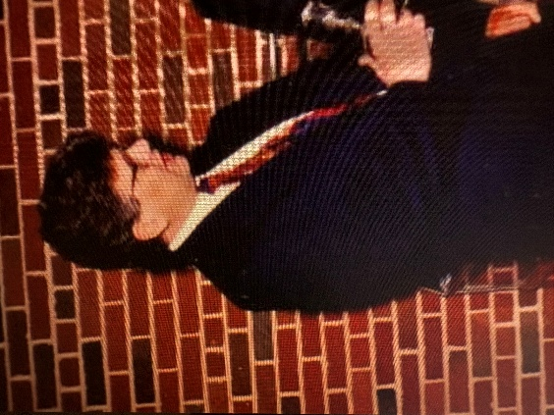

JEROME A VAN LOM (1949-2005) was born in Green Bay, Wisconsin and attended Premontre High School (class of 1968), where he was active in chorus, ROTC, National Honor Society, and notably served as a student librarian.

He worked as a librarian at Rosary College (Dominican University) in the 1970s where --with Sr. Mary Field, Library Director and Sr. Laurette McCusker, Dean of the Graduate School of Library and Information Science—he planned library regional cooperation initiatives.
He next worked at the Illinois Institute of Technology (IIT), Chicago where he served as Assistant Director of Libraries at the Galvin Library. During that time he wrote about “Fee-based reference service: a reevaluation.” RQ, 25, 1986: 295–299.
Jerome Van Lom served as Director of the Todd Wehr Library at St. Norbert College from 1991-2004.
He passed away in 2005 with burial at Nicolet Memorial Gardens in Green Bay, Wisconsin.

(Personal note: I worked with Jerry at Rosary in the early 1970s as we installed a photocopy machine, were a Beta site for OCLC, and tried to keep up an aging set of microform machinery. He was witty, technologically astute, and devoted to serving our students-K.McCook)

