Paul K. Sybrowsky – 1944-2014

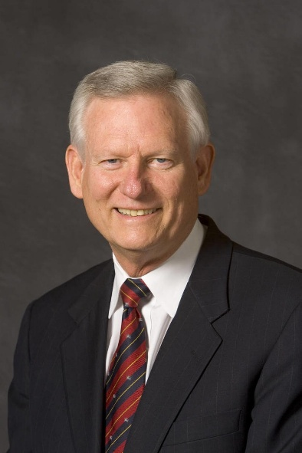

Paul K. Sybrowsky was President and CEO of Dynix. His leadership within Dynix revolutionized the way a vendor respected the contributions of their customers
He provided the majority of funding for the Snowbird Library Leadership program from 1990 to 1998 to ensure unique and exceptional training was available for young leaders in the library profession.
He served on the Board of Trustees of the Provo, Utah City Library from 1994 to 1997 and as Chair in 1997.
He served as Chair of the Board of Trustees of Utah Valley University from 1997 to 1999, Vice Chair from 1995 to 1997 and as a member of the executive board from 1995 to 2001.
He served as a commissioner for the Northwest Association of Schools and Colleges.
He was honored with the ALA Medal of Excellence in 2000.
He was He was a general authority of the Church of Jesus Christ of Latter-day Saints (LDS Church) from 2005 until 2011, Second Quorum of the Seventy.
He was President of Southern Virginia University from 2012 to 2014.

Sources
Former President Paul K. Sybrowsky Dies at 70 . Southern Virginia University
A Memorial Resolution Honoring Paul Kay Sybrowsky ALA Council, February 3, 2015.
Neely, Teresa Y., AND Winston, Mark D.. "Snowbird Leadership Institute: Leadership Development in the Profession" College & Research Libraries [Online], Volume 60 Number 5 (1 September 1999).
Paul K. Sybrowsky -Wikipedia

--Submitted by June Garcia

