Librarians We Have Lost, Sesquicentennial Memories

Lothar Spang (1942-2009)

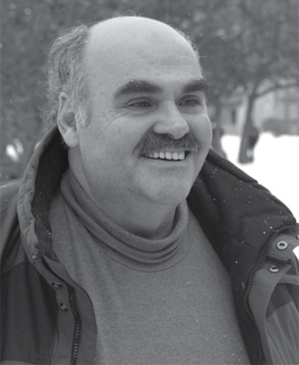
Lothar Spang, a librarian, educator, and academic, was born in Yugoslavia on December 14,
1942 and immigrated with his family to Michigan as a child where he grew up to attend the University of Michigan and Wayne State University. He received his Masters in Library Science at the University of Michigan and obtained bachelor’s and postgraduate degrees from Wayne State University where he began his career in the early 1960s as a student assistant. He later became a librarian at Wayne State, which he received tenure for in 1974, and held a variety of positions during his time with the libraries. These roles included, but were not limited to, assistant to G. Flint Purdy, adjunct faculty in the School of Library and Information Science, and building director of the Purdy-Kresge Library. In addition to these, Mr. Spang also served as a grievance coordinator and executive board member of the Wayne State University American Association of University Professional (AAUP) union until his passing on July 3, 2009.

Mr. Spang served as a member of various associations such as the American Library
Association; Association for College and Research Libraries; the Michigan Academy of Science, Arts and Letters; and the Michigan Library Association. Additionally, he served as a member of the Wayne State Academic Senate.

In the years prior to his death, Mr. Spang immersed himself in community service and outreach efforts, centering his efforts on information literacy and job training programs. These efforts included: directing the Book Lovers Collection Writing Contest which was an annual essay competition funded by the United Parcel Service that awarded cash prizes to junior and high school student essays that reflect the students’ private book collections; coordinating the Wayne State Library System’s annual job Shadow Days which introduced Detroit area schools students to librarianship and library resources; and most recently, initiating the Chapbook Literacy Project where Wayne State librarians mentored students in K-12 classrooms in the creation of artwork and poetry that was then compiled and published in the interest of increasing literacy, decreasing juvenile delinquency, and strengthening outreach. In terms of community service, Mr. Spang coordinated the Adopt-a-Family program run by the Wayne State Library System and developed a partnership with a guidance counselor at a nearby elementary school who would recommend families in need for the program.

In 2006, Mr. Spang received the Outstanding Faculty Award from Educational Accessibility
Services for his work and co-authored publications on community, partnerships, and outreach.

Selected Publications by Lothar Spang

Nichols, J. W., Spang, L., & Padron, K. (2005). Building a foundation for collaboration: K-20
partnerships in information literacy. Resource Sharing & Information Networks, 18(1-2),
5-12. https://doi.org/10.1300/J121v18n01_02
Spang, L., & Baker, L. M. (2000). Healthcare information delivery in public libraries:
Implications for academic reference librarians. Reference Services Review, 28(1), 81-94.
https://doi.org/10.1108/00907320010313867
Spang, L., Marks, E., & Adams, N. (1998). Health sciences information tools 2000 : A cooperative health sciences library/public school information literacy program for medical assistant students. Bulletin of the Medical Library Association, 86(4), 534-540.
Spang, L., & Kane, W. P. (1997). Who speaks for academic librarians? status and satisfaction comparisons between unaffiliated and unionized librarians on scholarship and governance issues. College & Research Libraries, 58(5), 446-462.
https://doi.org/10.5860/crl.58.5.446
Spang, L., & Tucker, D. (1995). Incorporating a comprehensive media services unit into an existing university library facility: The wayne state university libraries' experience after
10 years. The Journal of Academic Librarianship, 21(3), 187-194.
https://doi.org/10.1016/0099-1333(95)90038-1
Spang, L. (1993). Collective bargaining and faculty status: A twenty-year case study of wayne state university librarians. College & Research Libraries, 54(3), 241-253. https://doi.org/10.5860/crl_54_03_241

Lothar Spang’s entire career was spent at Wayne State where he was loved, respected, and valued for his service to the communities of Wayne State and Detroit. In honor and memory of Mr. Spang, his service, and his passions, the Wayne State University School of Information Sciences established two memorial funds, the Lothar Spang Memorial Annual Scholarship and The Lothar Spang Community Outreach and Engagement Tribute Fund. As of October 2025, the Spang estate has pledged a total of $517,000 to the Lothar Spang Memorial Annual Scholarship which supports scholarships for Wayne State University School of Information Sciences students and the Alternate Spring Break (ASB) program (Division of Development & Alumni Affairs, 2025).

References

Division of Development & Alumni Affairs. (2025). Spang estate continues to give SIS students plenty of horsepower. Giving; Wayne State University.
https://giving.wayne.edu/story/spang-estate-continues-to-give-sis-students-plenty-of-hors epower-67547
Ferndale Historical Society. (2023, May 1). In memory of Jean M. Spang. Ferndale Historical
Society. https://www.ferndalehistoricalsociety.org/people_jean.html
Galloway, A. (2009). People in the News. College & Research Libraries News, 70(9), 550-553.

doi:https://doi.org/10.5860/crln.70.9.8264

Wayne State University Library System, "Outlook, Fall 2006" (2006). Library Publications. 2.

https://digitalcommons.wayne.edu/libpub/2

Wayne State University Library System, "Outlook, Fall 2009" (2009). Library Publications. 3.

https://digitalcommons.wayne.edu/libpub/3
Tribute By:
Em Dohm
Graduate Student
Wayne State University School of Information Sciences

