Ward Shaw- 1945-2025

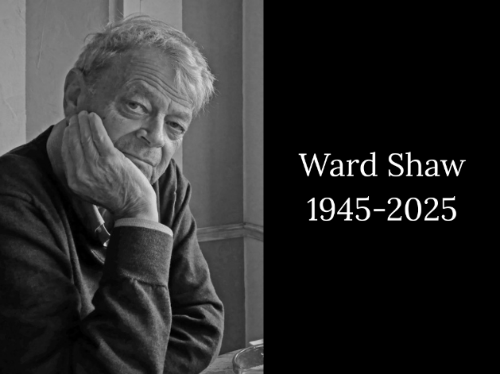

Ward Shaw, a library industry leader, died on July 2, at age 79. Ward’s development of the CARL integrated library system more than 40 years ago changed the library community in ways that are still felt today.
-- George Machovec in Katina, 2025.

Ward Eric Shaw (December 8, 1945 – July 2, 2025) was a pioneering figure in library automation and information technology.
He earned an A.B. from Hamilton College (1967) and an M.S. from Simmons College in Boston in library/information science). He later received an honorary Doctor of Laws (LL.D.) from the University of Northern Colorado in 1990 in recognition of his contributions to education and library services in the state.

Early career: Shaw began as assistant director of the Colby College Library in Waterville, Maine (1968–1972). He then served as associate director of technical services at the University of Denver (1972–1978).
By 1973, academic library deans and directors in Colorado, along with the City Librarian for Denver Public Library, had begun to work together on cooperative collection development initiatives and a vision for a shared computer system that would use the latest technology. Most other integrated library systems of that era were focused on circulation and could not handle the large bibliographic databases and transaction loads that were needed in a shared system, a problem that Ward solved by innovative design. (George Machovec in Katina, 2025).
1978 he became the founding executive director of the Colorado Alliance of Research Libraries (CARL), where he led the development of the innovative CARL integrated library system and the UnCover table-of-contents/document-delivery service. He spun off the for-profit CARL Corporation in 1988 and served as its chairman and CEO. The companies were later sold, after which Shaw remained active as an independent investor, board member (including for Ingenta), and contributor to library and information industry conferences.

Ward Shaw served as the founding editor of the journal Resource Sharing & Library Networks (published by Haworth Press) for its inaugural period, beginning with Volume 1, No. 1 (Fall 1981) until 1983.
Ward played important roles behind the scenes in initiatives such as the Ingenta board, the Fiesole Conference, and The Charleston Advisor. (TCA was sold to Annual Reviews and later evolved into Katina.) Ward’s work in the library automation industry continues to influence how library systems and other online services operate today. (George Machovec in Katina, 2025)

Selected Publications

Shaw, W. (2002). Tasini v. New York Times. Against the Grain, 14(1), Article 10. https://doi.org/10.7771/2380-176X.3134 (Commentary on the Supreme Court case and its implications for publishers and libraries.)
Lenzini, R. T., & Shaw, W. (1996).” Facilitating copyrights: The role of the middleman” In Current legal issues in publishing (pp. 129–133). Haworth Press. (Discusses copyright challenges in document-delivery services such as UnCover.)
Lenzini, R., Shaw, W., & Tenopir, C. (1993). The year 2000: Dreams and nightmares. Searcher: The Magazine for Database Professionals, November 1993. (Co-authored outlook on future library and information technologies.)
Lenzini, R. T., & Shaw, W. (1992). UnCover and UnCover2: An article citation database and service featuring document delivery. Interlending & Document Supply (now Information Discovery and Delivery), 20(1), 12–20. https://doi.org/10.1108/02641619210154648
Shaw, W. (1989). UnCover: CARL’s article access solution. Bulletin of the American Society for Information Science, 15(5), 11–13. (Also indexed in ACM Digital Library.)
Shaw, W. (1987). Technology and transformation in academic libraries. ERIC Document Reproduction Service No. ED 284 594. (Background paper prepared for the Arden House Symposium Libraries and the Search for Academic Excellence, March 15–17, 1987.)
Shaw, W. (1986). Aristotle meets Plato in the library catalog: Part 1. In F. W. Lancaster (Ed.), What is user friendly? Papers presented at the 23rd annual Clinic on Library Applications of Data Processing (pp. 9–14). University of Illinois at Urbana-Champaign, Graduate School of Library and Information Science. (Proceedings from the April 20–22, 1986 clinic; also available via ERIC ED 293 562.)
Shaw, W. (1982). Resource sharing and the network approach. New Directions for Higher Education, 1982(39), 55–60. https://doi.org/10.1002/he.36919823908
Drabek, T. E., Shaw, W., & Culkin, P. B. (1978). The Query Analysis System: A new tool for increasing the effectiveness of library utilization by sociology students. Teaching Sociology, 6(1), 47–59. https://www.jstor.org/stable/1317165

Sources

Fisher, S. (2009). Research library collaboration in Colorado – the birth and early evolution of CARL, the Colorado Alliance of Research Libraries, 1(3), Article 3. https://doi.org/10.29087/2009.1.3.05
CARL Corporation, UnCover Company Purchased by Founder, Ward Shaw (1999). Library Technology Guides.
George Machovec Remembering Ward Shaw, the transformative library leader--The Library Innovator Who Made the Card Catalog Obsolete | Katina Magazine Katina 07.31.2025.

