Sallie H. Ellison
1944-1999
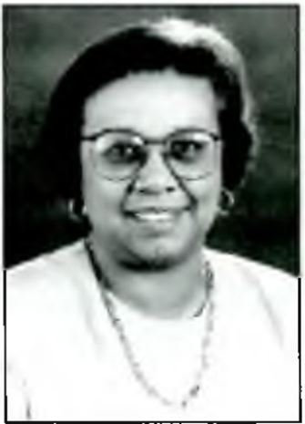

Sallie H. Ellison was a research librarian and library director committed to serving her community at Wayne State University in Detroit, MI. She had a bachelor's degree in political science from Fisk University in Nashville, Tennessee. She earned her master’s degree in information science from Drexel University in Philadelphia in 1968. She was a research librarian at General Motors Technical Center in Warren, Michigan. She was then the library director at the Industrial Technology Institute in Ann Arbor, Michigan. In 1989 she started at Wayne State University as the assistant director of Purdy-Kresge Library and was the director of media services from 1991-1996.
She published a journal article in 1994 titled, “Reciprocal Borrowing-Access and Risks the Wayne State University Perspective”. She was the director of Wayne State University’s Purdy-Kresge Library at the time of her death in 1999 at 55 years old. Outside of her position at Wayne State University, she was also a past president of the Michigan Database Users Groups and served on committees, including the American Council of Research Libraries International Relations Committee and Wayne State University’s Minority Faculty Hose Committee. She was also a member of the Special Libraries Association, Michigan Library Association, Michigan Libraries Research Triangle, and Michigan Library Consortium.
The Sallie Ellison Memorial Endowed Scholarship was established in her memory at Wayne State University. The award is to encourage and continue the progress of students in the School of Information Sciences by aiding students that exemplify the dedication Sallie H. Ellison had to inner city, urban, and minority communities, and quality library service. The Sallie Ellison Memorial Endowed Scholarship has helped School of Information Sciences students at Wayne State University for 25 years. It’s a testament to Sallie H. Ellison’s commitment to research librarianship and serving her community in Detroit, Michigan that this scholarship continues to this day. Even though her career in library and information science was cut tragically short, the Sallie Ellison Memorial Endowed Scholarship ensures her legacy for future generations of librarians to continue her service in the field and to inner city and urban communities.
Sources
Detroit Free Press. (December 29, 1999). . Newspapers.com. Retrieved April 8, 2026, from https://www.newspapers.com/article/detroit-free-press/8336140/
Ellison, S. H. (1994). Reciprocal Borrowing: Access and Risks the Wayne State University Perspective. Resource Sharing & Information Networks, 9(1), 33–44.
https://doi-org.proxy.lib.wayne.edu/10.1300/J121v09n01_04
Library Association, A. (1989). PEOPLE. College & Research Libraries News, 50(5), 423-428. doi: https://doi.org/10.5860/crln.50.5.423
Library Association, A. (2019). People. College & Research Libraries News, 52(11), 751-757. doi: https://doi.org/10.5860/crln.52.11.751
Student scholarship descriptions
https://sis.wayne.edu/alumni/slis_scholarship_descriptions.pdf

Corena Wienczak | Wayne State University | School of Information Sciences

