Randy Joseph Riley 1962 – 2026



Riley was born in Ionia, Michigan, on September 21, 1962, to Leonard and Camilla Riley. He married Lori Cunningham on August 27, 1988 and the couple had two children.
He received a bachelor's degree in education from Central Michigan University and a master’s degree of Information and Library Studies in the Archives and Records Management Program at the University of Michigan in 1989.
Riley began his career as a teacher, teaching history and social studies.
He began working for the Library of Michigan after getting his library degree in 1989.
He had many roles within the Library of Michigan including being head of special collections, and Michigan eLibrary (MeL) coordinator.
He was the editor of the Michigan Genealogist newsletter and in 2010 received the Filby Award for Genealogical Librarianship., a recognition given to the leading family history librarian in the U.S.
He played a founding role in the creation of the Michigan Service Hub for the Digital Public Library of America and the Michigan Digital Preservation Network.
He worked with Archives of Michigan to create Seeking Michigan, an online resource for genealogical research containing over one million freely available death records.
He served as a state librarian after being appointed in 2014. He coordinated the Michigan Notable Books program as well as the Michigan Center for the Book.
He worked on projects such as the Post-Pandemic Public Library Project, an initiative to help library directors and their communities reconnect after COVID.
Riley had a career belief in outreach saying "We have plenty of librarians that love books. We now need more librarians that love people."
In 2023 he was in the advisory board for the University of Michigan School of Information's Civic Librarian Project, a course encouraging librarians to work with local governments and residents on solutions to civic problems.

His work strengthened libraries across the state and supported countless library professionals, students, and community members. Colleagues remember him as friendly; generous with his time; known for his infectious humor, laugh, and smile; and a passionate champion for literacy, access, and the vital role libraries play in public life.

Riley died in East Lansing, Michigan, on January 3, 2026, at the age of 63. After his death, a memorial service was held at the Library of Michigan with over 500 attendees.

Tuesday, January 06, 2026 04:10 PM -Michigan Library Association tribute
Remembering Randy Riley
The Michigan Library Association mourns the loss of Randy Riley and expresses our deepest sympathies to his family and friends, the Library of Michigan team, and the hundreds of colleagues and friends across Michigan’s library community.
As Michigan’s State Librarian since 2014, Randy’s passion, character, and commitment to the betterment of libraries were always evident in his work. Today, MLA honors the life and legacy of our friend and library champion, Randy.
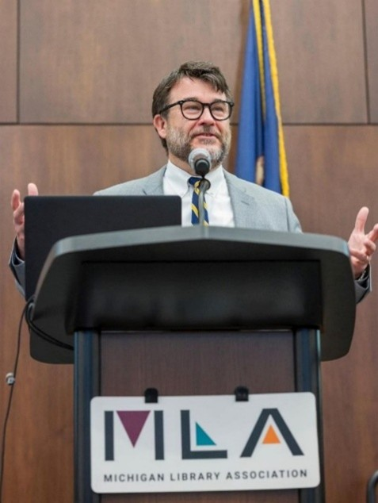

Randy brought a calm and thoughtful approach to his work that resonated with peers and colleagues across library types, associations, and organizations. His contributions and collaboration with so many of us have made for a stronger Michigan library community. As an ex officio member of the MLA Board of Directors during his tenure as State Librarian, Randy’s voice and institutional knowledge were instrumental in helping MLA envision what’s possible and how to achieve it in service to all Michigan libraries.
When MLA needed Randy’s expertise on an issue, he was always there for us. Whether he was on the other end of a phone call or presenting to MLA members online, Randy was quick and eager to commit his time to education and development in the Michigan library community. During a period of significant challenge for libraries over the last several years, Randy’s stable and steadfast leadership will be remembered by many.
The impact of losing Randy feels, in many ways, incalculable. His leadership, integrity, and presence shaped Michigan’s library community in ways that will continue beyond his tenure. While we grieve Randy’s absence, we know his example will continue to guide the work of Michigan libraries. At MLA, as we reflect on Randy’s enduring contributions, we send our condolences to his family during this difficult time.
Please visit the Library of Michigan Foundation website to share memories of Randy with his family and his Library of Michigan team. The family requests that, in lieu of flowers, those interested may make contributions to the Randy Riley Memorial Fund through the Library of Michigan Foundation.

Sources

State Librarian Randy Riley Remembered as Champion for Public Libraries. Library of Michigan, January 6, 2026.
State Librarian Randy Riley dies at 63 | WLNS 6 News
Remembering Randy Riley. Library of Michigan Foundation. Jan 6, 2026. Written By LM Foundation
- Many memories of Randy Riley by Michigan librarians are included at this site.
Randy Riley Obituary - East Lansing, MI
Randy Riley - Wikipedia

Submitted by Michigan Library Association
Library of Michigan and Library of Michigan Foundation
John Clexton
Lori Poznanski-Mason

