Lawrence Clark Powell - 1906– 2001

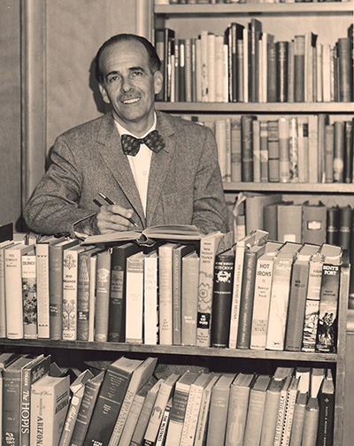

Dr. Lawrence Clark Powell (September 3, 1906–March 14, 2001) was Director of the University of California, Los Angeles (UCLA) libraries (1944-1961) and founding dean of UCLA’s School of Library Science in 1960.
In 1981 he was awarded American Library Association Honorary Membership.
Powell was a president of the Bibliographical Society of America, the California Library Association, the Zamorano Club of Los Angeles, and also a member of the Roxburghe Club of Los Angeles, the Caxton Club of Chicago, and the Grolier Club of New York.
He was also a literary critic, bibliographer and author.

Education and Career

Powell earned a B.A. in English from Occidental College in 1928. In 1932 he received a Ph.D. from the University of Dijon in France; his dissertation on the poet, Robinson Jeffers, was the basis for his first major published study.
During the Great Depression Powell worked in Los Angeles bookstores, including Vroman’s in Pasadena and Jake Zeitlin’s rare-book shop. Encouraged by Los Angeles City Librarian Althea Hester Warren, he earned a certificate in librarianship from the University of California, Berkeley, in 1937 and worked briefly at the Los Angeles Public Library before joining the UCLA Library staff in 1938.
In 1944 Powell was appointed UCLA University Librarian (serving until 1961) and director of the William Andrews Clark Memorial Library (until 1966). Under his leadership the UCLA collection grew from roughly 400,000 to more than 1.5 million volumes. He established a Special Collections department in 1946 and used a Guggenheim Fellowship year in England (1950–51) to acquire rare materials. Upon his retirement from UCLA in 1966, the university named its main undergraduate library the Powell Library in his honor.

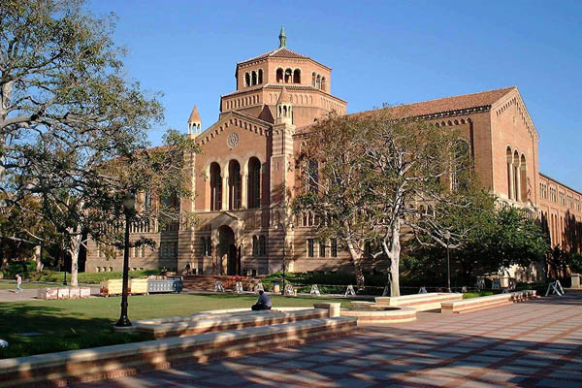

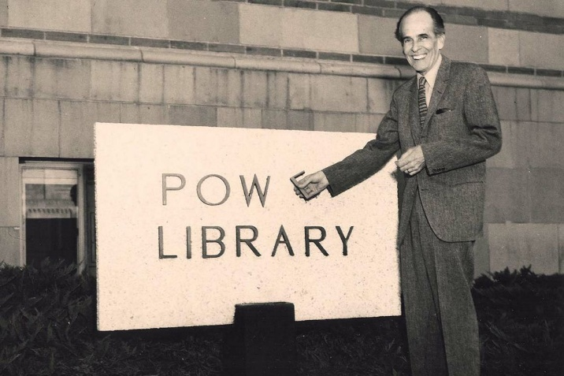

After retiring from UCLA in 1966, Powell moved to Tucson, Arizona in 1971, where he was Professor in Residence for two decades—at the University of Arizona Graduate School of Library Science.
The University of Arizona Libraries special collections hold Powell's papers documenting his time in Tucson, and the Fay and Lawrence Clark Powell Endowment for Southwest Research continues to support Powell's interest in the geography of the southwest United States.
For many years, Tucson hosted the Lawrence Clark Powell Memorial Lecture, an event established to honor Powell. The lecture series featured well-known authors who spoke about topics connected to his legacy.

Writings of Lawrence Clark Powell

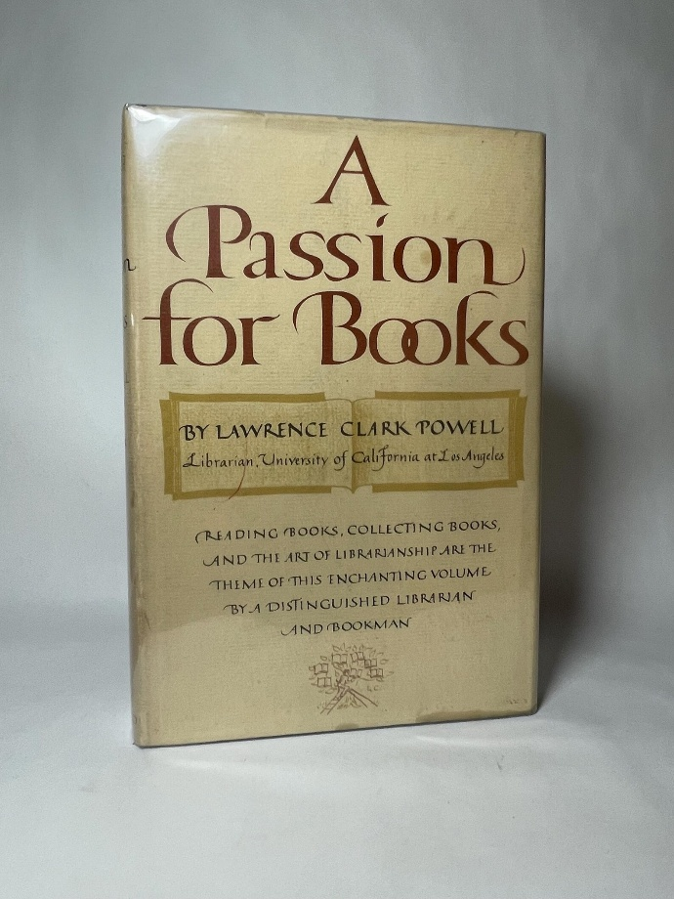

Powell produced more than one hundred books and hundreds of articles, essays, and speeches on librarianship, book collecting, California and Southwestern literature, travel, and autobiography. His interests are reflected in the subjects that recur throughout his writings; these are history and travel, especially concerning the American Southwest, rare books, libraries and librarianship, the book trade, and book collecting.

Selected Publications
[Note: Rosenberg, Betty, comp. Checklist of the Published Writings of Lawrence Clark Powell. Foreword by W. W. Robinson. Los Angeles: University of California, 1966. (A 46-page checklist, printed in stapled wrappers by the Ward Ritchie Press, covers all of Powell’s published writings—books, essays, articles, reviews, and other items—through 1966.)]

- On librarianship.

Lawrence Clark Powell published dozens of articles, essays, occasional papers, and columns on librarianship, library administration, rare books, book collecting, and the philosophy of the profession—primarily in Library Journal, Wilson Library Bulletin, College & Research Libraries, ALA Bulletin, and UCLA Library publications. Many were later reprinted or collected in his essay volumes such as The Alchemy of Books (1954), A Passion for Books (1958), and The Little Package (1964).
Powell, Lawrence Clark. “What Makes a ‘Rare Book’?” Wilson Library Bulletin 48, no. 3 (November 1973): 255–256.
Powell, Lawrence Clark. “The Elements of a Good Librarian.” Wilson Library Bulletin 32 (March 1958): 45–48.
Powell, Lawrence Clark. “What’s Wrong with Librarians?” University of California Library Occasional Paper, no. 9. Los Angeles: University of California Library, 1958.
Powell, Lawrence Clark. “The Excitement of Administration.” College & Research Libraries 15, no. 3 (July 1954): 326–329.
Powell, Lawrence Clark. “The Functions of Rare Books.” College & Research Libraries 1, no. 1 (December 1939): 97–103.

- Books

Powell, Lawrence Clark. Eucalyptus Fair: A Memoir in the Form of a Novel. Tucson: Books West Southwest, 1992.
Powell, Lawrence Clark. Life Goes On: Twenty More Years of Fortune and Friendship. Metuchen, NJ: Scarecrow Press, 1986.
Powell, Lawrence Clark. Winter Crossing 1952: Travel Notes from a Bygone Era. Privately published, 1986.
Powell, Lawrence Clark. Southwestern Book Trails: A Reader’s Guide to the Heartland of New Mexico and Arizona. Santa Fe: William Gannon, 1982.
Powell, Lawrence Clark. The River Between. Santa Barbara, CA: Capra Press, 1979.
Powell, Lawrence Clark. The Blue Train. Santa Barbara, CA: Capra Press, 1977.
Powell, Lawrence Clark. Arizona: Bicentennial History. New York: W. W. Norton, 1976.
Adams, Ansel. Photographs of the Southwest. Selected photographs 1928–1968; with an essay on the land by Lawrence Clark Powell. Boston: New York Graphic Society, 1976.
Powell, Lawrence Clark. From the Heartland: Profiles of People and Places of the Southwest and Beyond. Flagstaff, AZ: Northland Press, 1976.
Powell, Lawrence Clark. Southwest Classics: The Creative Literature of the Arid Lands; Essays on the Books and Their Writers. Tucson: University of Arizona Press, 1974. (First published Los Angeles: Ward Ritchie Press, 1974.)
Powell, Lawrence Clark. California Classics: The Creative Literature of the Golden State. Los Angeles: Ward Ritchie Press, 1971.
Powell, Lawrence Clark. Fortune & Friendship: An Autobiography. New York: R. R. Bowker, 1968.
Powell, Lawrence Clark. The Little Package: Pages on Life, Literature, and Landscape from a Traveling Bookman’s Baggage. Cleveland: World Publishing Company, 1964.
Powell, Lawrence Clark. Books in My Baggage: Adventures in Reading and Collecting. Cleveland: World Publishing Company, 1960.
Powell, Lawrence Clark. A Passion for Books. Cleveland: World Publishing Company, 1958.
Robinson, W. W., and Lawrence Clark Powell. The Malibu. Los Angeles: Ward Ritchie Press, 1958.
Powell, Lawrence Clark. A Southwestern Century: A Bibliography of One Hundred Books of Non-Fiction about the Southwest. Van Nuys, CA: J. E. Reynolds, 1958.
Powell, Lawrence Clark. Books West Southwest: Essays on Writers, Their Books, and Their Land. Los Angeles: Ward Ritchie Press, 1957.
Powell, Lawrence Clark. Heart of the Southwest: A Selective Bibliography of Novels, Stories and Tales Laid in Arizona and New Mexico & Adjacent Lands. Los Angeles: Printed for Dawson’s Book Shop at the Plantin Press, 1955.
Powell, Lawrence Clark. The Alchemy of Books: And Other Essays and Addresses on Books & Writers. Los Angeles: Ward Ritchie Press, 1954.
Powell, Lawrence Clark. Land of Fiction: Thirty-two Novels and Stories about Southern California from Ramona to The Loved One – A Bibliographical Essay. Los Angeles: Glen Dawson, 1952.
Powell, Lawrence Clark. Islands of Books. Los Angeles: Ward Ritchie Press, 1951.
Powell, Lawrence Clark. Philosopher Pickett: The Life and Writings of Charles Edward Pickett, Esq., of Virginia, Who Came Overland to the Pacific Coast in 1842–43. Berkeley: University of California Press, 1942.
Powell, Lawrence Clark. The Manuscripts of D. H. Lawrence: A Descriptive Catalogue. Los Angeles: Los Angeles Public Library, 1937.
Powell, Lawrence Clark. Robinson Jeffers: The Man and His Work. Los Angeles: Primavera Press, 1934.

Sources
Lawrence Clark Powell (1906-2001), California Library Hall of Fame.
“Lawrence Clark Powell" (2001). The Book Collector, 50 no.2 (summer) 273-274.
Oliver, Myrna. “Lawrence Clark Powell; Lifted UCLA Library to Prominence.” Los Angeles Times, March 20, 2001.
Lawrence Clark Powell papers. University of Arizona.
Powell (Lawrence Clark) papers, 1914-2001. OAC. (The Online Archive of California (OAC) provides free public access to detailed descriptions of primary resource collections maintained by more than 350 contributing institutions, including libraries, special collections, archives, historical societies, and museums throughout California as well as the collections maintained by the ten University of California (UC) campuses.
Rosenberg, Betty, comp. Checklist of the Published Writings of Lawrence Clark Powell. Foreword by W. W. Robinson. Los Angeles: University of California, 1966.
University of California, Los Angeles. “A Bookman’s Impact on the Library System.” UCLA Newsroom, February 24, 2022.

Submitted by Kathleen de la Pena McCook

