Foster E. Mohrhardt – 1907-1992

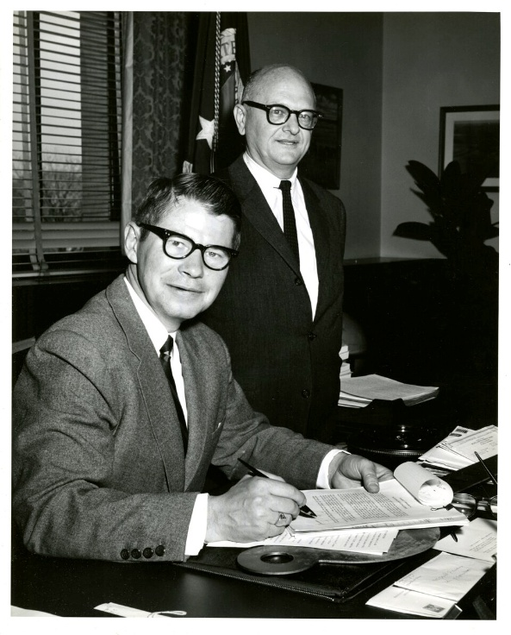

Foster Edward Mohrhardt (March 7, 1907 – June 7, 1992) was an American librarian and a leading figure in 20th-century library and information science. He was president of the American Library Association in 1967- 1968.
Named one of “100 Leaders of the 20th Century” by American Libraries magazine, Mohrhardt is best known for his work redesignating the U.S. Department of Agriculture Library as the National Agricultural Library.

Born in Lansing, Michigan, Mohrhardt earned a B.A. in English from Michigan State College, a B.S. in Library Service from Columbia University (1930), and an M.A. from the University of Michigan. He also studied at the University of Munich.
Early in his career Mohrhardt worked at the New York Public Library, the University of Michigan, Colorado State College of Education, and as librarian of Washington and Lee University (1938–1946), where he renovated the library and built special collections.
During World War II he offered library space at Washington and Lee to safeguard Library of Congress collections and served in the U.S. Army Air Force and Navy while performing civilian electronics and radar duties.
After the war Mohrhardt directed the Library and Report Division of the Department of Commerce’s Office of Technical Services, advancing mechanized information handling.
He later consulted at Brookhaven National Laboratory and taught library management at Columbia University.
From 1948 to 1954 Mohrhardt directed the Veterans Administration library system, centralizing administration and services for 450 libraries nationwide.
In 1954 he became director of the U.S. Department of Agriculture Library, serving until 1968. He immediately campaigned for its redesignation as the National Agricultural Library (achieved by Secretary of Agriculture Orville Freeman’s Memorandum 1492 in 1962—[see picture at top of this tribute]. He reorganized the library into specialized departments, expanded national and international services, adopted Library of Congress Subject Headings, championed a new building in Beltsville, Maryland, and supported the development of the AGRICOLA database. (see: Mohrhardt, Foster E. (1957). "The Library of the United States Department of Agriculture". The Library Quarterly: Information, Community, Policy. 27 (2): 61–82.)

After federal retirement he served as a program officer at the Council on Library Resources until 1975, focusing on library cooperation and international resources.
Mohrhardt was a founder and three-term president of the International Association of Agricultural Librarians and Documentalists (IAALD).
He also served as:
- president of the American Library Association (1967–68),
- president of the Association of Research Libraries (1966),
- vice president of the International Federation of Library Associations (IFLA, 1965–71)
- held senior roles in the International Federation for Documentation (FID) and other scientific-information bodies.
He actively promoted U.S.–Japan library and scientific cooperation and was awarded the Order of the Rising Sun (Third Class) by Japan in 1979.He received the USDA Distinguished Service Award (1963), an honorary Doctor of Laws from Kalamazoo College (1967), and fellowships from the American Association for the Advancement of Science and the Institute of Information Scientists.
Mohrhardt died in Arlington, Virginia. He is remembered for transforming the National Agricultural Library into a major national and international institution and for his lifelong leadership in global library cooperation and scientific information exchange.

Selected Publications

Mohrhardt, Foster E. “USA Librarians and the IFLA.” In IFLA’s First Fifty Years: Achievement and Challenge in International Librarianship, edited by W. H. R. Koops and J. Wieder, 1977.

Mohrhardt, Foster E. The Touch of Time: Observations on Foundations and Libraries. Conference Publication for IFLA, 1975.

Mohrhardt, Foster E., and Carlos Victor Penna. “National Planning for Library and Information Services.” In Advances in Librarianship, edited by Melvin J. Voigt, 5:61–106. New York: Academic Press, 1975.

Mohrhardt, Foster E. International Library and Information Service Developments As They Relate to the National Commission on Libraries and Information Science. 1974.

Mohrhardt, Foster E., ed. “Science Abstracting Services—Commercial, Institutional, and Personal.” Library Trends 16, no. 3 (Winter 1968).

Mohrhardt, Foster E., and Blanche L. Oliveri. “A National Network of Biological-Agricultural Libraries.” College and Research Libraries 28 (1967).

Mohrhardt, Foster E. “The Library of the United States Department of Agriculture.” The Library Quarterly 27, no. 2 (1957): 61–82.
Mohrhardt, Foster E. Federal Library Systems; Their Development and Trends. 1953.Mohrhardt, Foster E. “National Systems.” Library Trends, 1953.

Sources

"Foster E. Mohrhardt Papers, 1964-1975 | The American Library Association Archives". archives.library.illinois.edu.
Cragin, Melissa H (Spring 2004). "Foster Mohrhardt: connecting the traditional world of libraries and the emerging world of information science" (PDF). Library Trends. 52 (4): 833–852.
Haas, Warren J. “Foster Edward Mohrhardt (1907–1992), In Memoriam.” IFLA Journal 19, no. 1 (1993): 13–14.
In Memoriam Foster E. Mohrhardt". Agricultural Libraries Information Notes. 18 (5/6): 16–17. May–June 1992.
Leonard Kniffel, Peggy Sullivan, Edith McCormick, "100 of the Most Important Leaders We Had in the 20th Century," American Libraries 30, no. 11 (December 1999).
Foster E. Mohrhardt -Wikipedia

Submitted by Kathleen de la Peña McCook

