Roger McDonough 1909 –2001

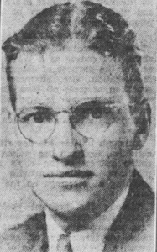

Roger H. McDonough (February 24, 1909 – December 2, 2001)[ was president of the American Library Association from 1968 to 1969.
He worked at the Rutgers University Libraries as an undergraduate and continued working there as a reference librarian while he attended the Columbia University School of Library Service for a degree in library science.
In 1937 he became the Director of New Brunswick, New Jersey Public Library.
In 1947, he was named the first professional State Librarian for the state of New Jersey. In that role, McDonough focused on cooperation among the state's libraries and developed a law library to serve the New Jersey state legislature. He served until 1975.

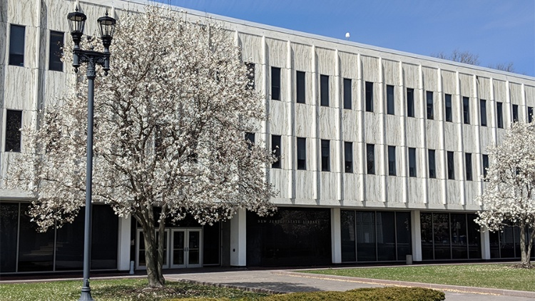

Under McDonough, the underdeveloped New Jersey State Library was revitalized, became an essential New Jersey archive with massive collections, and combined with the New Jersey State Library Commission to become a crucial force in the development of libraries of all types in the state.
His leadership saw the enactment of the State Library Aid Law and decades of appropriations to fund it. He also planned and oversaw the building of the New Jersey Cultural Center, which includes the state library buildings.

He wrote. “Public Libraries.” In A History of New Jersey Libraries, 1750–1996, edited by Edwin Beckerman, 1–26. Lanham, MD: Scarecrow Press, 1997.

McDonough also supported the creation of a graduate school of library science at Rutgers University in 1954 and the New Jersey State Cultural Center in 1965.

The Roger McDonough Librarianship Award is conferred annually by the New Jersey Library Association.

Sources

John Berry, "Roger McDonough Dies at 92," Library Journal, February 1, 2002
Brown, Robin (2015). "Roger McDonough: NJ State Librarian and Master Politician". CUNY Academic Works.
John T. Shaw, "The Origins of a State Library: New Jersey, 1704-1824," Information & Culture 48, no.1 (2013): 8-25.
Roger McDonough Librarianship Award is conferred annually by the New Jersey Library Association.
McDonough, Roger H. (1909-2002) | The American Library Association Archives

Submitted by ALA Member

