Errett Weir McDiarmid 1909 –2000

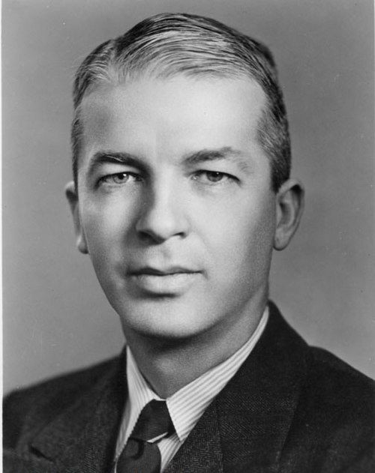

Errett Weir McDiarmid (July 13, 1909 – April 27, 2000)^{[1]} was an American librarian and academic who was president of the American Library Association from 1948 to 1949 and served the University of Minnesota in many roles.
He was also a scholar of Sherlock Holmes. (University of Minnesota is home to World’s Largest Sherlock Holmes Collection)

McDiarmid was born in West Virginia and received his bachelor's degree in 1929 from Texas Christian University and his master's degree in 1930, also from Texas Christian.
He went on to receive a bachelor's degree in Library Science in 1931 from Emory University and his doctorate from the University of Chicago Graduate Library School in 1934.
McDiarmid was the librarian at Baylor University from 1934 to 1937 and went on to be an associate professor at the University of Illinois Library School and from 1943 to 1951.
H was then university librarian and director of the Division of Library Instruction at the University of Minnesota.
At the University of Minnesota, McDiarmid served as Dean of the College of Science, Literature and the Arts and on the faculty of the Library School and Graduate School.
He established a Children's Literature Research Collection in 1949 based on a donation by Irvine Kerlan.
In 1951, McDiarmid became Dean of the University of Minnesota School of Liberal Arts. In 1963, he was appointed Director of the Graduate School Fellowship Office where he worked until his retirement in 1978.
He continued to volunteer in the University of Minnesota Special Collections unit, working with their Sherlock Holmes collections.
McDiarmid helped found the Norwegian Explorers, a group of faculty that are Sherlock Holmes fans. He donated over 15,000 items of Holmes-related materials to the University of Minnesota in 1995.

Selected Publications

McDiarmid, E. W., Jr. “Conditions Affecting Use of the College Library.” Library Quarterly 5, no. 1 (January 1935): 59–77. (Based on his Ph.D. dissertation, University of Chicago, 1934.)
McDiarmid, E. W., Jr., and G. R. Tatum. “Library Noise.” Library Quarterly 8, no. 2 (April 1938): 200–209.
McDiarmid, E. W., Jr. “An Approach to the Problems of Library Organization.” Library Quarterly 9, no. 2 (April 1939): 133–44.
McDiarmid, E. W. The Library Survey: Problems and Methods. Chicago: American Library Association, 1940.
McDiarmid, E. W. “The Place of Experience in Developing College and University Librarians.” Library Quarterly 12, no. 3 (July 1942): 614–21.
McDiarmid, E. W., and John McDiarmid. The Administration of the American Public Library. Chicago: American Library Association, 1943.
McDiarmid, Errett Weir. “A Crusade for an Educated America.” ALA Bulletin 42 (July 1948): 289–93.
McDiarmid, Errett W. “Scientific Method and Library Administration.” Library Trends 2, no. 3 (January 1954): 361–67.

McDiarmid also contributed to or edited Sherlock Holmes-related works

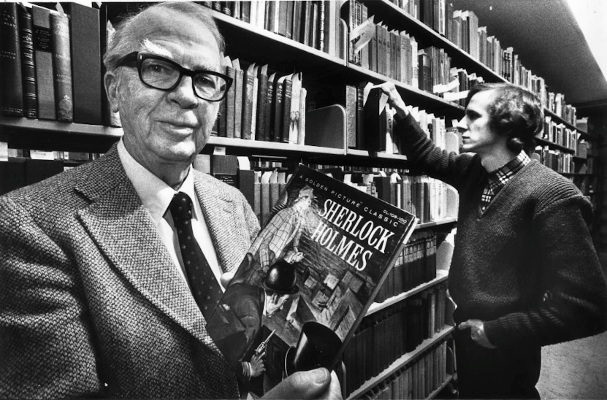
Blegen, Theodore C., and E. W. McDiarmid, eds. Sherlock Holmes: Master Detective. La Crosse, WI: Sumac Press (for the Norwegian Explorers of Minnesota), 1952.
McDiarmid, E. W., and Theodore C. Blegen, eds. Exploring Sherlock Holmes. La Crosse, WI: Sumac Press (for the Norwegian Explorers of Minnesota), 1957.
McDiarmid, E. W. The Real Sherlock Holmes. Minneapolis: The Norwegian Explorers of Minnesota, 1984.
Doyle, Arthur Conan. The Baker Street Dozen. Edited by P. J. Doyle and E. W. McDiarmid. New York: Congdon & Weed, 1987.
McDiarmid, E. W., and Peter Blau. A Basic Holmesian Library. Minneapolis: No Litter Press, 1995.

Sources
Erret Weir McDiarmid ( 1909-2000; Librarian 1943-1951)
Errett W. McDiarmid papers University of Minnesota Libraries.
Errett Weir McDiarmid. Young, Ann-Christe. “People in the News.” College & Research Libraries News 61, no. 7 (July/August 2000): 621. https://doi.org/10.5860/crln.61.7.621.
The Kerlan Collection of Children's Literature - The Kerlan
“University of Minnesota Home to World’s Largest Sherlock Holmes Collection.” FOX 9, October 25, 2022. https://www.fox9.com/news/university-of-minnesota-home-to-worlds-largest-sherlock-holmes-collection.
Errett Weir McDiarmid - Wikipedia

Submitted by Kathleen de la Peña McCook

