Sara R. Mack (1921 – 2010)

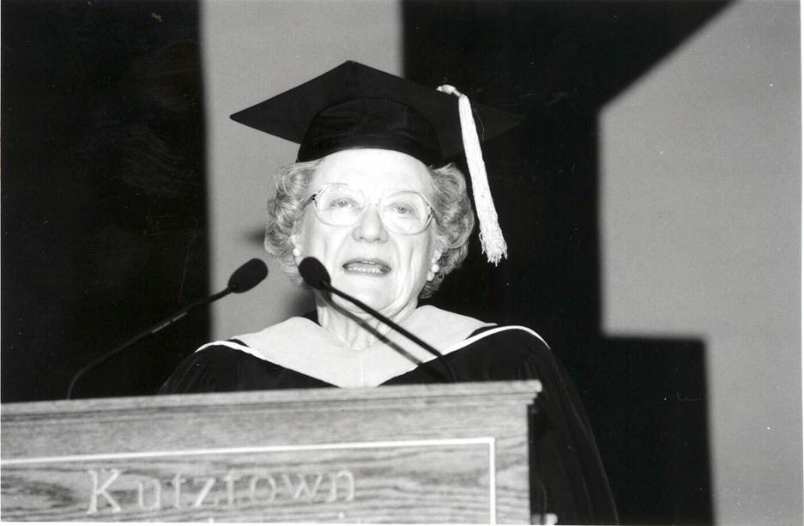

post was submitted by Dolores Fidishun, Head Librarian at Penn State Abington College. The photos are courtesy of Kutztown University of Pennsylvania.

Mrs. Sara R. Mack served as a school librarian in her early years, but her most significant contributions were as a member of the faculty at Kutztown State College, Kutztown, PA (now Kutztown University), where she taught Library Science courses for 25 years and became department chair before she retired. Mack influenced generations of school, public and academic librarians, some of whom became library school faculty themselves.
She taught future librarians how to teach, including the importance of instructional technology in their teaching; early on, she encouraged library students, most of whom were women, to learn computer programming and become proficient in the use of the large mainframe computers of the 1970s. In 1974 she advised library students that in addition to the required Library Science curriculum they should take computer programming, additional educational technology courses, and a course in how people learn to read.
Her futuristic view of library science sent many students on a course of innovative librarianship; they became the school library media specialists of the 1970s and went on to incorporate technology into their library instruction and to take on responsibilities for educational technology and instructional design. The computer background she encouraged put her students in the forefront of the implementation of microcomputers, online catalogs, databases, web-based learning, and other resources that today are considered vital parts of a library's services. She was a true pioneer in establishing librarians as the leaders they have become in the Knowledge Commons movement and the active role of the 21st Century Library.
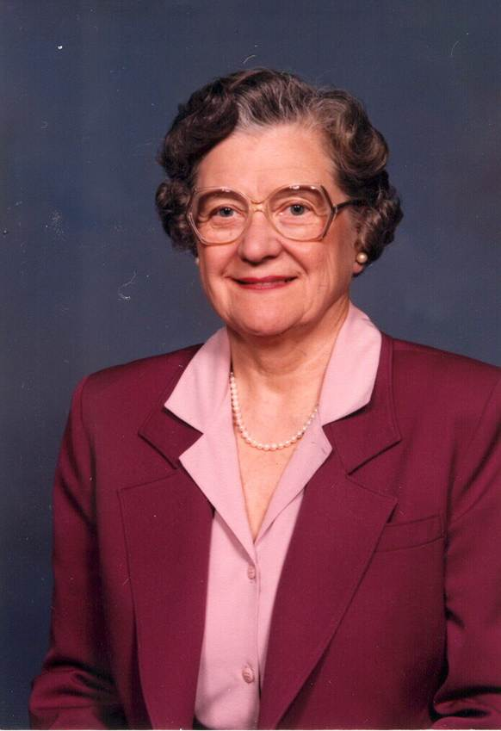
Born November 20, 1921, in Topton, PA, Sara was a daughter of the late Jonathan H. and Alda S. (Heffner) Rohrbach. She graduated from Kutztown State Teachers College (now Kutztown University) with a Bachelor of Science degree in Library Science. She received a Master of Science degree in Library Science from Columbia University. Later, she completed additional course work at Columbia, Temple University, and the University of Pennsylvania.
Sara Mack taught grades 4-6 at Chalfont Public School and served as librarian at Mount Penn-Lower Alsace Junior-Senior High School. In addition to the time she spent in school libraries and academia, Mack also served as the church librarian for Trinity Lutheran Church, Topton, PA and was a member of the Board of the Louisa Gonser Community Library, Kutztown, PA (now the Kutztown Community Library). As a Board member she is remembered as an outspoken and passionate believer in a library's ability to be a transformational force in a community. She was always present at meetings, ready to share her opinions and her wisdom, and she never hesitated to jump in and get things done.
Sara was the author of Inspirational Readings for Elementary Grades: An Anthology of Inspirational Verse and Prose from Children's Literature for Opening Exercises in Kindergarten through Sixth Grade, published by Kutztown Publishing Company in 1964. She also wrote book reviews for American Reference Book Annual, reviews in Church and Synagogue Libraries, articles in Along the Saucony (a publication by Kutztown Area Historical Society) and Historical Review of Berks County, and chapters in the Berks Authors Collection.
Throughout her career, Mack received a number of awards including the President's Award from Kutztown State College, the Award of Merit from Pennsylvania Library Association, Kutztown State College Alumni Association Citations, and the Pennsylvania School Librarians Award for Outstanding Contributions to School Library Media Programs in Pennsylvania. She became the first person from Kutztown University to be honored with Trustee Emeritus status.
Sara R. Mack had a lasting impact on the lives of the school children she introduced to books, reading, and research in school libraries, but an even more lasting influence on the hundreds of library school students who she prepared to lead the future of librarianship and pass on their knowledge and love of libraries to their students.

Source

Sara R. Mack Obituary. The Morning Call. Allentown, PA.

Submitted by ALA SRRT FEMINIST TASK Force, Dolores Fidishun and Diedre Conkling,

Women of Library History is a project of the ALA/SRRT/Feminist Task Force

