Katherine Laich (1910 –1992)

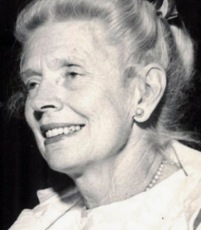

Katherine Laich (January 24, 1910 – November 16, 1992) was a prominent American librarian and leader in the profession, best known for her extensive service with the Los Angeles Public Library (LAPL) and her national roles in the American Library Association (ALA), including serving as ALA president from 1972 to 1973.
Her career spanned public library administration, specialized librarianship, state-level advocacy, and national professional governance during a transformative era for libraries in the mid-20th century.

She earned an A.B. in Latin and English from Wilson College in 1930 and a B.S. in Library Science from the University of Southern California in 1942.

She worked at the Los Angeles Public Library beginning in1943, shortly after completing her library science degree. She worked in reference and related services, including at the Los Angeles Municipal Reference Library (a specialized branch of LAPL) in the mid-1940s,

By the 1950s and 1960s, she had advanced through LAPL’s ranks to the position of Assistant City Librarian. In that role, she participated in public events such as the groundbreaking for the Chatsworth Branch library (documented in LAPL photographs) and was actively involved in broader California library efforts, including chairing three committees of the California Library Association.
. 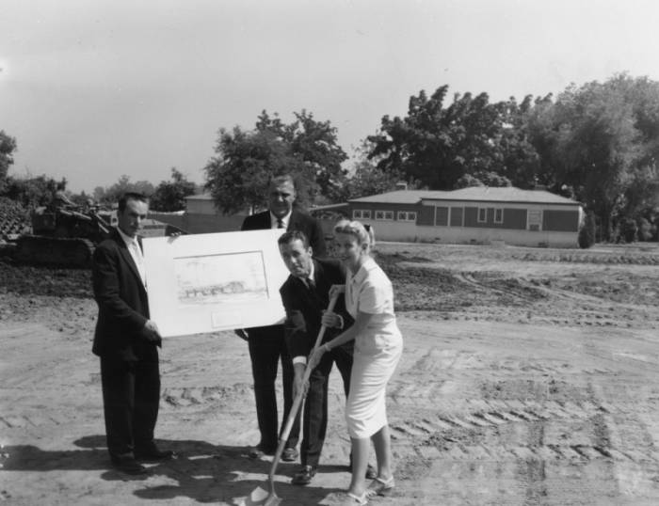

In February 1970, while still at LAPL, Laich transitioned to academia when she joined the faculty of the University of Southern California School of Library Science as a lecturer (later serving in roles that included coordinator of programs). She remained affiliated with USC until her retirement.

Leadership in the American Library Association
Katherine Laich’s
national leadership in the American Library Association was extensive and built steadily over more than a decade. She served on the ALA Council (1958 and 1963–1968), the ALA Executive Board (1964–1968), as chair of the ALA Committee on Organization (1961–1964), and as chair of the ALA Nominating Committee (1969–1970).
In 1970–1971 she chaired the Activities Committee on New Directions for ALA (ACONDA), a high-profile group that examined and proposed reforms to ALA’s structure, governance, and focus on social responsibility during a period of significant change in the profession.
Laich chaired ACONDA (1970–1971) and played a central role in drafting and presenting this influential document on ALA governance reform, democratization, social responsibility, and structural changes. It was widely discussed in ALA proceedings and influenced later organizational debates.

Laich was elected ALA president for the 1972–1973. Her presidential papers (1969–1973) are held in the ALA Archives, include correspondence, memoranda, and reports tied to her presidency and ACONDA work.
Her career spanned public library administration, specialized librarianship, state-level advocacy, and national professional governance during a transformative era for libraries in the mid-20th century.

Selected Publications

Laich, Katherine. “Achieving Standards through Cooperation: C.P.L.C. Report Shows the Way!” California Librarian 20 (January 1959): 20. (Analysis of the California Public Library Commissioners’ report on interlibrary cooperation and service standards.)
Laich, Katherine. “Preparing the Library’s Performance Budget.” California Librarian 20 (July 1959): 180–186.(
Laich, Katherine. “Origin and Development of the Library Administration Division.” ALA Bulletin, April 1963

Laich, Katherine. “ALA Headquarters Space Problem Grows.” ALA Bulletin 60, no. 5 (May 1966): 501–502. (
Laich, Katherine. “Keep the Lines Open.” ALA Bulletin 60, no. 11 (December 1966): 1161–1162.

Sources

American Library Association. Activities Committee on New Directions for ALA (January 1971). "ACONDA Revised Recommendations on Democratization and Reorganization: A Report Presented for Consideration of Council and Membership, Midwinter Meeting, January 1971". American Libraries. 2 (1): 81–93.
Laich, Katherine (1910-1992) | The American Library Association Archives.
“Memo to Members.” American Libraries 1, no. 6 (1970): 563–66. (Katherine Laich has accepted the chairmanship of the Activities Committee on New Directions for ALA. )
Memo to Members. (1970). American Libraries, 1(11), 1053–1056 (Katherine Laich is mentioned in the document as the chairman of ACONDA, one of the committees that is expected to complete its final reports by May 15. Members of the ALA are encouraged to send their comments and points of view to the two committees, including ACONDA, which she chairs. )
ALA's Past Presidents American Library Association.

Submitted by Kathleen de la Peña McCook

