Lisa Kucukdogerli (1961-2017)

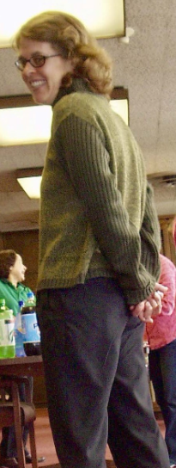
Lisa "Kay," as we called her, was a devoted and highly esteemed Library Assistant in our Access Services Department here at Gleeson Library, University of San Francisco. She worked with us for several years starting in 2005. While here, she filled various roles and was a very valuable and beloved member of our staff.
--Submitted by Penny Scott

