Sue Kamm, 1940 – 2025

Sue Kamm was born on February 29, 1940 in New Haven, daughter of Henrietta Epstein and Albert Kamm. She earned her Bachelor’s in Political Science from the University California, Berkeley (1961) and her Master’s of Library Science, University of California at Los Angeles (1967).

Sue Kamm has been listed as a noteworthy librarian by Marquis Who's Who.

Her career included work as a freelance law library consultant, Los Angeles (1979—1985); substitute Young Adult librarian at Los Angeles Public Library (1985—1991); and head, audio-visual/stack maintenance division, reference library Inglewood (California) Public Library (1991 until retirement).

Sue was a member of the American Library Association for 54 years. A brief summary of her devotion to ALA: her divisional and round table memberships included ALCTS, LLAMA, PLA, RUSA, YALSA, RMRT, and IFRT. She was repeatedly elected as a Member-at-Large of ALA Council, serving from 1997 – 2015. In that role, she served on the Council Orientation Committee, ALA Constitution and Bylaws Committee, and several times on the ALA Resolutions Committee. Sue was the Chair of the ALA Nominating Committee (a once in a career opportunity) in 2013/2014.

Intellectual Freedom was a passion throughout her career, and she served on PLA-IC Intellectual Freedom Committee, IFRT, including chair of the Publications Committee, LAMA/PRS Publications Committee, and the IFRT Executive Committee. She also served on the Reference Books Bulletin Editorial Board.

Sue was very active in the early days of electronic library communications. She was an early and active member of PUBLIB, an independent discussion group for public librarians, and of Project Wombat Stumpers. Her involvement in those groups starting in the 1990s led to many friendships and excellent working relationships in the profession. She was especially noted for her devotion to the Dodgers baseball team. Her standard signature file was:

Your friendly neighborhood cybergoddess,
Sue Kamm
"It's time for Dodger baseball!" – Vin Scully
Los Angeles Dodgers Truest of the Blue, 2000

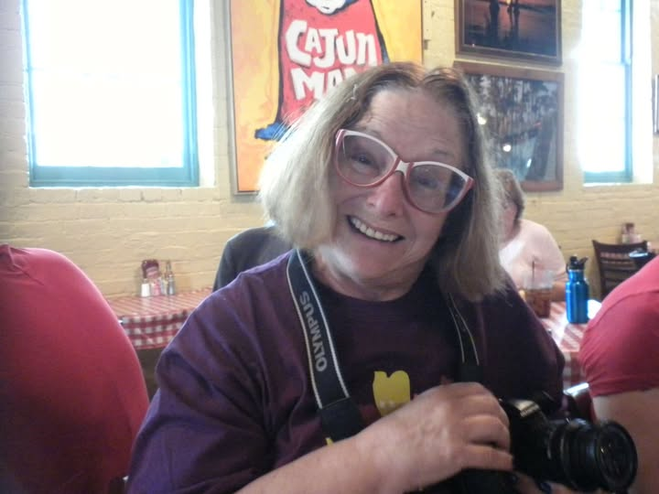
Sources:
https://prabook.com/web/sue.kamm/530729
https://www.facebook.com/sue.kamm.7
ALA Membership record provided by ALA’s Membership Office

This photo is from ALA Annual in New Orleans 2011—taken by the late Roberto C. Delgadillo.

Personal Reflection:

I first “met” Sue in the PUBLIB discussion group around 1995. She was a very, very active participant in that group, sometimes outspoken, but always kind and with a great sense of humor. When PUBLIB had occasional in-person meet-ups at ALA and PLA events, Sue was there. Soon after joining PUBLIB, my service on ALA Council began, and I had the opportunity to work with Sue. We served on the Resolutions Committee together and her work there was often unsung as she helped those writing resolutions craft better-worded and more workable resolutions for ALA Council. She had a great sense of humor. Her loyalty to the Dodgers was legendary in the library world (and I say that as a die-hard Red Sox fan). To say that she will be missed by those who knew her is a great understatement.

Michael Golrick, retired
ASCLA President, 2016-2017
LSSRT, President 2023-2024
ALA CT Chapter Councilor (97-03)
ALA EB (03-06)
ALA Councilor at Large (06-12)
ASGCLA Division Councilor, 2018-2021

