September 9, 2019
In Memoriam: Karen Johnson
Gleeson Gleanings: News & Updates from Gleeson Library
https://usfblogs.usfca.edu/gleeson-gleanings/2019/09/09/in-memoriam-karen-johnson/

Gleeson Library|Geschke Center staff fondly remembers Karen Johnson, Librarian Emerita.
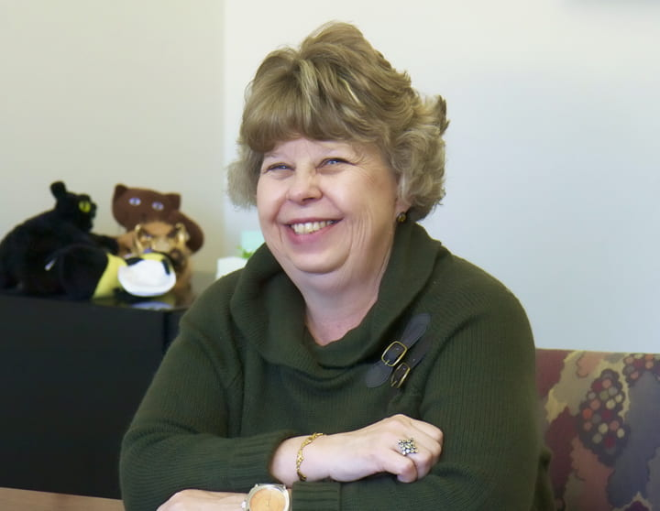
Karen Johnson retired as the Systems Head Librarian in December 2017. She was a cataloger when she joined the University of San Francisco in 1984 and was promoted to systems librarian in 1995.
Karen touched many lives, professionally and personally, and we miss her dearly. She was accomplished tremendously in her profession as a librarian, a department head and supervisor, as well as a mentor to her student assistants.
Karen was a beautiful person who cared for every individual she conversed with, collaborated with, and assisted in the university library, especially those who sought her expertise as a librarian at the reference and research service desk. Karen always had a friendly smile that welcomed, warmed the heart, and opened one to a moment of conversation or a casual greeting. Kind and generous, she was a frequent donor to USF and other charitable causes.
Karen’s contributions to the success of the university library mission include:
- Automating the library systems (planning and implementation in the late 1980s until the library became fully online in 1991)
- Managing the integrated library system, which powers most library operations and is publicly visible as the Ignacio online catalog
- Being a major force and legend in the Innovative Users Group, the interest group for our library system’s vendor, Innovative Interfaces, Inc.
- Supporting all library system operations and documentation
- Enhancing library space as a key participant in the expansion of the Gleeson Library with the addition of the Geschke Learning Resource Center (1995-1997)
- Initiating and managing the digital collections projects
- Collaborating with internal and external constituents on systems upgrades, new services such as e-commerce and ILLiad, and security, stability and performance of any new library system
- Supporting the library and university mission as a member of the university library leadership team
It is a great joy to have known the illustrious Karen Johnson, Librarian Emerita. We send our love to Karen’s family.
We invite you to share remembrances and thoughts of Karen Johnson below in the comments.
The University Library Family
Gleeson Library|Geschke Center
University of San Francisco
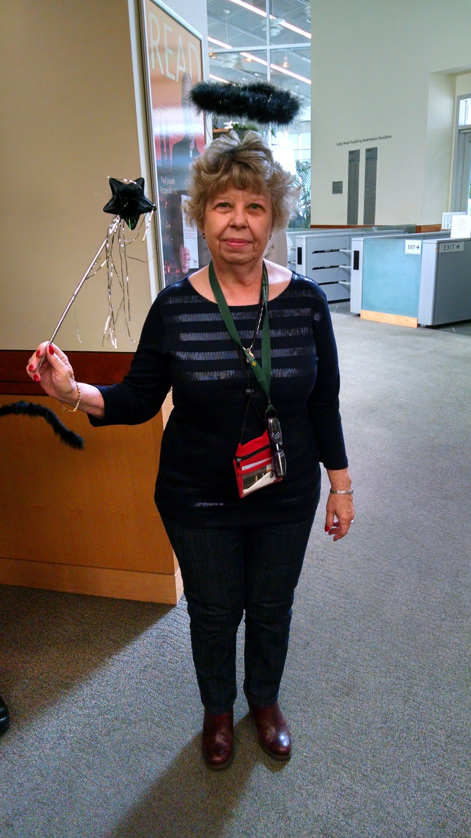
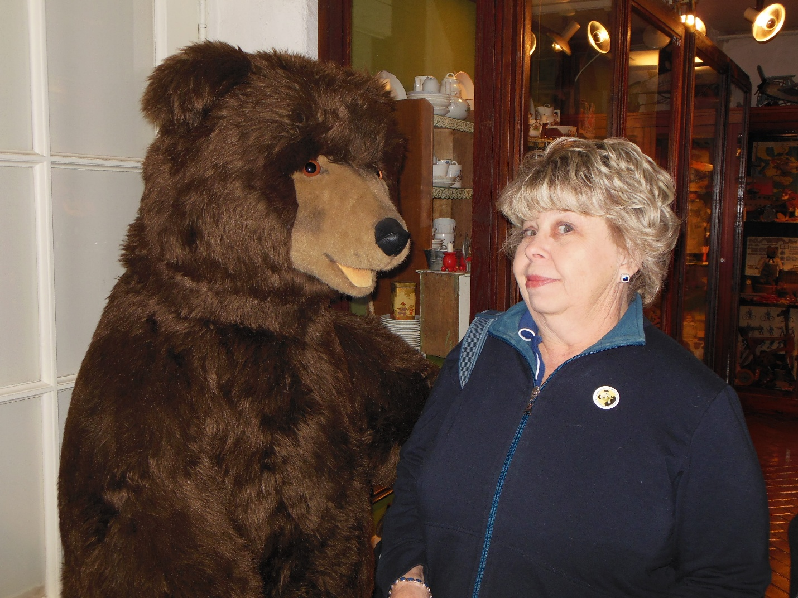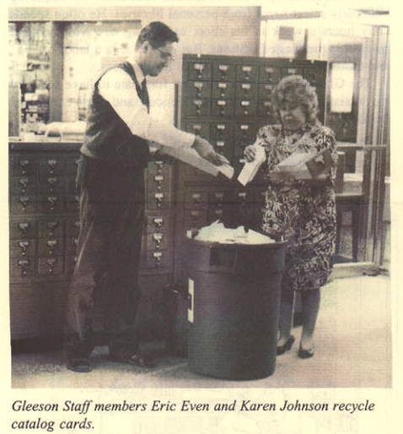
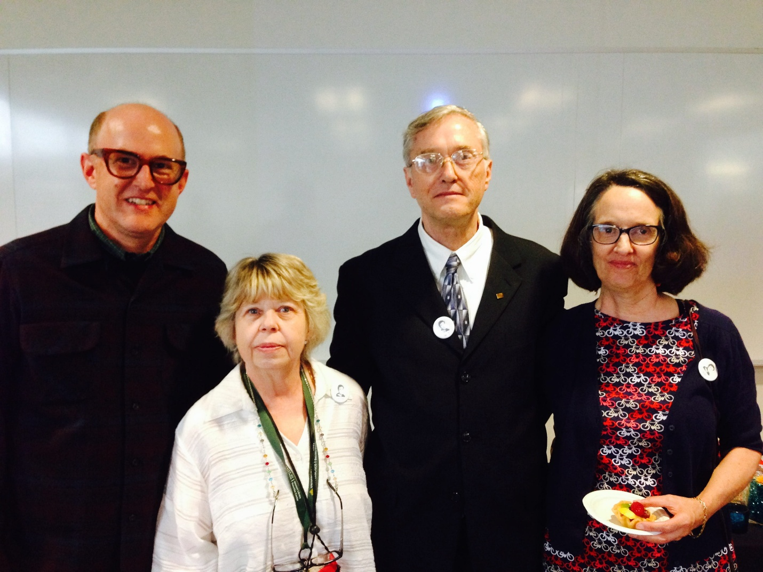
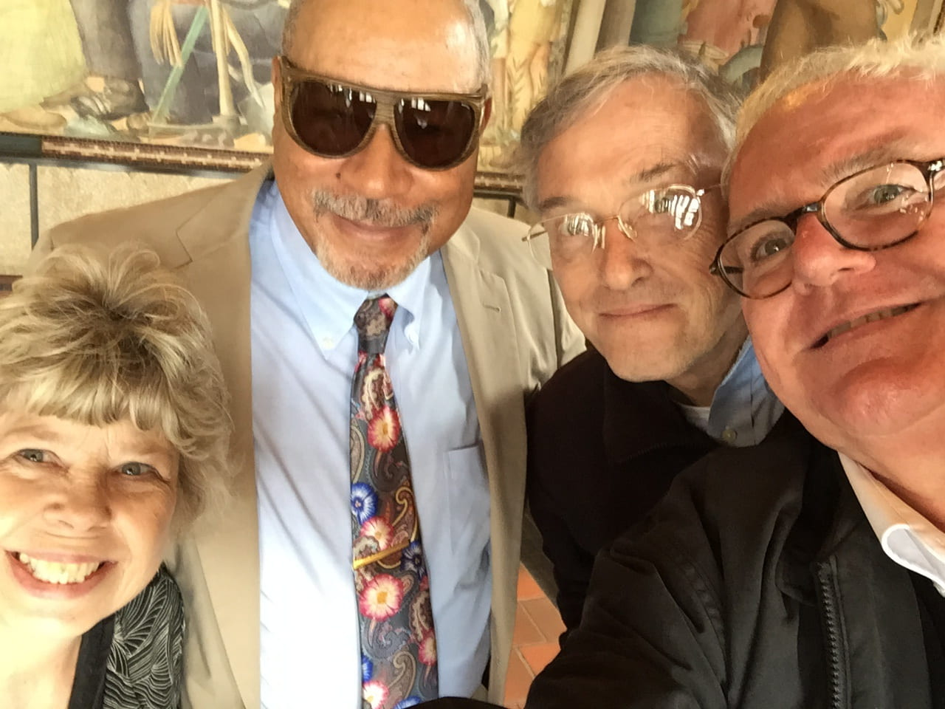
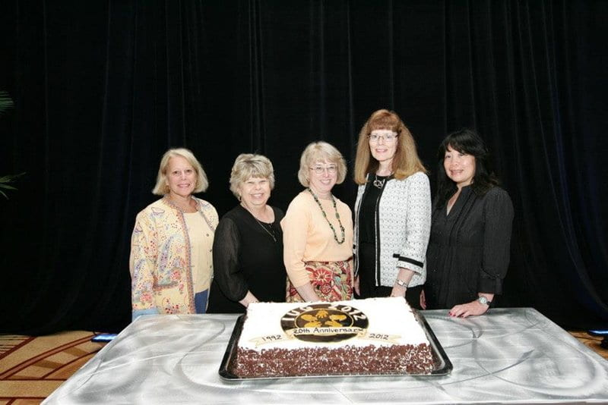
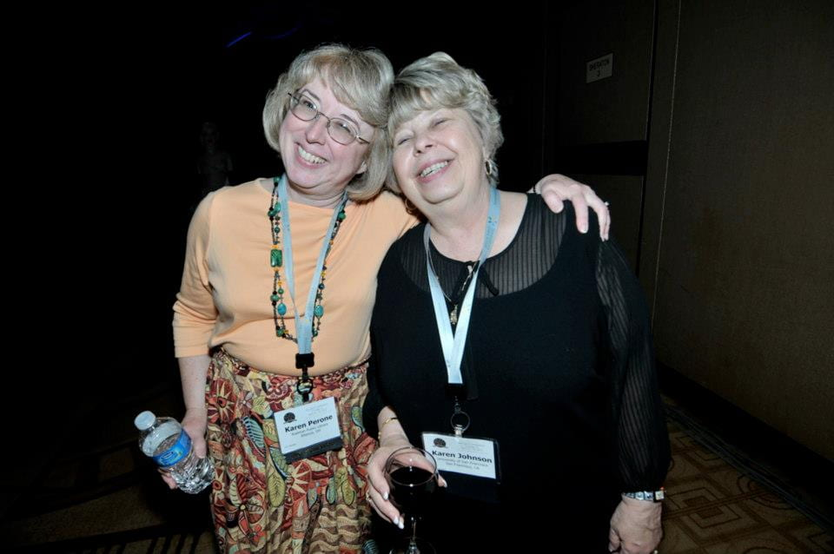
Share this:
- Facebook
- X


Published by
Justine Withers
View all posts by Justine Withers
CategoriesAnnouncements, USF HistoryTagsGleeson Staff, Gleeson Staff News, librarians, library staff10 Comments
10 thoughts on “In Memoriam: Karen Johnson”
- Karen Perone, Rodman Public Librarysays:
September 9, 2019 at 1:22 pm
What a beautiful tribute to my “Karen twin.” I was fortunate to get to know her through our perfect attendance years with IUG. If it weren’t for her, I wouldn’t have been introduced to Ethiopian food and customs. I will miss her.
- Debbie Benrubisays:
September 9, 2019 at 1:31 pm
Karen was an encouraging mentor and role model to me and to countless others, here at Gleeson as well as at IUG, in the classes she taught, and at home with her beloved extended family of nieces and nephews. She shared her expertise with great patience. I used to marvel at the equanimity with which she fielded dozens of phone calls and emails every day from library staff in every department who needed her help. I think it’s telling that when Karen retired, it took three people to replace her!
Karen loved Star Trek and the Beatles and music in general. She had tribbles in her office. She was always curious but never nosy. She laughed well and often. She was a great colleague and friend. How she will be missed!
- Heather Hawkins Hernandezsays:
September 9, 2019 at 2:09 pm
I am so sorry to hear of Karen’s passing–she was a pleasure to work with and I have so many fond memories of her smile and laughter that I will cherish. My thoughts are with her family and friends, especially those at Gleeson who had the pleasure of working closely with her.
- Elisesays:
September 9, 2019 at 5:08 pm
Karen will live in our hearts for a long long time.
- Stephanie Vandricksays:
September 11, 2019 at 6:13 pm
Karen was both a very accomplished and helpful librarian (as this post details) and a kind, warm, welcoming person to all of us who used the library and saw her on campus over these many years. I love the photos of her with many members of the library “family.” She will be missed.
- Mary J. Wardellsays:
September 12, 2019 at 12:46 pm
I remember Karen as a knowledgable, kind, and loving presence whenever I interacted with her; I find these traits among her former/ fellow library colleagues. Through how she lived, her life remains leaving with its’ imprint of good for all those she touched.
- Melodiesays:
September 17, 2019 at 12:30 pm
I was devastated to hear of Karen’s passing. She was a wonderful librarian, and, more importantly, a wonderful person.
- Michael Fraleysays:
September 21, 2019 at 11:33 am
Karen was always considerate and kind to me. She was intelligent and discriminating in the work we did together integrating the Innovative library system with our student, faculty & staff information. I will remember her fondly. My condolences to her family. What a good life she led! Thank you for this tribute to her.
- Penny Scottsays:
October 28, 2019 at 1:37 pm
I miss you, Karen. You were a wonderful colleague and friend, so generous, smart, funny, and fun. I will always be grateful to you for being one of the people who first hired me at Gleeson, which helped start my beloved career. My love and care goes to everyone who loved Karen.
- Bin Lusays:
November 22, 2019 at 12:00 pm
Karen was the most kind and thoughtful person I’ve ever met. She cared about others and indeed a great mentor. It was a great journey to work for her as student assistant for 3 years. She will be missed and live in our heart.

