Alice B. Ihrig -1921-2002

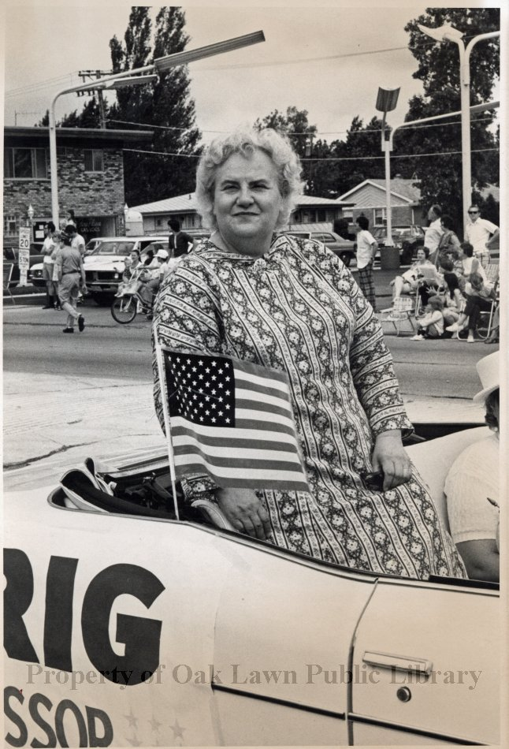

Alice Ihrig was a prominent civic leader, journalist, and dedicated library trustee from Oak Lawn, Illinois. She passed away on May 9, 2002.
Ihrig exemplified mid-20th-century civic engagement, blending journalism, grassroots organizing (especially via the League of Women Voters), and trustee leadership to strengthen public institutions like libraries and state government in Illinois.
Alice Ihrig was deeply involved in library governance and advocacy. She served as president of the Oak Lawn Public Library Board of Trustees She also held leadership positions as president of the Illinois Library Trustees Association and the American Library Trustee Association (ALTA, affiliated with the American Library Association).
She was a member of ALA Council and its Executive Board, and worked as a library consultant while editing or contributing to publications like Public Library Trustee. Her work emphasized library boards, decision-making, advocacy, and interlibrary cooperation.
Alice Ihrig was Chairperson of the ALA White House Conference Committee in 1979.

Mrs. Alice Ihrig, Past President of the American Library Trustee Association and of the Illinois Library Trustee Association received the ALA Trustees Citation given each year to distinguished library trustees. The citation:
To honor her for service to libraries on the local, regional and national levels. By providing enthusiastic leadership in her home community of Oak Lawn, Illinois, serving as member and President of the Oak Lawn Public Library Board; and, By extending her capable leadership to the Chicago suburban community, serving as member and President of the Board of Directors of the Suburban Library System; and, By further extending her able leadership to the state of Illinois, serving as President of the Illinois Library Trustees Association, member of the Board of Directors of the Illinois State Library Advisory Committee; and, By still further extending her talented leadership nationally, serving as President of the American Library Trustees Association, working as Acting Executive Secretary of the American Library Trustees Association, serving as a member of the Council of the American Library Association and as Editor of the PUBLIC LIBRARY TRUSTEE; and Most especially for sharing her many talents and vibrant enthusiasm with library groups throughout the country by addressing interested groups and conducting workshops and seminars to stimulate and better libraries and library service. (June 25, 1973)

==

She was born in St. Paul, Minnesota, graduated from the University of Minnesota, where she studied home economics and joined the rifle team (she reportedly disliked the limited physical education options available to women at the time). After college in the early 1940s, she worked as a food editor for the Minneapolis Journal and later as a reporter and editor for the Chicago Sun-Times and Chicago Daily News. She also did public relations work, teaching, and other civic roles in the Oak Lawn area.

Her most notable civic achievement came through the League of Women Voters of Illinois. From 1968 to 1970, she led a major campaign that resulted in the successful adoption of a new state constitution in 1970 (via the Illinois Constitutional Convention). This modernized the outdated 1870 document, strengthening the Bill of Rights (including equal employment opportunities for people with disabilities) and shifting to annual legislative sessions. She served as league president from 1971 to 1973 and was active in public speaking, writing articles, and press releases to build support.
In addition to libraries, she volunteered extensively: on the Southwest YMCA board, Illinois mental health planning board, Oak Lawn Planning and Zoning commissions, and as an Oak Lawn village trustee. In recognition of her service to the community, a street in Oak Lawn was named Alice Court after her.

Selected Publications

Editor of Public Library Trustee. She served as editor of this quarterly official publication of the American Library Trustee Association (ALTA, part of ALA). This was noted in her 1973 ALA Trustees Citation for national leadership.
Library Trustees in State Organizations (ALTA Publications No. 4, 1982): A standalone pamphlet/booklet she authored on the structure and role of trustee organizations at the state level.
Public Relations as a Library Trustee’s Responsibility – Not New, Just Different (ALTA Publications No. 10, 1990): An ALTA pamphlet she wrote on trustee advocacy and public relations.
Arizona Public Libraries: A Handbook for Trustees (1989): Commissioned handbook for the Arizona Department of Library, Archives & Public Records and Arizona State Library Association, covering administration and trustee responsibilities.

Sources:

The Oak Lawn Public Library maintains archival materials, including a resume and biography. Online Collections | Oak Lawn Public Library
American Library Trustee Association. Citation for award. 1973
"ALICE IHRIG, 81," Chicago Tribune, June 19, 2002. Available at: https://www.chicagotribune.com/2002/06/19/alice-ihrig-81/

Submitted by Kathlen de la Peña McCook

