Charlene S. Hurt- 1940 – 2025

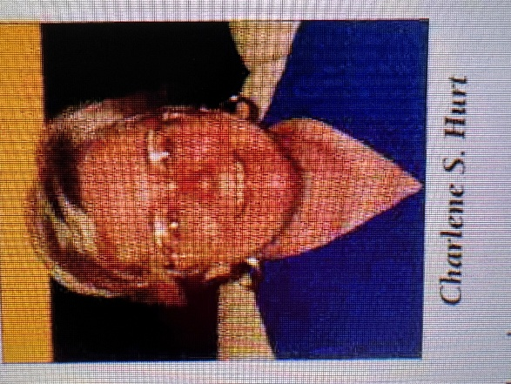

Charlene Schmidt Hurt began as a reference librarian, and with wit and tenacity progressed to become Dean of Libraries for Washburn University (1974-1976), George Mason University, and Georgia State University. Her leadership and vision shaped these institutions, leaving a lasting impact on students, faculty and friends alike for decades to come.
She was a champion of Fair Use.
Charlene S. Hurt was a longtime academic library administrator known for her leadership in modernizing library services, advancing digital/virtual library initiatives, and shaping innovative physical and conceptual library spaces.

At Washburn University she introduced OCLC and online searching and oversaw a major building project that transformed library services, including eliminating a traditional reference desk model in favor of more integrated access.
She then served as Director of Libraries at George Mason University (1980s–1998),

At George Mason, she played a central role in planning and developing the Johnson Center Library—an innovative, integrated facility that combined the library with a bookstore, food services, theater, media authoring center, and student/academic offices. This was frequently cited as a model for 21st-century academic libraries functioning as “information commons” or learning spaces rather than traditional book warehouses.

She was described as the “founding mother” of VIVA (the Virtual Library of Virginia), serving as the first chair of its steering committee. This consortium-focused digital resource-sharing initiative was a major advancement in statewide virtual library services.
She also served on the boards of the Washington Research Library Consortium and chaired the Virginia State Networking Users Advisory Board, in addition to serving on the Board of Directors of the Southeastern Library Network (SOLINET) and as a member of the OCLC Users Council.
Charlene S. Hurt was Dean of Libraries / Director of the William Russell Pullen Library at Georgia State University (GSU) from 1998 to 2008.
As Dean, she focused on professionalizing and modernizing GSU’s library operations, including enhancing teaching and learning engagement (such as through liaison librarian programs) and participating in statewide initiatives like the GALILEO consortium steering committee.
Champion of Fair-Use: the long-running 2008–2020 Georgia State University (GSU) e-reserves copyright lawsuit

- During Hurt’s tenure, GSU’s library policies on electronic reserves became central to the high-profile copyright/fair use lawsuit Cambridge University Press et al. v. Patton et al (also known as the GSU e-reserves case), filed in 2008. She was one of the university officials named in the suit, which tested fair use boundaries for digital course materials in higher education and drew widespread attention in the library and publishing communities

- .

- The case

was filed in 2008 by three academic publishers (Cambridge University Press, Oxford University Press, and SAGE Publications, backed by the Association of American Publishers and Copyright Clearance Center) against GSU officials. The suit alleged that GSU’s electronic reserves and course management systems involved systematic, unlicensed copying and distribution of copyrighted book excerpts for student use, exceeding fair use. The litigation spanned over 12 years with multiple district court rulings and two appeals to the Eleventh Circuit Court of Appeals. The core dispute centered on fair use analysis under 17 U.S.C. § 107 for digital excerpts placed on e-reserves. Final Outcome (September 29, 2020): In the district court’s final order (issued by Judge Orinda Evans), Georgia State University was declared the prevailing party. No damages were awarded against GSU, and the university’s overall approach to e-reserves was largely vindicated.
Hurt’s career

consistently emphasized libraries’ evolving role in teaching, technology, scholarly communication, and collaborative consortia, with a strong practical focus on both physical redesign and virtual infrastructure.
Charlene Schmidt Hurt, 84, passed away peacefully in her sleep after a ten year battle with Alzheimer's on January 31, 2025 in Oceanside, California. Due to the effects of this debilitating disease, she died not remembering the glorious life she led, nor the many lives she touched - that is left for those of us who remain to do. Always remember. She was not alone.
Beyond her professional achievements, Charlene was known for her unwavering commitment to Equality, Justice and Community. An activist at heart, she approached life with curiosity and an unshakable belief in the power of collective action. She was a devoted mother, a steadfast friend, and a formidable presence-—one who continually inspired those around her with intellect, compassion and her wry sense of humor. (Obituary).

Selected Publications
Note: These works reflect Hurt’s focus on library design as learning spaces, scholarly communication in the digital era, collection development, virtual consortia (e.g., VIVA), and the evolving role of academic libraries.
Hurt, Charlene S., and Thomas L. Findley. “Library Architecture and Design.” In Encyclopedia of Library and Information Sciences, 3rd ed., edited by Marcia J. Bates and Mary Niles Maack. Boca Raton, FL: CRC Press, 2010. (Also appeared in updated form in the 4th ed., 2017.)
Hurt, Charlene, and William Gray Potter. “CORC and the Future of Libraries: Two University Librarians’ Perspectives.” In CORC: New Tools and Possibilities for Cooperative Electronic Resource Description, edited by Karen Calhoun. New York: Haworth Information Press, 2001. (Also published in Journal of Internet Cataloging 4 [2001].)
Hurt, Charlene. “The Johnson Center Library at George Mason University.” In Building Libraries for the 21st Century: The Shape of Information, edited by Terry D. Webb, 83–104. Jefferson, NC: McFarland, 2000.
Rogers, Sharon J., and Charlene S. Hurt. “New Electronic Scholarship and Libraries; Or, the Medium Became the Message.” Journal of Library Administration 25, no. 4 (1998): 239–49.
Hurt, Charlene. “Building Libraries in the Virtual Age.” College & Research Libraries News 58, no. 2 (February 1997): 75–76, 91.
Hurt, Charlene S., Laura O. Rein, Maureen S. Connors, John C. Walsh, and Anna C. Wu. “Collection Development Strategies for a University Center Library.” College & Research Libraries 56, no. 6 (November 1995): 487–95.
Hurt, Charlene S. “Building the Foundations of Virginia’s Virtual Library.” Information Technology and Libraries 14, no. 1 (March 1995): 50–53.
Hurt, Charlene S. “A Vision of the Library of the 21st Century.” Journal of Library Administration 15, nos. 3–4 (1991): 7–19. (Also published in Library Management in the Information Technology Environment, edited by Bruce G. Hobrock, 1992.)
Rogers, Sharon J., and Charlene S. Hurt. “How Scholarly Communication Should Work in the 21st Century.” College & Research Libraries 51, no. 1 (January 1990): 5–8. (An earlier version also appeared as a Point of View column in the Chronicle of Higher Education, October 18, 1989.)
Sources
Albanese, Andrew. “Georgia State Sued Over E-Reserves.” Library Journal, May 21, 2010. https://www.libraryjournal.com/story/georgia-state-sued-over-e-reserves.
Burtle, Laura. “A Discussion with Charlene Hurt and Rich Meyer.” Georgia Library Quarterly 45, no. 2 (Summer 2008): 5–7. https://doi.org/10.62915/2157-0396.1199.
Cambridge University Press v. Patton
Young, Ann-Christe. “People in the News.” College & Research Libraries News 58, no. 10 (1997): 725. https://doi.org/10.5860/crln.58.10.725.
Charlene Hurt Obituary - Oceanside, CA
Submitted by Kathlen de la Peña McCook

