Charles W. Hunsberger 1929 — 2024

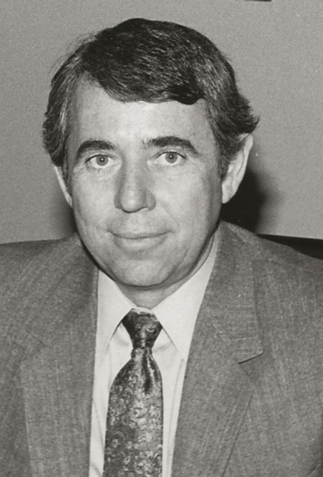

It seems counterintuitive that a man who was raised a Mennonite, spoke Pennsylvania Dutch before he spoke English, and was destined to quit school after eighth grade to work on the family farm would grow up to become one of the most progressive and visionary library directors in the United States. His participation in the “Building Las Vegas” project results from his being responsible for building twenty libraries in Clark County during his 1971–1994 tenure as director of the Las Vegas-Clark County Library District.
Building Las Vegas. Oral History Project.

Charles W. Hunsberger graduated from Bethel College,, Indiana with a BA in 1952 and entered missionary service with the United Missionary Church, serving for nine years, including seven years in Nigeria, West Africa. He worked with African leader who was building schools. Hunsberger’s job help get his teacher training college up and running. He helped build dormitories and laid concrete.
After his missionary service, Charles worked at the Fort Wayne (Indiana) Library from 1960-1962 . Because his undergraduate college was unaccredited he was required to take additional undergraduate study before enrolling in an LIS program. He began attending summers and then was able to qualify as director Columbia (Indiana) City Library, 1962-1964 .
While he was completing his LIS degree he was appointed the director of the Monroe County Public Library ( Bloomington, Indiana) and oversaw the merger of the city and the county from 1964-1971. He received his MS in Library Science from Indiana University in 1967. He oversaw the construction of a new library.
In 1971, Hunsberger was appointed Director of the Las Vegas and Clark County libraries, where he served until his retirement in 1993.
While Director of the Las Vegas and Clark County libraries, he increased the number of libraries by establishing over 20 new locations, always ensuring these included spaces for the arts. The oral history listed in sources for this tribute is available online and is a fascinating story of the political process and the public library.

Charles received the Nevada Governor’s Arts Award, for service to the Arts in 1989.
The Library Board President said of Charles, “he is a visionary and leader for the advancement of Libraries both locally and nationally.”

He was a member Nevada Council on Libraries, 1973-1981 and chairman, 1980-1981.
Charles was active in the Rotary Club, and was a charter member, past President, and Paul Harris Fellow, in the Paradise Rotary Club, of Las Vegas. Charles was a member of the International Library Director’s Association and traveled internationally each year with that group.

Sources
Charles W. Hunsberger oral history interview. Building Las Vegas. Oral History Project. Conducted by Stefani Evans and Claytee D. White on July 27, 2016. University of Nevada, Las Vegas. University Libraries. Special Collections and Archives. Transcript

Charles W. Hunsberger -obituary

