Thomas “Tom” Duszak 1951 – 2025

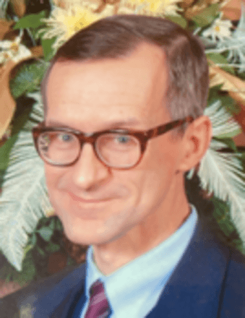

Thomas “Tom” Duszak, age 73, of Wilmington, DE, passed away on Thursday, February 20, 2025.
Born on June 15, 1951, to Eugene and Lucille (née Swierczewska) Duszak, Tom spent his early years in the Hedgeville neighborhood of Wilmington. He attended St. Hedwig’s School and cherished his time at the Boy’s Club. Tom was a proud graduate of Salesianum School, the University of Delaware, and Columbia University.
After earning a Master of Science in Library Science from Columbia University School of Library Service, Tom relocated to Harrisburg, PA in 1978.
He dedicated over 30 years to public service as a librarian for the Commonwealth of Pennsylvania. He was Librarian, Pennsylvania State Senate, 1981-1988. He was Department head, cataloging section, State Library, Commonwealth of Pennsylvania, 1988-2017 During his time in Harrisburg, he was an active and faithful member of St. Patrick’s Cathedral.

Tom had an enduring passion for research, history, religion, exercise, philately, and his Polish heritage, all of which shaped his personal interests. He wrote two books: Towarzystwo Czytelni Polskiej 1898-1998: The Centenary of the Polish Library Association (1998) and Sports and Recreation in Hedgeville and Browntown, Wilmington, Delaware (2002).

Tom Duszak was a member the Catholic Library Association (CLA), He joined the Catholic Library Association (CLA) around 1990 and about a decade later, answered the call to become the chair of the CLA’s Cataloging and Classification Roundtable, a position which he held until 2016, During his tenure as chair, Tom was a faithful representative of the CLA at the meetings of the Cataloging and Classification: Description and Access committee held during the annual and winter American Library Association (ALA) conventions; he also played an active role at meetings of the CLA, inviting speakers on cataloging issues. Most significantly, perhaps, it was under his initiative that the that the Oliver Leonard Kapsner, O.S.B. Newsletter was established in 2007, with Robert “Rob” Kusmer of the University of Notre Dame as founding editor. The Newsletter is a lasting legacy of his foresight and commitment to communicating information about cataloging to member of the Catholic library community. It is with good reason that the CLA presented him with the Mary A. Grant Volunteer Service Award in 2017.

Fiercely proud of his ethnic heritage, Tom was an active member of the Polish American Historical Association and conducted research on the history and bibliography of the Polish-American community. This led to a number of publications, most notably a book on the Towarzystwo Czytelni Polskiej [The Polish Library Association] of Wilmington, Delaware, as well as articles on information about notable Polish-American women in government documents, on information resources about Polish Americans and on internet resources about Poland, Polish Americans, and Lithuania.


He was also a member of the Susquehanna Valley Stamp and Postcard Club
After more than four decades in Midtown Harrisburg, Tom moved to the Ecumenical Retirement Community in Paxtang, PA, where he formed lasting friendships through his participation in the book club, exercise classes, and rosary group. He spent his final days in Wilmington, DE, at Kentmere Rehabilitation and Skilled Care, and his family is deeply grateful for the care he received there.

Publications

Thomas Duszak, Towarzystwo Czytelni Polskiej, 1898-1998: The Centenary of the Polish Library Association, Wilmington, Delaware. Camp Hill, Pa.: Plank’s Suburban Press, 1998.
Thomas Duszak, “Polish American Women: Tracing Ethnic Achievement in Published U.S. Government Sources, Journal of Government Sources, 25(1), 1998: 47-71.
Thomas Duszak, “The Polish Presence in North America”, Choice, 32(3), 1994: 399-419.
Thomas Duszak, “The Polish Presence in North America: An Update for Electronic Resources”, College & Research Libraries News, 66(10), 2005: 720-724;
“The Polish and Polish American Presence on the Web: Free Electronic Resources”, Catholic Library World, 86(3), 2016: 178-184;
“Lithuania on the Web: Free Electronic Resources”, Slavic & East European Information Resources, 17(4), 2016: 268-284

Sources
Thomas Duszak , Senate Librarian to Purchase
In Memoriam Thomas Duszak. Polish American Studies (2025) 82 (2): 7–8. https://doi.org/10.5406/23300833.82.2.02
Thomas Duszak (1951-2025): Initiator of the Oliver Leonard Kapsner, O.S.B. Cataloging Bulletin
Thomas “Tom” Duszak 1951 - 2025 Obituary

Submitted by Kathleen de la Peña McCook

