Sandra Friedman Dolnick (Sandy)- 1936-2016

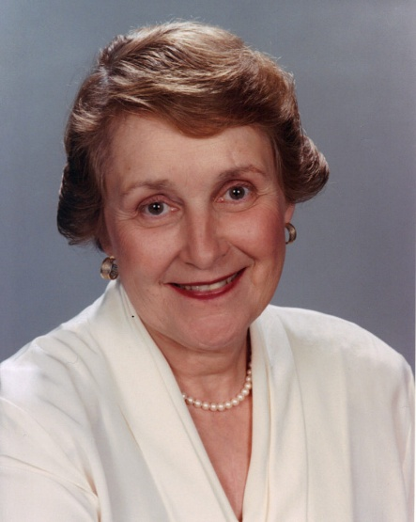

Sandy Dolnick was a visionary advocate whose passion for public libraries transformed how communities across the United States support and sustain them.

Dolnick’s journey into library advocacy began in the 1970s as a volunteer with the Friends of the Whitefish Bay Public Library in Wisconsin. She quickly rose to leadership roles, serving as president of the Milwaukee Bookfellows (now Friends of the Milwaukee Public Library) and becoming actively involved with Friends of Wisconsin Libraries
In 1975 when, as a member of a Friends committee within the American Library Association’s (ALA) Library Leadership and Management Association, she conceived the bold idea of uniting library “Friends” groups nationwide. Recognizing that isolated local efforts often reinvented the wheel, she proposed a newsletter to share best practices. With ALA’s support, she conducted a national survey of known Friends groups, laying the groundwork for a coordinated movement. This vision materialized in 1979 with the founding of Friends of Libraries USA (FOLUSA).
She was FOLUSA’s founding executive director for 23 years (until her retirement in 2002). Dolnick built the organization into a powerhouse with approximately 3,000 member groups. She forged enduring partnerships with publishers, corporate sponsors, and authors, bringing prominent writers to ALA conferences and creating innovative programs like the Barbara Kingsolver Award, which provided $10,000 for book purchases to outstanding small Friends groups. Her leadership turned FOLUSA into a vital national network that amplified local voices and secured critical resources for libraries everywhere.

In 2009, FOLUSA merged with ALA divisions to form United for Libraries: Association of Trustees, Advocates, Friends and Foundations—ensuring her foundational work would continue to strengthen library advocacy for generations. Colleagues remembered her as “kind, fierce, funny and whip smart,” a tireless innovator who was “greatly admired by publishers, authors and librarians across the country.” Sally Gardner Reed, executive director of United for Libraries, noted that Dolnick “laid a great foundation for working with library support groups across the country,” providing a lasting “roadmap” for the field.
In 2017, she was posthumously inducted into the Wisconsin Library Hall of Fame, a fitting honor for a pioneer who elevated the role of citizen advocates in preserving America’s public libraries.

Sandy Dolnick’s career reminds us that great change often begins with one person’s simple act of volunteering—and grows, through vision and persistence, into a national movement. Her genius lay in connecting people, sharing knowledge, and championing the idea that libraries thrive when communities rally around them. She was, in every sense, a true friend to libraries and to the larger world of books and learning. Her impact endures in every local Friends group that draws strength from the network she built.

Selected Publications

Dolnick, Sandy, comp. Friends of the Library National Notebook: A Directory of Friends of Libraries Groups in the United States. Chicago: American Library Association, 1978.

Dolnick, Sandy, ed. Friends of Libraries Sourcebook. Chicago: American Library Association, 1980.

Dolnick, Sandy, ed. Friends of Libraries Sourcebook. 2nd ed. Chicago: American Library Association, 1990.

Dolnick, Sandy, ed. Friends of Libraries Sourcebook. 3rd ed. Chicago: American Library Association, 1996.

Dolnick, Sandy. The Essential Friends of Libraries: Fast Facts, Forms, and Tips. Chicago: American Library Association, 2005.
Dolnick also founded and edited the FOLUSA News Update newsletter (beginning in the late 1970s), contributed fact sheets and columns through FOLUSA, and is credited with early survey-based directories that supported national coordination of Friends organizations, though those appear primarily in organizational rather than individually attributed form.

Sources
“Sandra Friedman Dolnick, Public Libraries Advocate, Dies at 80.” Wisconsin Jewish Chronicle, December 23, 2016.
Sandra Dolnick Obituary. Milwaukee Journal Sentinel. Jan. 1, 2017.
Nix, Larry. Sandra (Sandy) Friedman Dolnick, 2017 Wisconsin Library Hall of Fame Inductee.
Memorial Resolution Honoring Sandra (Sandy) Friedman Dolnick ALA Council of the American Library Association Tuesday, January 24, 2017.

Submitted by ALA Member

