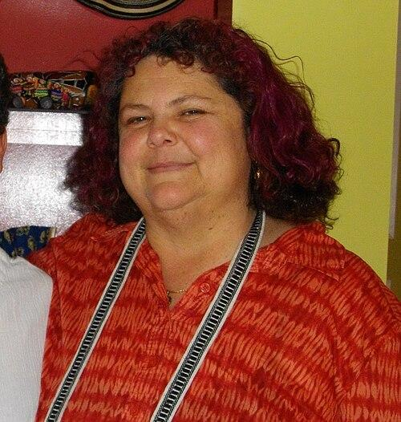

Tatiana de la Tierra (1961–2012) was a librarian, writer, editor, and activist, who dedicated her life to creating a space where marginalized identities could be seen, heard, and celebrated leaving an enduring impact on queer, Latina, and feminist information communities.
Tatiana de la Tierra was born in Colombia in 1961 and emigrated to the USA in 1969. From a young age, she volunteered and worked in her school libraries. She obtained a bachelor's degree in psychology from the University of Florida in 1984 before going on to become a writer and librarian.
Beyond her role as a librarian, de la Tierra was a pioneering force in queer publishing. She founded and edited Esto no tiene nombre and later Conmoción, two groundbreaking Latina lesbian zines (De la Tierra, 1997). Through these publications, though they were not published for long, she fostered a sense of community and belonging, connecting readers and writers across geographic and cultural boundaries. Her editorial work was deeply intertwined with her librarianship, reflecting a belief that access to information and the creation of knowledge are fundamentally linked acts of empowerment (González, 2003).
Her writing challenged dominant narratives and invited readers to engage with questions of identity, sexuality, and cultural heritage. De la Tierra’s work reminds us that libraries are not neutral spaces; they are shaped by the choices of those who build and maintain them (Samek, 2007). Her legacy calls on librarians to be intentional in whose stories they collect, preserve, and uplift. For many emerging librarians and writers, particularly those from Latin and LGBTQ backgrounds, she served as a model of what it means to bring one’s full self into professional practice.
Tatiana de la Tierra’s work in librarianship was inseparable from her activism. Throughout her career, she advocated for inclusive collections that reflected the lived experiences of LGBTQ+ individuals, particularly those within Latina communities. Her commitment to representation extended beyond collection development; she actively worked to ensure that libraries could become welcoming environments for all, even going so far as to implement hispanic specific programs (Espinal, 2001).
In remembering Tatiana de la Tierra, we honor a life devoted to expanding the boundaries of librarianship and to affirming the dignity and visibility of all people. Her contributions continue to shape conversations around diversity, equity, and inclusion within the field, reminding us that the work of librarians is not only to preserve the past, but also to imagine and build a more inclusive future. May her legacy endure in every collection that reflects the richness of human experience, and in every librarian who carries forward her commitment to justice, representation, and the transformative power of words.
References
American Library Association. (n.d.). Librarians we have lost. https://www.ala.org
De la Tierra, T. (1997). Esto no tiene nombre.
Espinal, I. (2001). A new vocabulary for inclusive librarianship. Library Trends, 49(4), 680–696.
González, E. (2003). Latina lesbian voices in literature and culture. Journal of Lesbian Studies, 7(1), 23–35.
Morales, M. (2014). Diversity, social justice, and the future of libraries. Progressive Librarian, 42, 15–27.
Samek, T. (2007). Librarianship and human rights: A twenty-first century guide. Chandos Publishing.

