Jack Dalton (1908–2000)

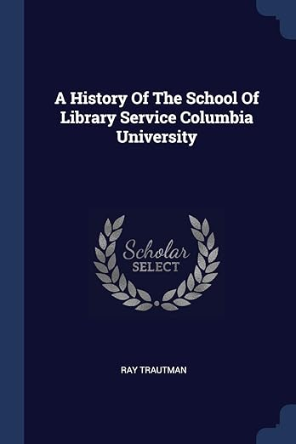

Jack Dalton (1908–2000) was an influential American librarian, educator, and administrator who served as Dean of Columbia University’s School of Library Service from 1959 to 1970.
Born in Holland, Virginia, Dalton earned a bachelor’s degree (1930) and a master’s degree (1935) from the University of Virginia. He also completed library science courses at the University of Michigan in 1935–1936.

His professional career began at the University of Virginia Library, where he held successive positions: assistant reference librarian (1934–1935), reference librarian (1936–1942), associate librarian (1942–1950), and university librarian (1950–1956).
In 1956 he left UVA to direct the American Library Association’s International Relations Office (1956–1959). He also served on the ALA Council (1964–1968) and chaired its Ethics Committee.

In 1959 Dalton was appointed Dean of Columbia University’s School of Library Service. During his eleven-year tenure (until 1970), he modernized the curriculum by introducing courses in information science and recruited an outstanding faculty.
After stepping down as dean, he directed Columbia’s Library Development Center (1970–1978), an initiative focused on expanding library services for people with disabilities and other underserved populations. He later worked as a consultant to the H.W. Wilson publishing company.

Dalton was widely respected in the library profession and received the American Library Association’s Honorary Membership in 1983.

His professional papers, covering the period 1940–1976 and including correspondence, reports, and materials from his time at Columbia and the ALA, are preserved in the Columbia University Archives.

Sources

The Honorary Membership Committee’s nominees (including Dalton) were reported in the “ALA Report” section of American Libraries (February 1983).
Dalton, Jack. 1970. D.L.S. Degrees Granted by Columbia University, School of Library Service, 1954-1969.
Jack Dalton, 92, Authority in Library Studies.” New York Times, July 16, 2000. https://www.nytimes.com/2000/07/16/nyregion/jack-dalton-92-authority-in-library-studies.html.
Jack Dalton papers, 1940-1976. Columbia University Libraries. Archival Collections.
Young, Ann-Christe. “People in the News.” College & Research Libraries News 61, no. 10 (November 2000): 953. https://crln.acrl.org/index.php/crlnews/article/view/19984.

Submitted by ALA Member

