Frank Kurt Cylke - 1932-2019

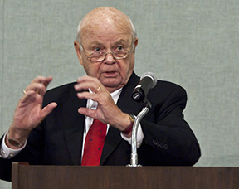

Frank Kurt Cylke served for thirty-eight years (1973–2011) as Director of the National Library Service for the Blind and Physically Handicapped at the Library of Congress.

- Undergraduate: B.A. from the University of Connecticut (UConn), completed in 1954. He studied American Literature and Culture.
- Graduate: Master of Library Science (M.L.S.), Pratt Institute, Brooklyn, New York, completed in 1957.

Early Career
- Bridgeport Public Library, Bridgeport, CT (1958–1962)
Reference Librarian.
- New Haven Public Library, New Haven, CT (1962–1965)
Head of Public Services.
- Providence Public Library, Providence, RI (1965–1968)
Assistant Librarian (or similar public-service role).
- U.S. Office of Education, Washington, DC (1968–1970)
Director/Chief, Library Research and Development Branch (or equivalent federal library development role).
- Federal Library Committee, Library of Congress, Washington, DC (1970–1973)
Executive Director. (This marked his entry into the Library of Congress proper and federal library leadership; he chaired the committee as part of this role.)

Director of the National Library Service for the Blind and Physically Handicapped at the Library of Congress.

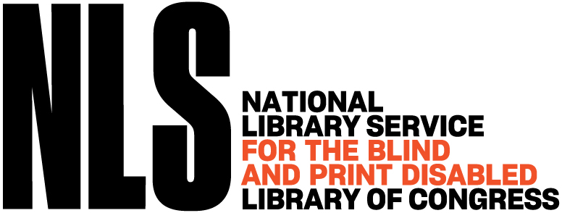

Frank Kurt Cylke chaired the Federal Library Committee and served for thirty-eight remarkable years (1973–2011) as Director of the National Library Service (NLS) for the Blind and Physically Handicapped at the Library of Congress.
Under his visionary leadership, the NLS grew into a powerhouse of accessibility. He guided the program through two seismic technological shifts: from phonograph records to cassette tapes, and later from cassettes to digital cartridges and downloadable books. He expanded the collection, strengthened congressional support, and—crucially—transformed the service into a truly consumer-oriented enterprise.
He built lasting partnerships with blind and physically handicapped readers, invited their organizations into every major decision, and insisted that the library’s users must help shape the very tools and titles they would use.

Frank Kurt Cylke also taught he taught as an adjunct professor for twenty-five years in the library school at Catholic University of America, where he offered a course in special librarianship.

For his lifetime of distinguished service, the American Library Association awarded Frank Kurt Cylke the Joseph W. Lippincott Award in 1994.

He retired from NLS in 2011.

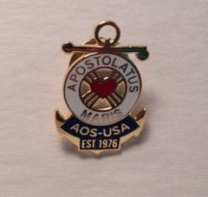
In retirement he found special purpose in the Apostleship of the Sea, Stella Maris, offering weekly companionship and comfort to seafarers at the Port of Baltimore. He was a Knight of Columbus and a proud member of the Crow’s Nest Officers’ Club in St. John’s, Newfoundland.
In every Talking Book that reaches a new reader, in every digital download that opens a new world, in every young person inspired to love libraries because of the doors he helped swing wide, his legacy lives on.

Sources

“National Library Service Director Receives Newel Perry Award.” Library of Congress Information Bulletin 64, no. 9 (September 2005). https://www.loc.gov/loc/lcib/0509/perry.html.
“Lippincott Award to Go to LC Employee.” Library of Congress Information Bulletin 53, no. 9 (May 2, 1994). https://www.loc.gov/loc/lcib/94/9409/cylke.html.
Wunder, Gary. “An Interview with Frank Kurt Cylke.” Braille Monitor, May 2011, National Federation of the Blind, https://nfb.org/images/nfb/publications/bm/bm11/bm1105/bm110505.htm.
“In Memoriam: Frank Kurt Cylke.” News April–June 2019, National Library Service for the Blind and Print Disabled, Library of Congress, Apr.–June 2019, www.loc.gov/nls/news-and-updates/quarterly-newsletter-news/news-april-june-2019/.
Frank Kurt Cylke – Obituary

Submitted by Kathleen de la Peña McCook

