Dorothy M. Broderick -1929 –2011

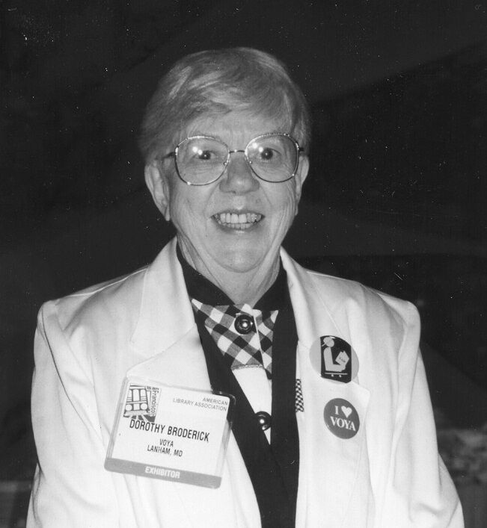

Dorothy M. Broderick (June 23, 1929 – December 17, 2011) was an American writer, college professor, editor, and "a legend of YA librarianship." She was co-founder and editor of VOYA: Voice of Youth Advocates, a professional magazine for librarians concerned with services for children and youth.
Dorothy Broderick graduated from New Haven State Teachers College in 1953, and earned a master's in library science (MLS) from Columbia University, School of Library Service in 1956.
She completed a doctorate in library science (DLS) in 1971. Her dissertation advisor was Frances E. Henne.

Career
Broderick was a librarian in Milford, Connecticut, and Hicksville, New York, as a young woman, and at Western Reserve University and the University of Wisconsin after she earned her DLS.
She was the children's library consultant for the New York State Library. She taught children's literature at Dalhousie University beginning in 1972. In 1977, she organized the first science fiction fan convention in Nova Scotia.
Broderick was an active member of the American Library Association and of YALSA. Broderick spoke and wrote often on censorship issues and on the evolving nature of public libraries, especially for younger patrons.

Dorothy Broderick received the Robert B. Downs Intellectual Freedom Award (1986) and is on the Freedom to Read Foundation's Roll of Honor.

Selected Writings by Dorothy M. Broderick
Broderick contributed to dozens of editorials and reviews in VOYA: Voice of Youth Advocates (which she co-founded and edited from 1978).)

Broderick, Dorothy M. “Turning Library into a Dirty Word: A Rant.” Library Journal 122, no. 12 (July 1997): 42–43.

Broderick, Dorothy M. “Moral Conflict and the Survival of the Public Library.” American Libraries 24, no. 5 (May 1993): 447–48.

Broderick, Dorothy M. “Reviewing Young Adult Books: The VOYA Editor Speaks Out.” Publishing Research Quarterly 8, no. 1 (March 1992): 34–40.

Chelton, Mary K., and Dorothy M. Broderick, eds. The VOYA Reader Two. Lanham, MD: Scarecrow Press, 1998.

Broderick, Dorothy M., and Silk Makowski, eds. Serious about Series: Evaluations and Annotations of Teen Fiction in Paperback Series. Lanham, MD: Scarecrow Press, 1998.

Broderick, Dorothy M., ed. The VOYA Reader. Metuchen, NJ: Scarecrow Press, 1990.
Curley, Arthur, and Dorothy M. Broderick. Building Library Collections. 6th ed. Metuchen, NJ: Scarecrow Press, 1985.

Broderick, Dorothy M. “Censorship: A Family Affair?” Top of the News 35 (Spring 1979): 223–32.
Broderick, Dorothy M. "Intellectual Freedom and Young Adults" Drexel Library Quarterly 14(1)(January 1978): 65-77.
Broderick, Dorothy M. Library Work with Children. New York: H. W. Wilson Co., 1977.
Broderick, Dorothy M. Image of the Black in Children’s Fiction. New York: R. R. Bowker Co., 1973. (Based on her 1971 Columbia University DLS dissertation.)

Broderick, Dorothy M. An Introduction to Children’s Work in Public Libraries. 2nd ed. New York: H. W. Wilson Co., 1965.

Broderick, Dorothy M. Leete’s Island Adventure. Englewood Cliffs, NJ: Prentice-Hall, 1962.

Sources

Bernier, Anthony, ed. The Collected Wit and Wisdom of Dorothy M. Broderick: The VOYA Editorials and More. Bowie, MD: Kurdyla Publishing / VOYA Press, 2013.

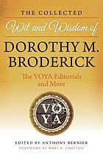

In Memoriam: Dororthy Broderick – YALSA Blog
“Dorothy Broderick, 1929-2011" Newsletter on Intellectual Freedom 61. Vol 61, No 2 (2012)
Dorothy M. Broderick - Wikipedia

