Peggy Barber – 1943-2019

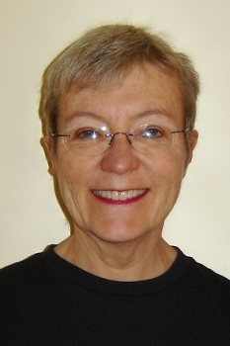

Peggy once observed: “Librarians are stewards of all the world's creativity ....We run institutions that are open to all people and have the potential for serving all people. But we get to deal with folks as individuals - one at a time. In this work, I think it's possible to make a difference in the world - one person at a time."

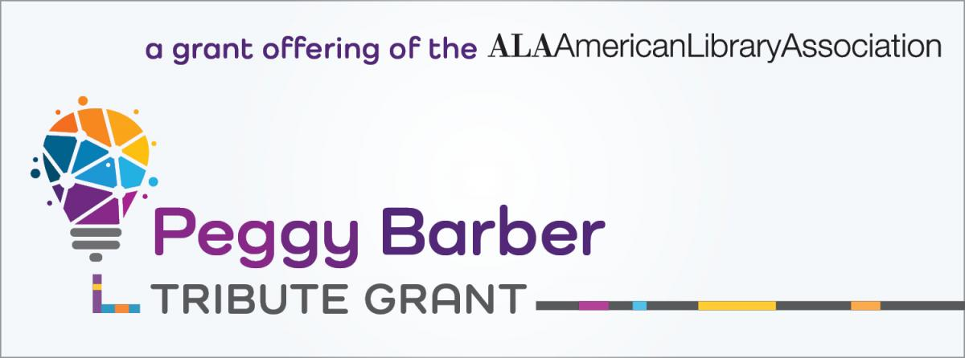

Margaret “Peggy” Barber (c. 1943/1944 – August 25, 2019) was a pioneering librarian and marketing/communications expert best known for her transformative work at the American Library Association (ALA).
Before ALA, Peggy worked as a coordinator for the Orange County Cooperative Library System in California and as a reference librarian at the San Francisco Public Library. She held a B.A. in English from the University of California–Riverside and an M.L.I.S. from Rutgers University.

American Library Association

Peggy Barber served as Associate Executive Director for Communication at ALA from 1970 -2000 and established several key programs that professionalized how libraries promote themselves nationwide:
- The ALA Public Information Office and Public Programs Office.

- The ALA Graphics program, which created the iconic Celebrity READ poster series (featuring celebrities, characters like Miss Piggy as “America’s Library Spokespig,” Mickey Mouse, Yoda, and stars such as David Bowie).
- The universal library logo (the book-and-person symbol still used on street signs across the U.S.).
- In her role as associate executive director for communication, she launched two of ALA’s major initiatives: National Library Week (NLW), which had previously been a publishers’ program, and ALA’s annual communications audits, which help guide its public programs.

- ALA’s NLW campaign rolled out in 1975 with the theme "Information Power," accompanied by posters, bookmarks, print ads, and radio public service announcements. Libraries and individuals requested additional campaign posters from the outset, so Barber encouraged ALA to meet the demand with a separate line featuring a dedicated message.

Barber also chaired the National Coalition for Literacy and the Community Advisory Board of Chicago's public radio station, WBEZ,

In 1999, Peggy Barber received the American Library Association Joseph W. Lippincott Award for distinguished service to the library profession.

ALA Standing Committee on Literacy (after Barber’s retirement)

Peggy Barber served as the first chair (or founding chair) of the ALA Standing Committee on Literacy, which was formally established in January 2001.

The committee’s charge was to develop and recommend ALA policies for promoting literacy, along with programs, educational opportunities, and resources to help libraries and librarians support community literacy efforts (with a focus on adult lifelong learning and literacy).
Key documented contribution in her role as chair:
In January 2002, Barber compiled the foundational document
Chronology of Milestones for Libraries and Adult Lifelong Learning and Literacy, explicitly created for the ALA Committee on Literacy.
This 48-reference timeline (spanning 1924–2001) documented the historical relationship between libraries, adult education, and literacy initiatives. It served as a key advocacy and policy resource for the committee and the broader library field.
Barber also co-authored a related peer-reviewed article that same year:
McCook, Kathleen de la Peña, and Peggy Barber. “Public Policy as a Factor Influencing Adult Lifelong Learning, Adult Literacy and Public Libraries.” Reference & User Services Quarterly 42, no. 1 (Fall 2002): 66–75.

These outputs aligned directly with the committee’s policy-development mandate and helped position libraries as central to national adult literacy efforts. Barber took on this volunteer leadership role shortly after retiring from her 30-year ALA staff position (as Associate Executive Director for Communication). She brought deep prior experience in literacy advocacy, including helping found the National Coalition for Literacy (1981) and coordinating literacy-related partnerships during National Library Week. The committee marked its 10th anniversary in 2010 with a celebration in Washington, D.C.; at that time, ALA President Camila Alire credited the group (which Barber had launched) with sponsoring health-literacy preconference,s, webcasts, site visits to community literacy programs, and ongoing advocacy for library literacy services.
Barber’s foundational leadership helped establish the committee’s long-term focus on literacy policy and library support.

In 2009 she and Peggy Danhof served as copresidents of ALA’s Association of Library Trustees, Advocates, Friends, and Foundations, which later became United for Libraries. Barber “was such a strong, positive, and uniting force as we brought together Friends, Trustees, and Foundations together in one ALA division, said ”Jillian Wentworth, United for Libraries manager of marketing and membership.
After her work with ALA Barber continued her active focus on the development of library communications and support through Library Communications Strategies. She was a longtime supporter of FOLUSA and has served as United For Libraries co-President.

Peggy Barber Tribute Grant

After her death colleagues and friends established the Peggy Barber Tribute Grant (now an annual ALA award) to support innovative, budget-challenged library programming—especially cultural and community-focused efforts.
Barber was “a consummate innovator and a pioneer,” Patricia Glass Schuman, 1991–92 ALA past president, told the Chicago Tribune. “Peggy’s efforts changed the way librarians and library supporters think about communication and advocacy—and she pushed us all with determination, style, and grace.”.
“Peggy and I were on the Program Committee of United for Libraries five years ago,” recalled United for Libraries board member and library consultant Dick Waters. “We put together a program titled ‘Getting a Bigger Piece of the Pie.’ Peggy had the idea of having pie slices ([to] eat) for those who attended. The program drew a standing room only crowd, said Waters, and every person who wanted a “piece of the pie” got one. “Peggy was a jewel,” he told LJ. “She was smart, full of energy, and resourceful. She was a friend, a colleague, a very good person.”
“Like everyone else who dealt with [ALA], I was in love with Peggy Barber,” said former Library Journal Editor-at-Large John N. Berry III. She was “the happiest person I ever worked with,” Berry said,
“and one of the most effective at her work as ALA’s voice to the world. She navigated the complexities of that often-impenetrable organization and I think she was the key to much of ALA’s success as it interacted with librarians and publishers and, of course, the press and world. I was always happy when our LJ coverage of ALA meant I would have some time with Peggy.”

How did Read posters become the basis for national library promotion?
Peggy Barber, ALA associate executive director for Communications told us and wrote the origin story: Peggy Barber - American Libraries, May 2003, Vol. 34 Issue 5, p60.

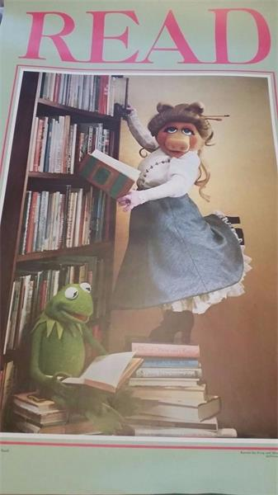
In the mid-1970s, then-ALA Executive Director Robert Wedgeworth decided to combine the membership promotion and public-relations staff positions. I joined the ALA staff in 1970 as director of the Office for Recruitment, then applied to head the new Public Information Office and got the job.
NLW moves to ALA
At about the same time, the leading publishing companies were becoming more business-minded, and promoting reading and libraries was no longer on their agenda. The National Book Committee folded, but not before asking Director Wedgeworth if ALA wanted to take on National Library Week. Without a second thought and with the ALA Executive Board firmly behind him, he agreed. All of a sudden we were in the poster business. ALA Graphics was in the delivery room.
Read series kicks off
The first Read poster was produced in 1980 and featured Mickey Mouse reading by a fire, with faithful Pluto lying next to him. Paul Brawley, then editor of ALA's Booklist magazine, secured permission to use Mickey's 50th birthday portrait for a magazine cover and helped us get permission for a poster.
Our PR pro Betty Steams suggested starting the Read series. I was hesitant, because many librarians had criticized the Book Committe's NLW materials as promoting books rather than libraries. But I agreed with her advice to make it strong, simple, and focused on benefits. What could be more strong, basic, and beneficial than "Read"?
In 1981 we sought out Miss Piggy. I wrote to Henson Associates and received a positive response from Creative Director Michael Frith, who had written children's books and was enthusiastic about a library Read poster. I bragged to anyone who'd listen that Miss Piggy was in the bag. Months went by and nothing happened. I was panicky and desperate, so we wired Miss Piggy a long-stem red rose saying we were waiting for her to become America's Library Spokespig. She responded "Mai Oui," and the poster was shot in New York City. New York Public Library provided books for the set, and the Henson folks created some wonderful new titles like The Days of Swine and Roses and Tinker, Tailor, Soldier, Frog.
I was really nervous that Miss Piggy's appearance on this poster as a librarian--glamorous, but complete with bun--would mean big trouble. I came into the boss's office wringing my hands and I whining. Wedgeworth looked up from his work, shook his head, and asked, "Isn't she a puppet?" He was right. There were very few complaints about Miss P's stereotypical librarian costume. The complaints we did receive came from children's librarians who feared her coquettish stance on a pile of books would inspire kids to do the same. There were also complaints from rare-book librarians who feared for the books themselves.
In the years that followed, Read posters featured Yoda, Annie, and Snoopy (in Spanish and English). We also launched the "Call Your Library " campaign, complete with posters by illustrator Tomie de Paola, and TV spots featuring actor Bob Newhart. For almost an entire season, Johnny Carson used reference questions supplied by librarians on the Tonight Show.
We also produced posters designed by award-winning graphic artists, such as John Massey. Remember the "Red/Read" poster, or the die-cut ones, such as the big gym shoe that said: "jog your mind...run to your library"? Most of these images were also distributed as print public-service ads and appeared in national magazines. I had this little superstition that when flipping through magazines in my dentist's office, if I didn't find a library ad, I'd need major repairs. Almost always, I was lucky enough to say: "No cavities!"
Then the question was how could we take the Read poster campaign beyond critters to real people? Writer-designer Bob Belinoff, who became one of our agency pros, helped us line up the stars.

Selected Publications

Barber, Peggy. “Contagious Marketing: How Libraries Can Get More Word-of-Mouth Buzz.” American Libraries 45, no. 1/2 (January/February 2014): 32–35.

Barber, Peggy, and Linda Wallace. Building a Buzz: Libraries and Word-of-Mouth Marketing. Chicago: American Library Association, 2010. (Published late 2009.)

Barber, Peggy. “Mickey Mouse, Miss Piggy, and the Birth of ALA Graphics.” American Libraries 34, no. 5 (May 2003): 60–63.
McCook, Kathleen de la Peña, and Peggy Barber. “Public Policy as a Factor Influencing Adult Lifelong Learning, Adult Literacy and Public Libraries.” Reference & User Services Quarterly 42, no. 1 (Fall 2002): 66–75.

McCook, Kathleen de la Peña, and Peggy Barber. Chronology of Milestones for Libraries and Adult Lifelong Learning and Literacy. Prepared for the ALA Committee on Literacy, January 2002. ERIC ED458888.
This chronology highlights milestones for libraries and adult lifelong learning and literacy from 1924-2001, including the following events:
  - William S. Learned's "The American Public Library and the Diffusion of Knowledge" is published (1924).
  - establishment of the ALA (American Library Association) Adult Education Section (1946).
  - the "Great Issues" program adult discussion group launched at ALA (1948).
  - funding of the America Heritage Project (1951).
  - funding of the ALA Office of Adult Education (1952).
  - the ALA Adult Services Division (ASD) established (1957).
  - the Adult Education Act (1966).
  - adoption of the "Library Rights of Adults" (1970).
  - ; merger of ASD and RSD (Reference Services Division) (1972).
  - White House Conference on Library and Information Services (1979).
  - founding of the National Coalition for Literacy (1981).
  - Adult Services in the Eighties project (1983-1990).
  - Library Literacy Program (1986-1995).
  - ALA Literacy Assembly convenes (1989).
  - White House Conference on Libraries and Information Services (1991).
  - ALA adopts literacy as one of five key action areas (1998).
  - development of a national literacy agenda with focus on the role of libraries (1999). National Literacy Summit (2000).
  - ALA Standing Committee on Literacy established (2001) .
Reports on related issues are listed throughout.

Barber, Peggy. “The American Library Association’s Literacy Initiatives: History and Hope.” In Literacy and Libraries: Learning from Case Studies, edited by GraceAnne A. DeCandido, 154–158. Chicago: American Library Association, Office for Literacy and Outreach Services, 2001.
Peggy. “Computers, Technology, Books—Yes, But Literacy Must Come First.” American Libraries 28 (May 1997): 42–43.

Barber, Peggy, and Linda D. Crowe. Getting Your Grant: A How-to-Do-It Manual for Librarians. New York: Neal-Schuman Publishers, 1993.
Barber, Peggy, ed. Sixty-Eight Great Ideas: The Library Awareness Handbook. Chicago: American Library Association, 1982.

Sources

American Library Association. Peggy Barber.
American Library Association Archives- Peggy Barber
Dempsey, Kathy. “In Remembrance of Peggy Barber, Who Shaped Library Promotion and Marketing.” Marketing Library Services 33, no. 6 (November/December 2019).
Landgraf, Greg (March 1, 2018). ""Wake Up and Read" to "Libraries Lead"". American Libraries.
Peet, Lisa. “Peggy Barber, Library Promotion Pioneer, Dies at 75.” Library Journal Sep 25, 2019 .
Goldsborough, Bob. “Margaret ‘Peggy’ Barber, Promotional Mastermind Behind National Library Week, Celebrity ‘Read’ Posters, Dies.” Chicago Tribune, September 20, 2019. (obituary).

Submitted by Kathleen de la Peña McCook

