Helen Amabile, 1931 - 2024

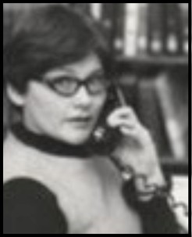

Helen Amabile née Lodahl was the former Deputy Director of the United States Information Agency’s (USIA) international library and information resource center program. Amabile grew up in Medicine Lake, Montana and passed in Media, Pennsylvania.

Amabile grew up in Medicine Lake, Montana before moving to Minnesota where she graduated with Bachelor’s in English Literature at Augsburg College and Seminary in 1953. A lover of language and literature, she was a member of the writer’s club and an editor for their yearbook. After a short career in teaching high school, she received her MLS (Masters of Library Science) and worked overseas in Stuttgart, Germany as a library practitioner for the U.S. Department of Defense Dependents’ school, which educated children of military service members. This school system is now the Department of Defense Education Activity (DoDEA), a network of primary and secondary schools serving U.S. military and civilian dependents across 11 different countries.

Amabile’s experiences in Germany fostered a passion for international relations, and she moved back to Washington, D.C. with her husband to work for the USIA. The USIA, which operated from 1953 to 1999, was a State Department managing U.S. embassy libraries and promoting American standard library practices and procedures to their foreign partners. As Deputy Director, Amabile acted as a trusted mentor, ambassador, and friend to her colleagues.
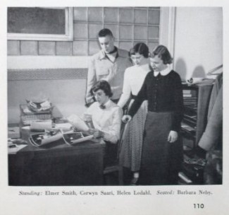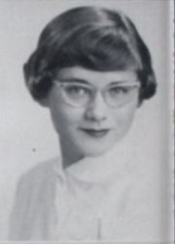
Augsburg College and Seminary Yearbook, 1953

Among the many highlights of her career was the implementation of the USIA’s Library Fellows program, of which Amabile was a founder and dedicated advocate. The Library Fellows program, which operated between 1986 and 1998, was a Fulbright foreign exchange program administered by the ALA and funded by the USIA. For twelve years the program selected 118 exceptional U.S. librarians to act as information ambassadors abroad for short terms, assigning them to American Cultural Centers in consulates worldwide to promote the library as a democratic institution. This involved pursuing projects such as book translation, implementing automated library systems, and enabling diverse and accessible collections to embody intellectual freedom and encourage cultural understanding.

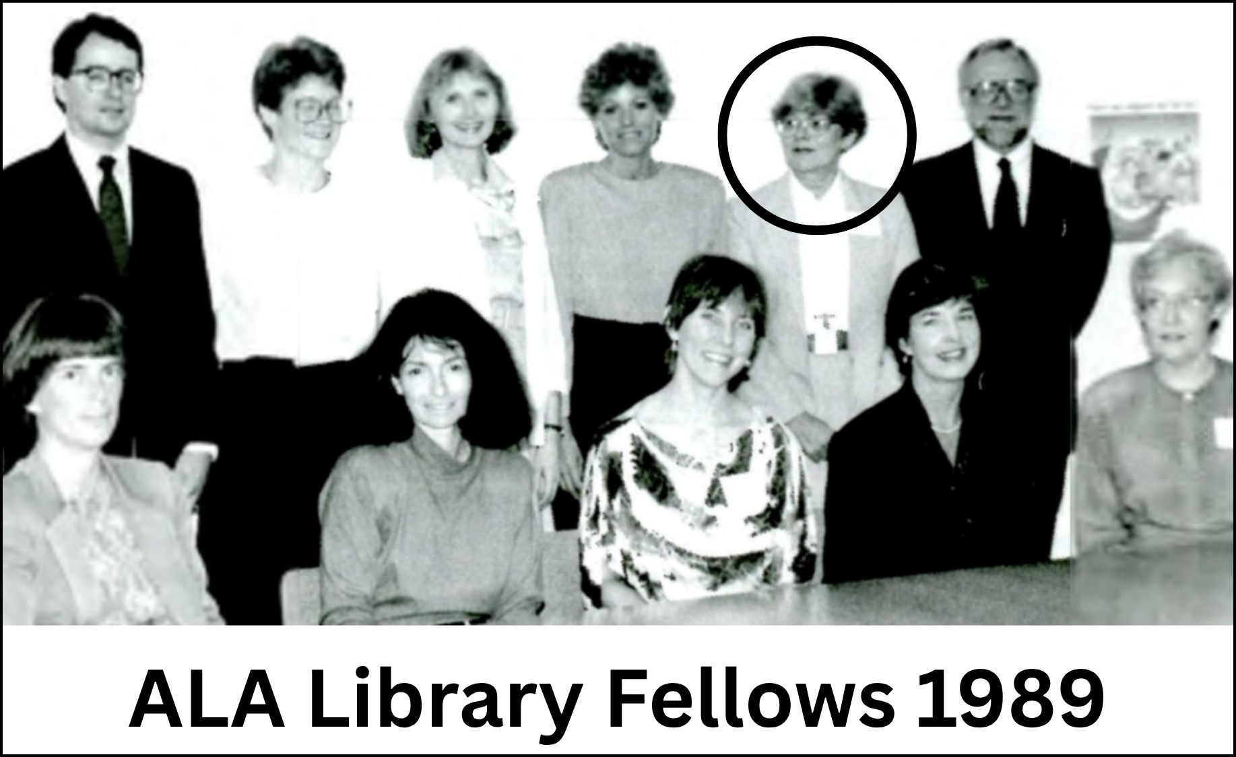

The Library Fellows simultaneously hosted 41 librarians from 35 different countries in the United States to share resources, assimilate American library practices to be applied to their home libraries abroad, and to facilitate lasting intercultural relationships. Before its termination, the Library Fellows program had established a partnership with 83 countries.

Amabile’s involvement in the program made her a pivotal figure in strengthening connections between U.S. and foreign information professionals. She personally oversaw 28 assignments of U.S. foreign service librarians, keeping in touch with those who were far away from home for many months during an era of limited communication pathways. Through her expertise and interminable guidance throughout this program, Amabile advanced American ideals of intellectual freedom, accessibility and resourcefulness.

Amabile is remembered by colleagues and mentees for her adaptability, cultural awareness, and enduring integrity.

Tribute by Sarah Keizer
Graduate Student
School of Information Sciences
Wayne State University 10 April, 2026

