Donna M. Alexander
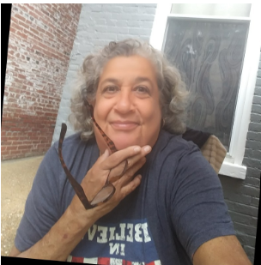

Donna M. Alexander, MLIS, 67, passed away on January 4, 2026. Donna was working as the Clinical Librarian at the Louis Stokes Health Sciences Library at Howard University in Washington, DC. In her role she supported the faculty and residents at Howard University Hospital and the Graduate Medical Education Program.
Her inquisitiveness, commitment, and sense of humor made an impact on her co-workers and the library patrons fortunate to have worked with her.
Donna received her MLIS from Rutgers University in 1992 and throughout her career she has worked as an information professional in the Washington, DC metro area, California, Nevada, New Jersey, and more.
Donna was kind, outgoing, and social by nature which was borne of a lifelong involvement in music and team sports and her friends, neighbors and community called her “Magic”.
More than anything, Donna loved her dog Willie, who has been lovingly adopted by her neighbor.

Submitted by Jeremy Gunnoe, Assistant Director, Louis Stokes Health Sciences Library, Howard University, Washington, D.C.

