Meredith Bloss (1908- 1982)

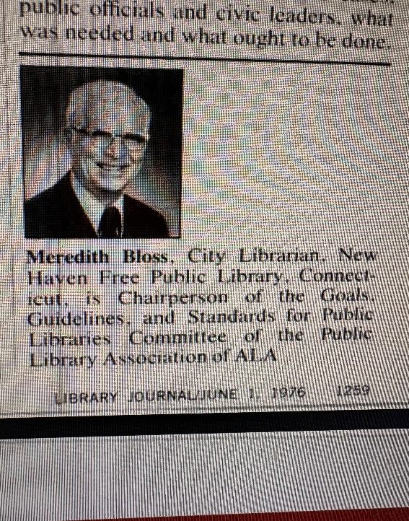

Mr. Meredith Bloss, visionary City Librarian, and champion of “Living Libraries” viewed libraries as a force for community good. He was director of the New Haven Free Public Library , CT from 1959-1978.

Standards for Public Library Service—Quo Vadis?” – Meredith Bloss’s 1976 Library Journal article is widely cited as a turning point: it declared the old standards era effectively over and laid the intellectual foundation for the modern, user-centered, evidence-based approach to public library service planning that remains influential today.

Meredith Bloss was one of the most forward-thinking public librarians of the mid-20th century. As the third City Librarian of the New Haven Free Public Library from 1959 until his retirement in 1978, he transformed a traditional urban library system into a vibrant network of community-centered institutions at a time when cities faced profound social and economic challenges.
Bloss believed passionately that libraries must be active forces in people’s lives, not quiet institutions. He pioneered the concept of “living libraries”—neighborhood centers that combined books, reading programs, and reference services with job training, literacy support, cultural events, and social services.
In 1965 he helped secure major funding to create these innovative branches, declaring that they would serve as true community anchors.
His landmark 1969 report, A Report on New Haven’s Library Neighborhood Centers, documented the success of this model and became an influential blueprint for libraries across the country.
A committed advocate for the disadvantaged, Bloss chaired the American Library Association’s Committee on Library Service to the Disadvantaged (1973/1974) and played a key role in the ALA Ad Hoc Committee that led to the creation of the Office for Library Outreach Services.

Standards for Public Libraries- Quo Vadis?
In his capacity as former chair of the Public Library Association’s Goals, Guidelines, and Standards Committee), Meredith Bloss (then recently retired as New Haven’s City Librarian) sharply questioned the future direction of national public library standards. The Latin title “Quo Vadis?” (“Where are you going?”) signals his central thesis: traditional, rigid, input-based national standards had become outdated and largely irrelevant in an era of diverse communities and changing library roles.

Impact

Earlier in his career, as assistant librarian at the Milwaukee Public Library, he contributed to national conversations on intellectual freedom and equitable access.
His most famous and often-quoted declaration perfectly captures his life’s work:
“A library should be a force, not an institution.”
That simple, powerful idea still echoes today. Successive New Haven City Librarians have invoked Bloss’s words when describing their own missions of openness, inclusion, and community impact.
Meredith Bloss left the New Haven library system stronger, more responsive, and more deeply woven into the fabric of the city he served. His vision helped redefine what a public library could be in postwar America: a place of opportunity, connection, and hope for every neighborhood.

Publications

Bloss, Meredith. 1979. Conversations on Libraries. [New York]: Library journal.
Bloss, Meredith. A Report on New Haven's Library Neighborhood Centers (New Haven, CT: New Haven Free Public Library, 1969), ERIC ED032078, https://files.eric.ed.gov/fulltext/ED032078.pdf.
Bloss, M. (1976). Standards for public library service—quo vadis? Library Journal, 101, 1259–1262.
Bloss, Meredith. “Check for Action,” ALA Bulletin, November 1953, 464.

Sources
- Bloss, M. (1978). Meredith Bloss. city librarian, Free public library, New Haven, Connecticut, will retire on December 15, 1978. Library Journal, 103, 2475.

- Brown, Eleanor Frances. Library Service to the Disadvantaged. Metuchen, NJ: The Scarecrow Press, Inc., 1971. 20-21.
- New Haven Free Public Library, “Library History” (official timeline), nhfpl.org/about/the-library/history/
- Bloss, Meredith. A Report on New Haven’s Library Neighborhood Centers. New Haven Free Public Library, June 12, 1969 (Internet Archive)
- “25 Years of Outreach: A Bibliographic Timeline,” ERIC Document ED396755 (1996) — includes 1982 obituary reference and notes his ALA leadership
- Contemporary citations in Library Journal (1966–1970) and ALA proceedings
- Quotations preserved in New Haven Independent (2014) and New Haven Arts (2019) articles honoring later librarians

Submitted by Kathleen de la Peña McCook

