Sylvia Sprinkle- Hamlin (1945-2022)

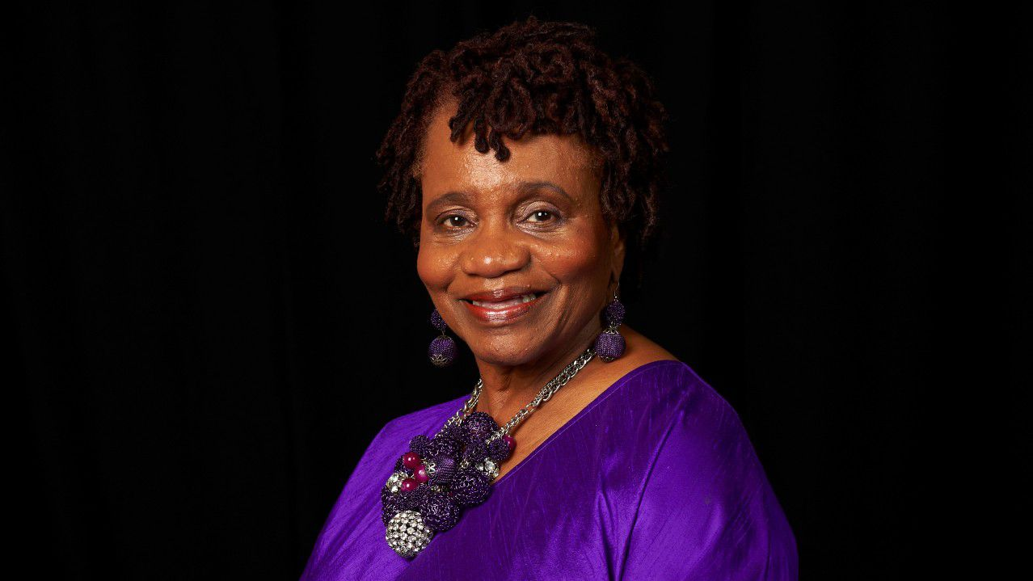

"The Forsyth County Board of Commissioners and the Forsyth County Public Library Board of Trustees dedicated Central Library as the Sylvia Y. Sprinkle-Hamlin Building...Sprinkle-Hamlin served as the director of the Forsyth County Public Library system from 2000-2019. She was the first African American and first woman to serve in that role...She served as the chair of the board of the N.C. Black Repertory Company and the executive producer of the National Black Theatre Festival."
--Forsyth County North Carolina
Be inspired by a librarian for the ages, who was a shining star in supporting the arts:
"The American Library Association (ALA), on behalf of its members: 1. eulogizes the memory of Sylvia Sprinkle-Hamlin by trying to bring into our own lives the exuberance combined with kindness, sustained commitment, vision, and purpose that made her life a pattern worthy of our emulation, and that we earnestly try to live as purposely and unselfishly as did Sylvia Sprinkle-Hamlin; and 2. expresses, along with members of the Black Caucus of the American Library Association, its sincere sympathy to the family of Sylvia Sprinkle Hamlin, that we place a copy of this resolution in the permanent archives of the American Library Association, and that we also send a copy of this resolution to the members of Sylvia Sprinkle-Hamlin's family in order to show her loved ones the high esteem in which we hold her life and her memory.
--ALA Memorial Resolution -2022

"Sylvia is a stalwart African American Woman with a pure heart and a voracious representative of the arts and art Justice. She almost single handedly revitalized the Library system statewide. History will remember and celebrate her vital foot print. A truly Marvtastic Icon, a womb to the North Carolina Black Repertory Company."
-Nathan Ross Freeman -Tribute Wall

"The late Mrs. Sylvia Sprinkle-Hamlin will live on in the memories of everyone who has been blessed by her kind and generous heart, and spirit. "
--Herman Jones--Tribute Wall

Mrs. Sylvia Yvonne Sprinkle Hamlin was born on April 25, 1945 in Forsyth County and departed this earthly life on Monday, January 3, 2022.
Upon graduating from Carver High School in 1963, she attended Winston-Salem State University where she received a B.S. degree in Education. After teaching in the public schools for a brief while, Sylvia furthered her education at Clark Atlanta University where she earned an M. S. degree in Library Science and later on, a Certificate of Advanced Study in Educational Administration at Cheyney State University in Pennsylvania.
After working in the library system in Pennsylvania for a few years, Sylvia returned to her alma mater, Winston-Salem State University where she was employed in the C. G. O’Kelly Library.

In 1979, she was hired as head of Children’s Outreach at the Forsyth County Central Public Library. and ultimately became the director of the entire Forsyth County Public Library system, the first woman and the first African American to serve in that position.
Under her leadership, new programs were established at all of the library branches, including advanced technology made available for the attendees, computer learning centers, bilingual story times, On the Same Poem community read, a Teen Central department, E-readers that were loaned to library customers, the opening of the new Central Library in 2017, the Paddison Memorial Kernersville Branch Library in 2018, and the groundbreaking for the new Clemmons Branch Library in 2018, and so much more.
Professional Associations
Along with her success as a library director came her professional involvement in organizations at the local level and beyond. Some of her accomplishments include:
- President of the Black Caucus of the American Library Association and Chair of the National Planning Conference for the Black Caucus of American Library Association.
- Director of the North Carolina Library Association and Chair, Roundtable for Ethnic Minority Concerns of the North Carolina Library Association.
- Chair of the E. J. Josey Scholarship Committee;
- She was the first African American member on the Board of Forsyth County Employees Credit Union

Awards and Honors
Because of her substantial involvement in the library profession and the community, Sylvia was the recipient of several awards. These include:
- Library Director of the Year Award by the North Carolina Public Library Directors Association.
- DEMCO Award for Excellence in Librarianship.
- Annette Lewis Phinazee Award.
- Winston-Salem Chamber of Commerce Duke Energy Community Achievement Award,
- Honoree in the North Carolina Heritage Calendar by the Governor of North Carolina for her contributions to the African American Experience in North Carolina.
- Arts Council of Winston-Salem/Forsyth County Volunteer of the Year Award,
- The Winston-Salem Chronicle Woman of the Year Award.
- Gateway YWCA's Legacy Award

Church and Community
At a young age, Sylvia joined Center Grove AME Zion Church in Tobaccoville. Later on, she became a member of St. Stephens Episcopal church where she served on the vestry and was a part of other ministries at the church as well.
In the community, Sylvia was an active volunteer in several organizations. These include:
- Shepherd Center of Greater Winston-Salem,
- Women’s Fund,
- the Up-and-Coming Investment Club,
- President of Forsyth Early Childhood Partnership,
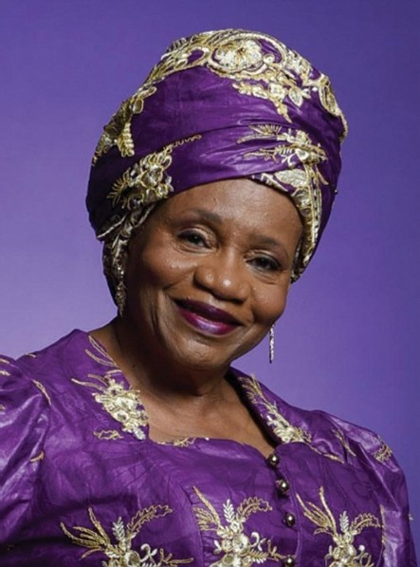
She was President, Board of Directors of the North Carolina Black Repertory Company, and the executive producer of the National Black Theatre Festival, the largest event in the history of Black theatre in the world. Sprinkle-Hamlin stepped into her leadership roles within the N.C. Black Repertory Company immediately following the 2007 death of her husband, Larry Leon Hamlin who founded the company and produced its first festival in 1989.
In essence, Sylvia Sprinkle Hamlin was indeed a phenomenal woman.

Sources

Sylvia Sprinkle-Hamlin .pdf American Library Association Council. January 24, 2022.
WSSU Mourns Sylvia Sprinkle-Hamlin, Who Made a Lasting Impression On City's Arts, Educational Landscape - HBCU Buzz
Remembering the life and recognizing the legacy of Sylvia Sprinkle-Hamlin | Music | yesweekly.com
Sylvia Sprinkle-Hamlin's Biography The HistoryMakers. February 2012.
Mrs. Sylvia Sprinkle- Hamlin Obituary - Visitation & Funeral Information

--Submitted by Wanda Kay Brown

