Louis Shores - 1904 – 1981

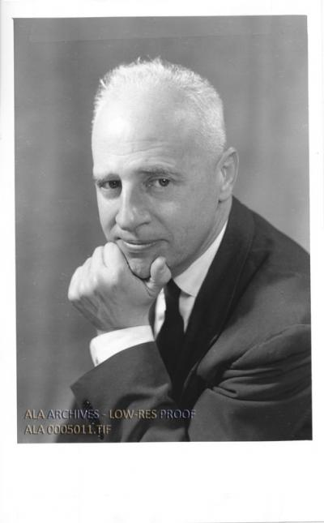

Louis Shores was a founder of the Library History Round Table. In 1961 he wrote the essay, “The Importance of Library History.”
Dr. Shores was recognized by American Libraries as one of the “100 Most Important Leaders” of twentieth-century librarianship.

Louis Shores graduated from high school in Toledo, Ohio, in 1922. He earned his bachelor’s degree from the University of Toledo in 1926, then moved with his family to New York City and completed a master’s degree in education at the City College of New York.
In 1927 he entered the Columbia University School of Library Service to begin formal training in librarianship. Although he spent a brief period at the University of Chicago’s Graduate Library School, he ultimately earned his Ph.D. in Education from George Peabody College for Teachers in 1933. His doctoral dissertation examined the origins of the American college library from 1630 to 1800 and was later published as Origins of the American College Library in 1935.
Shores built a career that combined practical library administration with leadership in library education. As a teenager he worked as a page at the Toledo Public Library, and in the early 1920s he held a position in the University of Toledo library.
From 1928 to 1933 he served as librarian at Fisk University in Nashville, Tennessee. In 1933 he returned to George Peabody College to establish and direct its library training program.
During World War II Dr. Shores served in the U.S. Army from 1943 to 1946 in the Army Airways Communications System (AACS), responsible for global air traffic control, communications, navigation aids, and weather services supporting long-range transport and supply missions.
In 1946 he accepted the position of founding dean of the Library School at Florida State University, a role he held until his retirement in 1967. He was honored with the Beta Phi Mu Award in 1967.

Dr. Shores also served as an editorial advisor to P.F. Collier & Son, helping shape major reference works such as Collier’s Encyclopedia.
In 1947, together with Wayne Shirley, Dr. Shores co-founded the American Library Association’s Library History Round Table, an organization that helped establish the serious study of library history.
Shores’ most lasting contribution was his vision of the library as a “materials center” where books, films, recordings, slides, and other media were treated as equally important resources. At Florida State University he created one of the nation’s first integrated collections of audiovisual and print materials and introduced innovations such as color-coded catalogs and listening stations. He developed the concept of the “generic book,” arguing that knowledge could be conveyed through any medium and that libraries must embrace them all.
Dr. Shores received numerous honors, among them recognition by American Libraries as one of the “100 Most Important Leaders” of twentieth-century librarianship and the naming of the Louis Shores Building at Florida State University.
Shores’ philosophy—that libraries are superior to traditional classrooms for independent, lifelong learning—remains alive in every public and academic library that combines print and digital resources under the guidance of information professionals.

Selected Publications

Shores, Louis. The Generic Book: What It Is and How It Works. Library-College Associates, 1977.
Shores, Louis. Quiet World: A Librarian’s Crusade for Destiny—The Professional Autobiography of Louis Shores. Linnet Books, 1975.
Shores, Louis. Audiovisual Librarianship: The Crusade for Media Unity (1946–1969). Libraries Unlimited, 1973.
Shores, Louis. Library Education. Libraries Unlimited, 1972.
Shores, Louis. Looking Forward to 1999. South Pass Press, 1972.
Shores, Louis. Mark Hopkins’ Log and Other Essays by Louis Shores. Selected by John D. Marshall, Shoe String Press, 1965.
Shores, Louis. Shores, Louis. “The Importance of Library History.” In An American Library History Reader: Contributions to Library Literature, compiled by John David Marshall. Hamden, Conn.: Shoe String Press, 1961.

Shores, Louis. Instructional Materials: An Introduction for Teachers. Ronald, 1960.
Shores, Louis. Basic Reference Sources: An Introduction to Materials and Methods. American Library Association, 1954. Reprint, Libraries Unlimited, 1973.
Shores, Louis. Basic Reference Sources: An Introduction to Materials and Methods. American Library Assn., 1954.
Shores, Louis. A Profession of Faith. State University Teachers College, 1953.
Shores, Louis. Challenges to Librarianship. Florida State University, 1953.
Shores, Louis. Highways in the Sky: The Story of the AACS. Barnes & Noble, 1947.
Shores, Louis. Basic Reference Books: An Introduction to the Evaluation, Study, and Use of Reference Materials with Special Emphasis on Some 300 Titles. American Library Association, 1939.
Shores, Louis. Know Your Encyclopedia: A Unit of Library Instruction Based on Compton’s Pictured Encyclopedia. F. E. Compton & Co., 1937.
Shores, Louis. Origins of the American College Library, 1638–1800. Barnes & Noble, 1935.

Sources

Kniffel, L., Sullivan, P. & McCormick, E. (1999, December). 100 of the most important leaders we had in the 20th century. American Libraries 30, 11. p 38.
Marshall, John David. 2000. “The Library History Round Table’s First Twenty-Five Years: Reminiscences and Remarks.” Libraries & Culture 35 (1): 41.
Martin, R. S., & Shiflett, L. (1996). Hampton, Fisk, and Atlanta: the foundations, the American Library Association, and library education for blacks, 1925-1941. Libraries & Culture, 31, 299–325.
Shifflett, Lee. (1996) Louis Shores: Defining Educational Librarianship. Lanham, MD: Scarecrow Press.
Shiflett, L. (2000). Louis Shores and library history. Libraries & Culture, 35(1), 35–40.
Shiflett, L. (2000). Sense-making and library history. Journal of Education for Library & Information Science, 41(3), 254–259.

Submitted by Kathleen de la Peña McCook

