Frances Clarke Sayers - 1897-1989

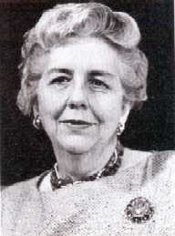

Frances Clarke Sayers children's librarian, author of children’s books and lecturer on children’s literature was named by American Libraries as one of the “100 Most Important Leaders We Had in the 20th Century.”
She attended the University of Texas at Austin, but after spending two years there she left in order to attend the Carnegie Library School in Pittsburgh because that university was "noted for its devoted staff and belief in taking books to children wherever they were." After graduation, she began her career in librarianship when Anne Carroll Moore, Superintendent of the Department of Work with Children at the New York Public Library, invited her to come to work there which she did from 1918-1923.
In 1923, after five years with the NYPL, Frances Clarke decided to move to California to be closer to her family. There she wed Alfred H.P. Sayers. The couple moved to Chicago where Alfred Sayers owned a bookstore. In Chicago, Sayers helped her husband run his bookstore and worked part-time as an editorial assistant for the American Library Association. Unfortunately, the Great Depression caused a lack of business for the Sayers's bookstore and they decided to move back to California.
Shortly after relocating, Sayers joined the California Library Association where she met Sydney Mitchell, Dean of the Berkeley library school. Mitchell approached Sayers with the proposition that she lead a three day institute on children's librarianship for librarians from Northern California. Pleased with the results, the next year Mitchell invited Sayers to give a course on children's librarianship at the Berkeley library school. For seven years (1934-1941) she lectured at Berkeley and worked on other special projects with Mitchell, including a correspondence course for children's librarians and a national institute on children's work held at Berkeley in 1939.
Soon Sayers began to write children's books that would delight and enchant children, as well as adults, throughout the years. Her books were often semi-autobiographical, often bringing back the sights, smells, and sounds of her childhood in Texas.

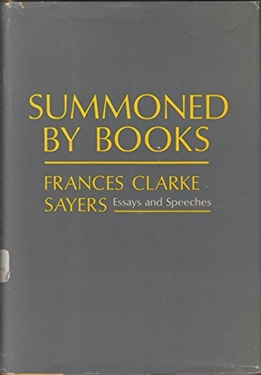
“Summoned by Books,” one of her most famous essays, was first delivered at the California Library Association conference in 1962.
She spoke on the issue that librarians need to make themselves known and appreciated and to do that, they need to appreciate themselves. Sayers told the audience that not only are they responsible for helping patrons find the information they want, but that as librarians, they are responsible for sharing with patrons the same love and appreciation they feel for books as well. She stated that, "…as librarians we are not only summoned by books ourselves, but we are the instrumentation for the summoning of others."[

In 1941, Sayers moved back to New York to replace Anne Carroll Moore at the New York Public Library as Superintendent of the Department of Work with Children. While Superintendent Sayers also "taught a course in writing for children at the New School for Social Research and served as a consultant to the Library of Congress for the reorganization of its Children's Book Collection. She retired from NYPL in 1952.
Impressed by Sayers’ growing renown as an author and storyteller, Leora Lewis, the library representative for Compton 's Pictured Encyclopedia, invited her to undertake a one year lecture tour to promote children's literature and reading to audiences of parents and teachers. Having no career plans following her resignation from NYPL, Sayers accepted this unique and unexpected offer She traveled to more than two dozen states.
On returning to Los Angeles, she worked as school librarian at the Corinne Seeds University Elementary School on the UCLA campus. Sayers was offered a part-time lecturership in the UCLA English department. In 1954 she launched her remarkable children's literature course that inspired hundreds of undergraduate students--including a few who found their way to the UCLA School of Library Service when it opened in 1960.
As the new school was being planned, its founding dean, Lawrence Clark Powell asked Sayers to prepare a curriculum on library work with children. She designed and taught these courses and was a founding faculty member of UCLA’s School of Library Service until 1965, when she retired.
Sayers had a profound influence on the status and role of children’s library services, particularly the evaluation and use of children’s literature. She developed collaborative relationships with celebrated editors, authors, and illustrators and was a frequent contributor to the Horn Book and other review journals.
Sayers’ impact at the national level was evidenced by her successful proposal (ca. 1942) for a dedicated Children’s Room in the Library of Congress.

Selected Publications

Sayers, Frances Clarke. Anne Carroll Moore: A Biography. New York: Atheneum, 1972.
Sayers, Frances Clarke, and Gunnar Anderson. Oscar Lincoln Busby Stokes. New York: Harcourt, Brace & World, 1970.
Sayers, Frances Clarke, and Evelyn Sickels, eds. Anthology of Children's Literature. 4th ed. Boston: Houghton Mifflin, 1970.
Sayers, Frances Clarke. Introduction to Grimm's Fairy Tales, by Jakob Grimm. New York: Follett, 1968.
Sayers, Frances Clarke (Summer 1963). "The American Origins of Public Library Work with Children". Library Trends. 12 (1): 6–13.
Sayers, Frances Clarke, and Marjeanne Jensen Blinn. Summoned by Books: Essays and Speeches by Frances Clarke Sayers. New York: Viking Press, 1965.
Sayers, Frances Clarke. Foreword to From Two to Five, by Kornei Chukovskii. Brisbane: Jacaranda, 1963.
Sayers, Frances Clarke. Ginny and Custard. New York: Viking Press, 1951.
Sayers, Frances Clarke. Sally Tait. New York: Viking Press, 1951.
Sayers, Frances Clarke, and Helen Sewell. Tag-Along Tooloo. New York: The Viking Press, 1941
Sayers, Frances Clarke. Mr. Tidy Paws. New York: Viking Press, 1935.

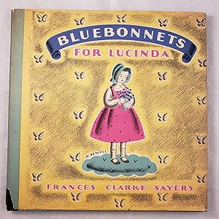
Sayers, Frances Clarke, and Helen Sewell. Bluebonnets for Lucinda. New York: Viking, 1934.

Sources

California Library Hall of Fame. Frances Clarke Sayers (1897-1989)
Grotzinger, Laurel A. (2003). "Frances Clarke Sayers". In Marilyn Lea Miller (ed.). Pioneers and Leaders in Library Services to Youth: A Biographical Dictionary. Libraries Unlimited. pp. 215–18.
Kniffel, Leonard, Peggy Sullivan, Edith McCormick, "100 of the Most Important Leaders We Had in the 20th Century," American Libraries 30, no. 11 (December 1999).
Maack, Mary Niles. “Frances Clarke Sayers (1897–1989).” In Dictionary of American Library Biography, Second Supplement, edited by Donald G. Davis, Jr., 192–96. Westport, CT: Libraries Unlimited, 2003.
Sayers, Frances Clarke. "Small Felicities of Life.' Oral History Transcript, UCLA Oral History Program, 1987.
Wedgeworth, R. "Sayers, Frances Clarke". In ALA world encyclopedia of library and information services. 2nd ed. 1986
Frances Clarke Sayers. Wikipedia.

Submitted by Kathleen de la Peña McCook

