Charles W. Robinson – 1928-2016

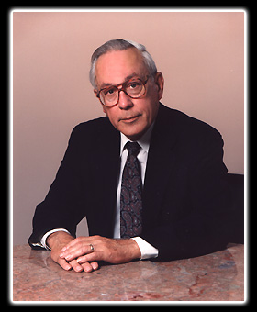

“Mr. Robinson's theory of “Give ’em what they want” revolutionized the library world by focusing on popular titles that customers desired to read. His leadership at Baltimore County Public Library from 1963 to 1996 was instrumental in moving the library service to the forefront of public service in the nation. He is recognized as one of the most influential librarians of the 20th century, and his innovative approach to library management has left a lasting impact on the field.”
–-Foundation for Baltimore County Public Library. April 10, 2016.

“Charles, known to many as Charlie, was a public librarian, a visionary, a curmudgeon, a leader, and a mentor.”
-- A Memorial Resolution Honoring Charles Weld Robinson. American Library Association Council and Maryland Library Association, June 28, 2016

Charles Weld Robinson was born in Peking, China, in 1928, where his father was a medical missionary. He attended Colby College where he majored in history, government and economics. After graduation, he entered Simmons College, School of Library Science, graduating with a Master of Library Science degree in August 1951.
Mr. Robinson then served as a sergeant with the 2nd Infantry Division in Korea, where he was in charge of battle casualty reporting and awards and decorations for the 38th Infantry Regiment.

Charlie began his professional library career at the Free Library of Philadelphia as the administrative assistant to Emerson Greenaway.
He joined the staff at Baltimore County Public Library (BCPL) as assistant county librarian in 1959; and was named director by the Board of Library Trustees in 1963. Thus began a 33-year era of innovative, progressive and inspired leadership that moved Baltimore County Public Library to the forefront of public library service in the nation. He oversaw the openings of nine branches, as well as several mini libraries. Mr. Robinson forever changed the library world with his revolutionary (and controversial at the time) theory of “Give ’em what they want,” focusing on more popular titles that customers wanted to read. He is considered one of the most influential librarians of the 20th century.
Charlie forever changed the library world with his revolutionary theory of “Give ‘Em What They Want” focusing on the popular materials that customers want and customer-centered library service.
He shared his way of thinking with his staff, growing a generation of library leaders, he was then encouraging as they left to share his vision as library administrators all over the country.

He served as:
- President of the Public Library Association (PLA)
- Council of American Library Association,
He received the Maryland Library Association Outstanding Member Award and was awarded honorary membership in the Maryland Library Association.
Charlie had a major role in the development of several American Library Association/Public Library Association publications considered vital to the management of public libraries.
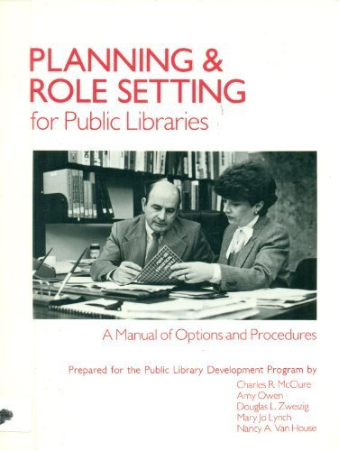

- Output Measures for Public Libraries
- Planning and Role Setting for Public Libraries
- The Public Library Data Service Statistical Report.

Upon his retirement the Public Library Association, with funding from the Baker & Taylor Company, Inc., established the Charles W. Robinson Award given annually to an outstanding practitioner in the library field who has demonstrated innovative and responsive leadership resulting in the improvement of public library service.
After Charlie’s retirement in 1996, he edited the Library Administrator’s Digest until November, 2015 when his health forced him to step down.

Sources

John N. Berry. “Charles W. Robinson, Baltimore Library Head and PLA Leader.” Library Journal. Apr 12, 2016 .
A Memorial Resolution Honoring Charles Weld Robinson, 2015-2016 ALA Memorial #15_62416
Robinson, Charles W. | American Libraries Magazine
In Memory of Charles Robinson - Foundation for Baltimore County Public Library
Early Word, “Charles W. Robinson, Keeping the Public in Public Libraries”

Submitted by Kathleen de la Peña McCook

