John B. Richard (1932- 2025)

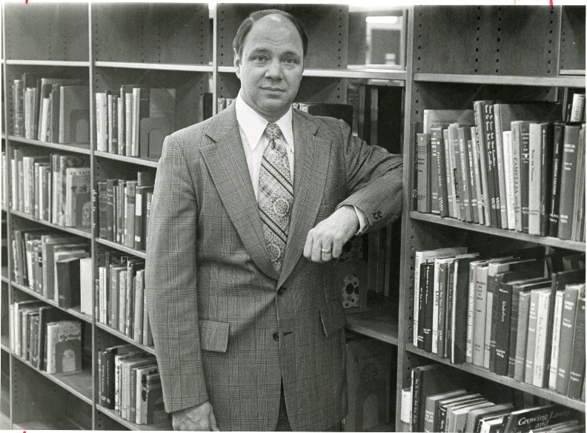

Colleagues remember him for his generosity of spirit and willingness to lend a hand wherever needed. Whether directing bounce house traffic at the summer reading party, delighting children in the summer puppet show as “The Blatch,” or joining staff in Circulation to help manually check out hundreds of books during the busiest summer days, Mr. Richard never hesitated to serve alongside his team. He had a wonderful sense of humor, even approving a Jazz Funeral to celebrate the retirement of the old card catalog as the Library moved online
—East Baton Rouge Parish Library

John Benard Richard, retired Director of the East Baton Rouge Parish Library System, died on Sunday, August 31, 2025. He was born November 2, 1932, in Gulfport, Mississippi to John Jesse Richard and Helen Schott Richard.
He graduated as valedictorian from Woolmarket High School in 1950. He graduated from Perkinston Junior College in 1952 and received a B.S. from Mississippi Southern College in 1954.
John Richard served three years in the U.S. Army Security Agency, mostly in Europe from 1954-1957.

He earned a M. S. from Louisiana State University, Graduate School of Library and Information Science in 1960.
His library career began in the seventh grade as a library page, and he continued working in libraries throughout his college career. He worked in the Humanities Division and the Preparations Department at Louisiana State University-Baton Rouge until he was selected to start a library at the newly legislated LSU-Alexandria in 1960, where he remained for 16 years.
His leadership and organizational skills were used to select staff, plan the library building, develop the library collection as well as teach Books and Libraries. He also taught library administration and library reference sources in the LSU Graduate School of Library and Information Science.

In 1977, he became the third director of the East Baton Rouge Parish Library System, where he remained until his retirement in 2003.
Standing at 6’6”, Mr. Richard was affectionately known as “The Tall Man.” He was not only a gifted storyteller but also a thoughtful and strategic planner. During his tenure, the Library flourished.
With the Library Board of Control, he was responsible for encouraging the citizens of East Baton Rouge Parish to vote for the first dedicated millage for the support of the library system. The continued passage of this tax, built new buildings, programs, and technologies to make the East Baton Rouge Parish Library one of the premier public library systems in the country. This crucial milestone allowed the Library to rehire staff, expand hours and services, implement automation, and launch a carefully crafted Capital Improvements Plan—all under a Pay-As-You-Go model.
John Richard championed new initiatives, including the Author-Illustrator Program and the Prime Time-Family Reading Time program. A passionate supporter of the arts and culture, he established the Library’s circulating art and music collections, making these resources accessible to the community.
He served as President of the Louisiana Library Association.
He was a delegate to the first White House Conference on Libraries.
Mr. Richard was, for many years, one of the official reviewers for the Library Journal Annual Reference Book Review issue.
Mr. Richard left behind a legacy of vision, service, and dedication that continues to shape the East Baton Rouge Parish Library today. He is deeply missed by colleagues, friends, and the countless community members whose lives were enriched by his leadership.
A lifelong Catholic, John was a longtime member of St. George Catholic Church, where he served on several committees throughout the years.

Awards
Louisiana Library Association Essae M. Culver Distinguished Service Award—its highest honor.,
Outstanding Alumnus of the Year from the LSU Board of Library and Information Science.
Louis Shores-Onyx Press Award for Excellence in Reviewing Reference Books and other Library Materials.
Alexandria Daily Town Talk’s Noteworthy Achievement Award for the Central Louisiana Area.

Sources

East Baton Rouge Parish Library's Post at Facebook, September 3, 2025.
John B. Richard Obituary August 31, 2025 - Resthaven Gardens of Memory & Funeral Home

