Mildred Ramga
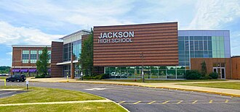
Mildred Ramga was my Mother. She began her teaching career in a 1 room school after attending Ohio Northern Normal School. She eventually went back and finished her degree. She earned her library degree from Kent State in 1952, I think. (I was very young.) She was librarian at Jackson Memorial High School in Massillon, Ohio, and retired in 1968 as an English teacher in that school system.

Obituary:
https://www.tampabay.com/archive/1994/08/20/pinellas-obituaries/

