Librarians We Have Lost- Sesquicentennial Memories - 1976-2026: David Oberhelman
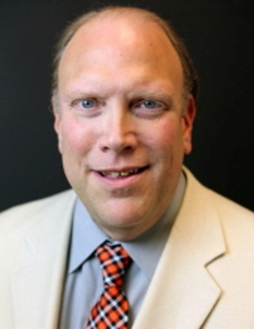
Tribute 1
David Oberhelman, a librarian at Oklahoma State University Libraries from 1999 to 2018, passed away in 2018. He was a deeply kind man and made many contributions to ACRL, especially the ACRL Literatures in English section. He is greatly missed by those who worked with him.
To learn more, https://news.okstate.edu/articles/library/2018/remembering-david-oberhelman.html
--Submitted by Arianne Hartsell-Gundy
Tribute 2
David was more than a colleague but a true friend. We shared the love of good reference work and book hunting. His ability to have compassion for students was something all to emulate. The service extended to ALA and the Oklahoma Library Association as well. These organizations benefited from his hard work and personable spirit. It is fitting that I last saw David in Chicago at ALA and this past week I will be making a return trip to ALA in 2026. I miss him.
--Submitted by Jacob Sherman
Obituary:
https://www.dightonmarler.com/obituaries/david-dean-oberhelman#:~:text=David%20was%20an%20active%20member,Oklahoma%20State%20University%20and%20elsewhere.
The obituary author notes that he produced “over 100 scholarly publications and numerous professional presentations.”

