Ralph Munn 1894 –1975

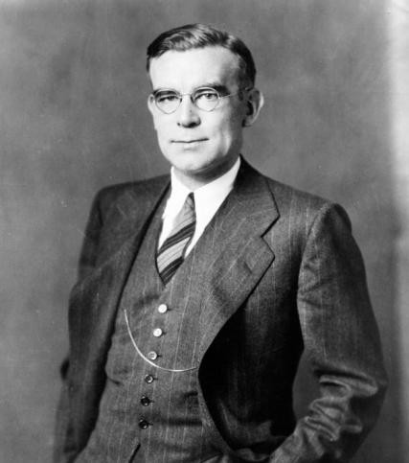

Ralph W. Munn (September 19, 1894 – January 2, 1975) was an eminent figure in the field of American and international library and information science. Recognized by the journal American Libraries as one of "100 of the most important leaders we had in the 20th century", and described as an "administrator, educator, and author ... known for his fairness, clarity, and grace", he was also widely known within the profession as "the father of the modern library movement in Australia and New Zealand".

Munn was born in Aurora, Illinois and raised in Colorado. He attended Ohio State University Moritz College of Law from 1912 to 1913 and transferred to the University of Denver where he received both his Bachelor of Law degree from Sturm College of Law in 1915 and Bachelor of Arts degrees in 1917.
Munn served in the United States Army from April 1917 to July 1919 in the 30th Ambulance Company. He served in the headquarters of the 88th Infantry Division of the American Expeditionary Forces from August 1918 to July 1919 and served in Sorbonne, Paris from February to July 1919, He became a master hospital sergeant.
After military service, Munn earned the Bachelor of Library Science degree from New York State Library School at Albany in 1921

Library Career
Munn worked as a librarian at the Seattle Public Library in Washington state and later at the Flint Public Library in Michigan.

He was Director of the Carnegie Library of Pittsburgh, from 1928 to 1964, during which time he also served as Director, then Dean, of the Carnegie Library School of Carnegie Institute of Technology.
Highlights of Munn's contributions to librarianship during his tenure as Director of the Carnegie Library of Pittsburgh can be summarized as the perpetration of the idea of the public library as "educational, informational, and cultural", the expansion and unification of library services, and his influence in establishing an American-modeled library system and professional librarianship
Australia and New Zealand.
Munn's view of the library as "educational, informational, and cultural" sparked" controversy. His preference for a high-quality collection over popularly requested materials led to a "revised book selection policy” that sharply defined and limited the purchase of 'light, recreational fiction' and effectively eliminated the acquisition of books that he categorized as 'shopping bag fiction'."
He was also lauded for his role in the 1956 merger of the Carnegie Free Library of Allegheny and the Carnegie Library of Pittsburgh.
In recognition of his authorship and outreach and development of services directed at young people, the annual "Ralph Munn Creative Writing Contest" was established in his name at the Carnegie Library of Pittsburgh.
Australia and New Zealand
In 1934, Munn was commissioned by the Carnegie Corporation of New York to conduct a survey of public libraries in Australia and New Zealand, which he did in conjunction with Ernest Pitt, then Chief Librarian of the Public Library of Victoria. The resulting Munn-Pitt Report had a major impact in Australia. In an article published in the Australian Library Journal evaluating the survey's impact, the author states that "the key recommendations of the Munn-Pitt report were easily identified by its lay readers: 1. to establish tax-supported municipal 'free libraries'; and 2. to strengthen and extend librarianship by professionalizing the training and registration of librarians."
Honors and accomplishments
American Library Association President, 1939–40 Pennsylvania Library Association President, 1930–31
Honorary Degree of Doctor of Laws, 1940, University of Pittsburgh
Distinguished Service Award, 1959, Pennsylvania Library Association
Honorary Degree of Doctor of Laws, 1960, Waynesburg College in Pennsylvania Director Emeritus, 1964, Carnegie Library of Pittsburgh

Selected Publications
Munn served on The Library Quarterly Board of Editors/Advisory Board during the 1930s–1950s and was a frequent book reviewer for the journal during this period.

Munn, Ralph. “Libraries for Allegheny County.” Carnegie Magazine 32 (October 1958): 263–264. (Companion or related: A Plan for the Federation of Libraries in Allegheny County. Pittsburgh: [Carnegie Library of Pittsburgh?], ca. 1958.)

Munn, Ralph. [1954 essay on library staffing and specialization]. Professional journal article, 1954. Essay discusses the need for specialized expertise in “personnel management, public relations,
audio-visual materials and equipment, adult education, and the public school curriculum” in large libraries, marking a shift from his earlier views on librarian training.)
Munn, Ralph. “It Is a Mistake to Recruit Men.” Library Journal 74 (November 1, 1949): 1639–1640. (Later reprinted, e.g., Library Journal 118, 1993 supplement.)
Githens, Alfred Morton, and Ralph Munn. Program for the Public Libraries of New York City. Prepared under the direction of Lawrence M. Orton for the New York City Planning Commission. New York: City Planning Commission, 1945.

Munn, Ralph. “Fact versus Folklore.” American Library Association Bulletin 34 (June 1940): 380–384, 422.(Presidential address to the ALA.)
Munn, Ralph. Conditions and Trends in Education for Librarianship. New York: Carnegie Corporation of New York, 1936.
Munn, Ralph, and Ernest Roland Pitt. Australian Libraries: A Survey of Conditions and Suggestions for Their Improvement. Melbourne: Australian Council for Educational Research, 1935.
(The influential “Munn-Pitt Report”; a companion survey, New Zealand Libraries: A Survey of Conditions and Suggestions for Their Improvement, is also attributed to Munn around the same period.)
Joeckel, Carleton B., Ralph Munn, C. C. Williamson, and Louis R. Wilson. “Proposals Submitted to the American Library Association for a Program of Library Education.” The Library Quarterly 3, no. 4 (October 1933): 390–407. https://www.jstor.org/stable/4302013.

Sources
Amey, Larry (2001). "When Libraries Made History". The Australian Library Journal. 50 (3): 229–
234. doi:10.1080/00049670.2001.10755958
Doms, Keith (1993). "Munn, Ralph". In Wedgeworth, Robert (ed.). World Encyclopedia of Library and Information Services (Third ed.). ALA Editions. pp. 595–6. ISBN 978-0-8389-0609-5.
Kniffel, Leonard; Sullivan, Peggy; McCormick, Edith (1999). "100 of the most important leaders we had in the 20th century". American Libraries. 30: 38–47.
Wikipedia. Ralph Munn.

Submitted by Kathleen de la Peña McCook

