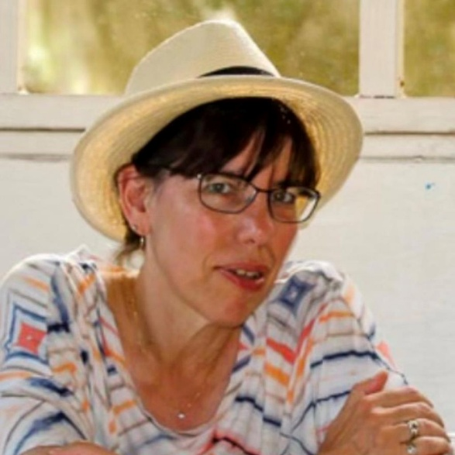
Linda R. Most - 1956-2024

Dr. Linda R. Most was professor at Valdosta State University. Department of Library and Information Studies in Valdosta, Georgia.
She completed her undergraduate studies at Goucher College, where her passion for education and the arts was nurtured.
She earned the PhD from Florida State University, where her scholarly work set the foundation for her influential career.
Her professional life was equally distinguished, as she was deeply involved in numerous cultural and educational organizations. She was a proud member of the American Library Association, where she contributed to the advancement of library services and literacy.
Her commitment to the field of library science extended to her involvement with the Association for Library and Information Science Education, where she engaged with fellow professionals to further the growth of the discipline.
Dr. Most also served as a board member of the South Georgia Regional Library, where she helped steer the library’s strategic direction and community outreach.
She was an active participant in the Valdosta Symphony Guild, working to promote the arts and support local musical endeavors.
She was a passionate advocate for birds and environmental conservation, dedicating much of her time to supporting initiatives that protected wildlife.

Through her multifaceted involvement in libraries, the arts, and wildlife advocacy, Linda made a lasting impact on both her local community and the broader academic world.

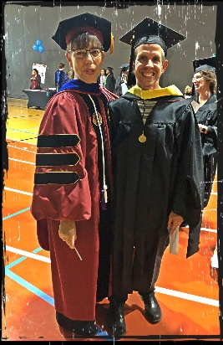

Selected Publications

Most, L. R., Kazmer, M. M., & Marty, P. F. (2013). Intangible Factors Influencing the Successful Completion of Graduate LIS Coursework by Non-traditional Students: A Case of Two IMLS-funded Scholarship Projects. Journal of Education for Library & Information Science, 54(3), 205–219.

Most, Linda R. 2013. “Modeling the Public Library as Place.” Proceedings of the Annual Conference of CAIS / Actes Du Congrès Annuel de l’ACSI. https://doi.org/10.29173/cais584.

Most, L. R. (2011). Hands on from a Distance: The Community-Embedded Learning Model Contextualizes Online Student Coursework. Journal of Education for Library & Information Science, 52(4), 295–304.

Most, Linda R. 2011. “The Rural Public Library as Place: A Theoretical Analysis.” In Advances in Library Administration and Organization, 51–149. https://doi.org/10.1108/S0732-0671(2011)0000030005.

Most, L. R. (2011). Second group of LBC scholars begin classes in Valdosta. Georgia Library Quarterly, 48(2), 19.

Most, Linda R. 2009. “The Rural Public Library as Place in North Florida : A Case Study.” Dissertation. Florida State University.

Sources

Remembering Dr. Linda Most - Georgia Library Quarterly -Compiled by Emily Rogers- GLQ > Vol. 62 > Iss. 2 (2025)

This article collects tributes to the late Dr. Linda Most, who passed away in November 2024. Dr. Most was professor and the former director of the Valdosta State University (VSU) MLIS program, longtime chair of the Georgia State Board for the Certification of Librarians, and a trustee for the South Georgia Regional Library.

Linda Rachel Most Obituary November 19, 2024 - Music Funeral Services

Submitted by Kathleen de la Peña McCook

