Francis Miksa Jr.
09/24/1938 – 03/20/2019
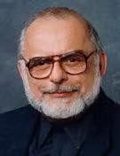
Dr. Francis (Fran) Miksa Jr. (1938-2019) was a key scholar in information access. Born in
Illinois to parents who emigrated from Poland, he grew up and graduated in 1956 from East High
School and 1960 from Wheaton College. He later obtained a D.B. From Bethel Theological Seminary in Minnesota in 1965 and a Ph.D. from the University of Chicago Graduate Library School in 1974.
An active faculty member, while at Louisiana State University from 1972-1984, he helped bring computerization to the school and served as Acting Assistant Dean and Acting Dean. He later joined the faculty at the University of Texas at Austin Graduate School of Library and Information Science - now known as the School of Information (iSchool) - in 1984, where he spent the majority of his career. His work there included serving as Coordinator of Doctoral Studies, Acting Dean, and he is credited with helping revive the Ph.D. program. He also served as Visiting Distinguished Scholar in the Office of Research at the Online Computer Library Center in Ohio from 1986-1987, where his appointment focused on the implementation of classification and categorization across disciplines as well as the development of classification as a field within Library and Information Science. While at UT Austin, he earned the Excellence in Teaching Award three times, and conducted a phased retirement from 2005 to 2008 as faculty emeritus.
As a scholar, Miksa’s work focused on classification, categorization, document representation, and intellectual access. Several papers of his tracked the development of classification in all sorts of places from the Library of Congress to Research Libraries in general. He was particularly fascinated by the work of Charles Cutter, writing two books on him and his work. His seminal work “Library and Information Science: Two Paradigms” defined the field of Library and Information Science by combining the “Library” and “Information Science” fields. His most cited work, the book The DDC, the Universe of Knowledge, and the Post-Modern Library, tracks the development of the Dewey Decimal System and proposes its role in the “post-modern library.” He was very active in the early days of the digital library movement. He authored several grant initiatives in the field and participated in the creation of the first two national digital library conferences from 1994-1996.
Miksa was active in service as well. At UT Austin, he served two terms on the Graduate
Assembly and served for two years on the University’s Faculty Computer Committee and Multimedia Instruction Committee. He served as a member of the dean search committee in 1989 and chaired it in 1996.
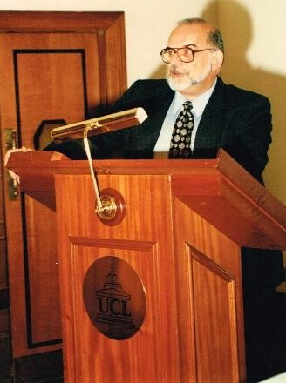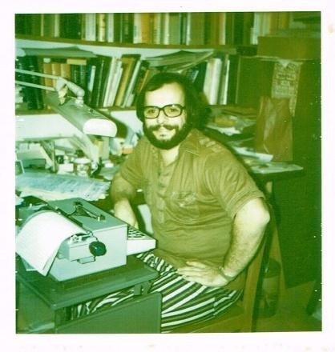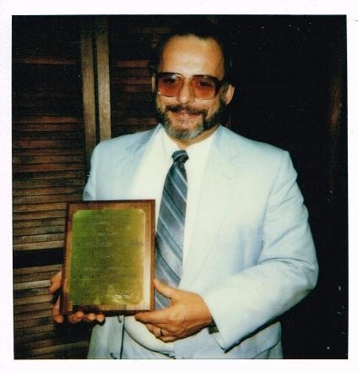

Selected publications include:
Miksa, F. (2012). The Legacy of the Library Catalogue for the Present. Library Trends,
61(1), 7–34. https://dx.doi.org/10.1353/lib.2012.0023
Miksa, F. (2009). Information Organization and the Mysterious Information User. Libraries & the Cultural Record, 44(3), 343-370,375. https://doi.org/10.1353/lac.0.0075
Miksa, F. (1998). The DDC, the Universe of Knowledge, & the Post-Modern Library. Forest Press.
Miksa, F. (1996). The Cultural Legacy of the “Modern Library” for the Future. Journal of Education for Library and Information Science, 37(2), 100–119. https://doi.org/10.2307/40324266
Miksa, F. (1992). Library and Information Science: Two Paradigms. In P. Vakkari and B. Cronin (Eds.), Conceptions of Library and Information Science. Historical, Empirical and Theoretical Perspectives (pp 229-252). Taylor Graham.
Miksa, F. (1989). The future of reference II: A paradigm of academic library organization.
College & Research Libraries News, 50(9), 780a-790. https://doi.org/10.5860/crln.50.9.780a
Miksa, F. (1983). The Subject in the Dictionary Catalog from Cutter to the Present. American Library Association.
In 2009, Miksa was awarded the Association for Library Collections & Technical Services’s Margaret Mann Citation for his research in information storage and organization, cataloging, classification, controlled vocabulary, and digital initiatives. This award included a $2000 scholarship donated to the library school of the winner’s choice - Miksa chose UT Austin’s School of Information as the recipient.
Outside of his career, Miksa had a great love of bowling, where he played on teams in Louisiana and Texas. He also enjoyed woodworking, having built mission-style furniture including bookcases, fireplace mantels, shelving, plant stands, and desks. He frequently generously offered to build things for friends and family and passed his woodworking passion down to his children.
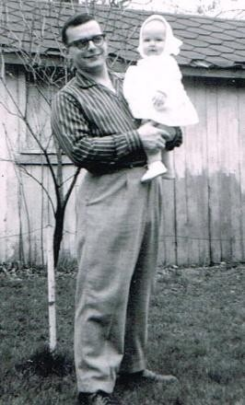

Tribute by Vaughn Haynes, February 2026

