Friar Jovian P. Lang OFM (1919-2009)

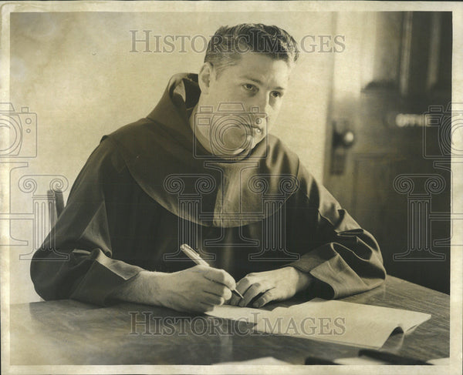

Friar Jovian P. Lang OFM (OFM stands for Order of Friars Minor: Latin: Ordo Fratrum Minorum, which is the official name for the Franciscan friars, a major branch of the Franciscan religious order in the Catholic Church founded by St. Francis of Assisi).

Friar Lang was born June 2, 1919, in Sioux City, Iowa and received the name of Peter. In 1939 he entered the novitiate of the Order of Friars Minor and was given the religious name of "Jovian.”
AB, Our Lady of Angels Seminary, Cleveland, 1942.
After first profession in 1940 and solemn profession of vows on August 23, 1943, he was ordained a priest on June 20, 1946.
He spent his first year of ministry in an internship program based at the Franciscans' Quincy College (now University) in Quincy, Illinois.

He earned the Master of Library Science, Case Western Reserve University, 1950. Master of Arts, Case Western Reserve University, 1955.
His professional expertise was library science. He exercised this expertise at Quincy College (now Quincy University) for 20 years (in two stints).
He then taught at St. Joseph Minor Seminary in Westmont, Illinois, for two years where he was a mentor to Boxer, Sugar Ray Robinson, who said of him-- “And I owe so much to Father Lang (Rev. Jovian Lang of the St., Joseph Seminary in Westmont, Illinois) for his spiritual help.”

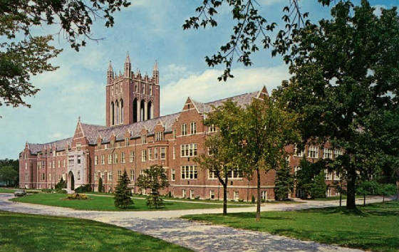

He then taught at the University of South Florida, School of Information as a faculty member for from 1971- 1974.
He was a member of the faculty of the Master of Science (M.S.) program in Library and Information Science at St. John’s University (New York) from 1974-1989.
He was Associate professor St. Vincent de Paul Regional Seminary, Boynton Beach, Florida in 1989 and adjunct professor for University of South Florida-East Coast program. While there he wrote Reference Sources for Small and Medium-Sized Libraries (ALA, 1992).
In 1992 Friar Jovian Lang moved to St. Maximilian Friary in Crowley, Texas, where he began a period of semi-retirement during which he taught library and information science for eight years at the University of North Texas Library Science Master’s Program and the Texas Woman's University School of Library & Information Studies in Denton, Texas.
During most of the years of working in library science either as a professor or as a librarian, he also provided a very valuable service to English-speaking Franciscans in North America. He prepared and edited the Guide for the Liturgy of the Roman-Seraphic Calendar (also called The Ordo) which provides the order, instructions, and options for praying the Liturgy of the Hours.
The personality of Jovian Lang OFM mirrored his ministry. He loved to read and kept a massive library; he once said, "I pick up a book, and all my troubles seem to go away each time I turn the page. To read a good book not only stimulates the mind but also the heart.
He was a very organized person and was a stickler for everything being "right? for praying the Office or celebrating Mass. He enjoyed life and drew people to him like a magnet. The exacting nature he had in earlier years, though, mellowed into greater patience and acceptance as he aged and became more frail.
Friar Jovian moved into full retirement in 2005 when he went to Our Lady of Angels Friary at Villa West in Sherman, Illinois, because of failing health.
Mass of Christian Burial, November 7, 2009
Interment: Calvary Cemetery, Springfield, IL

Publications

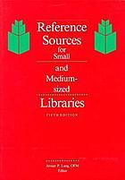

Lang, Jovian, and American Library Association Reference and Adult Services Division Reference Sources Committee. 1992. Reference Sources for Small and Medium-Sized Libraries. 5th ed. Chicago: American Library Association.

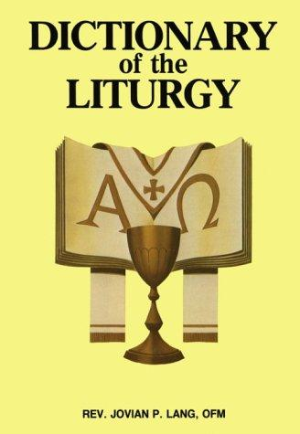

Dictionary Of The Liturgy – Catholic Book Publishing

Dictionary of the Liturgy is truly an encyclopedic work, abounding with clear, accurate explanations of everything connected with Liturgy words, gestures, rites, prayers, themes, service books, sacred vessels, vestments, art, music, and much more. Illustrated throughout, this book includes special charts and tables as well as a unique pronunciation guide.

Sources
On This Day: Sugar Ray Robinson landed the perfect punch | Boxing News
Obituary - Father Jovian Lang, OFM - Catholic Times
Jovian P. Lang - (June 2, 1919 - November 4, 2009).

