Dr. Lucille Cole Thomas – 1921-2019

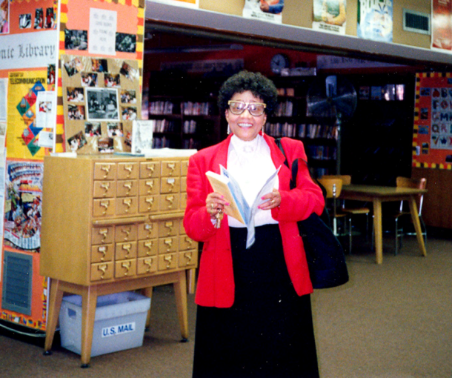

Dr. Lucille Cole Thomas was a pioneering force in American librarianship and broke barriers as the first African American to serve as president of both the New York Library Association and the New York City School Librarians Association.
Dr. Thomas also served as president of the International Association of School Librarianship and the New York Library Club.
Lucille Cole Thomas received a Bachelor of Arts degree from Bennett College, Master of Arts from New York University, and Master of Library Science, Columbia University, serving as President of the library school’s alumni association and received the “Distinguished Alumni Award” in 1986) and was awarded an honorary doctorate from Bennett College.

A longtime member of the American Library Association council and executive board, she was awarded the organization's highest distinction, Honorary Membership, for her exceptional contributions. She was one of the most respected and beloved figures in the profession, known for her warmth, vision, and commitment to public service.
Dr. Thomas dedicated nearly 30 years to Brooklyn Public Library – where she began her career – serving on the BPL Board of Trustees, including as chair from 2003 to 2006. Her impact is honored annually through the Dr. Lucille C. Thomas Award for Excellence in Librarianship, Brooklyn Public Library's highest award for librarians. This award is presented to staff who embody her values of service, curiosity, and compassion.
Jesse Owens Elementary School (P.S. 026) in Brooklyn dedicated the Lucile C. Thomas Library in 1980.

Throughout her long and active life, Dr. Thomas remained a steadfast advocate for libraries through authoring reports, mentoring students, and representing librarianship at conferences across the world even after her official retirement in 1985. She believed that "libraries don't just work with books, but with communities."
Honors and Awards
- Honorary Member. American Library Association (2003)
- Silver Award from the U.S. National Commission on Libraries and Information Science (1996)
- Black Caucus of the American Library Association's highest honor, the Trailblazers (1995)
- John Ames Humphrey Award, OCLC/Forest Press (1995)
- Distinguished Service Award, American Association of School Librarians (1994)
- Grolier Foundation Award (1988)
- Distinguished Alumni Award, Columbia University (1986)

Dr. Thomas was also a dedicated member of Alpha Kappa Alpha Sorority, Incorporated®, joining as a graduate member in 1988 and later serving as president of the Pi Phi Omega chapter from 1994 to 1998 before transferring to Eta Omega Omega. Her passion for scholarship and youth development was evident through her support of the AKAteens Rites of Passage scholarship program.
In 2023, a portrait of Dr. Thomas by artist Charles Edward Williams was unveiled and now hangs in the trustee room at Brooklyn Public Library's Central branch, a tribute to her lifelong service.
Dr. Thomas exemplified the very best of librarianship: intellectual rigor, boundless dedication, and a deep love for her community. Her legacy lives on in the many librarians she mentored, the organizations she shaped, and the countless lives she touched.

Sources

Memorial Resolution Honoring Dr. Lucille Cole Thomas (October 1, 1921 – June 15, 2019)
LUCILLE THOMAS Obituary (2019) - New York, NY - New York Times
Lucille Cole Thomas - Wikipedia

Submitted by Angela Phuong, Communication Office, Brooklyn Public Library

